The weather 2nd June 2020
What’s the weather like today? Is it raining? Is it cloudy? Is it sunny? Can you say?
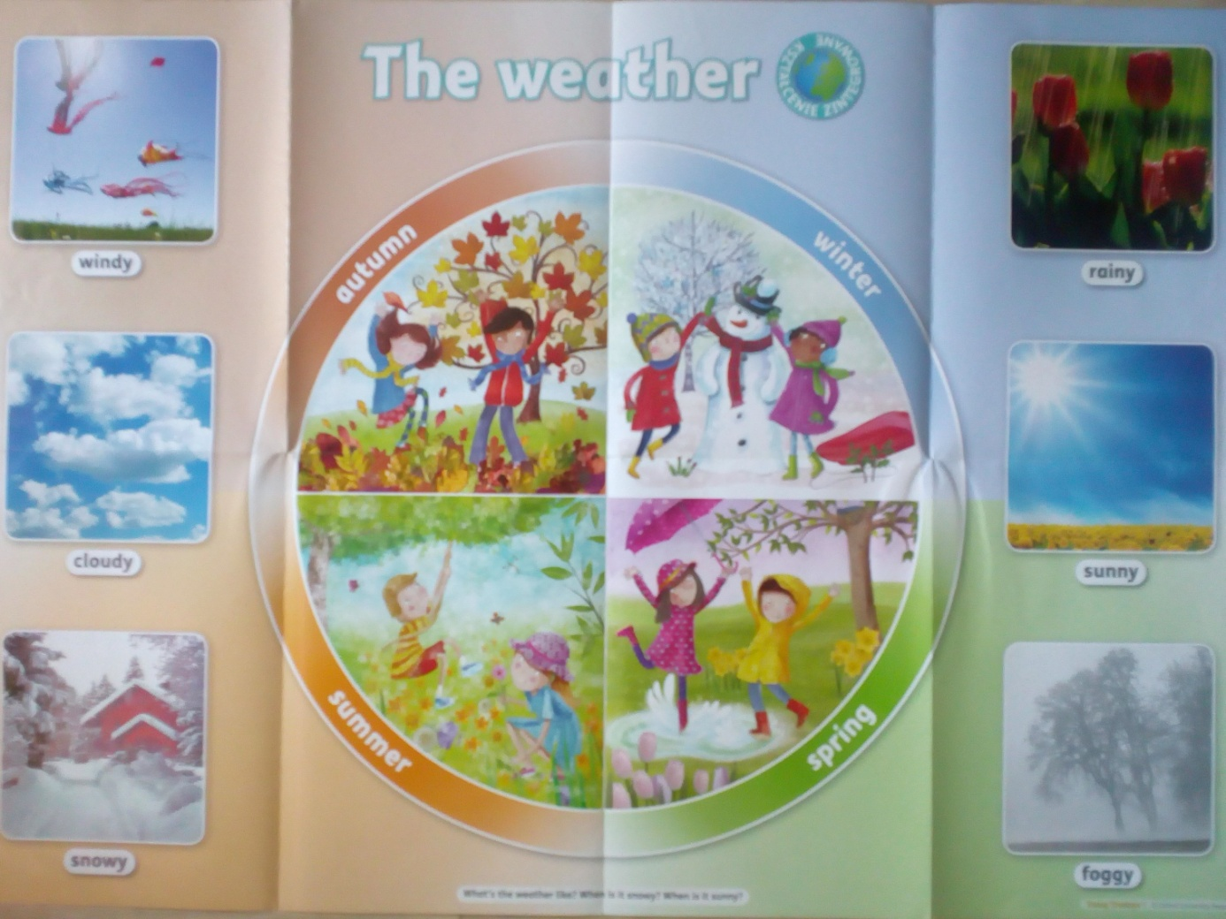

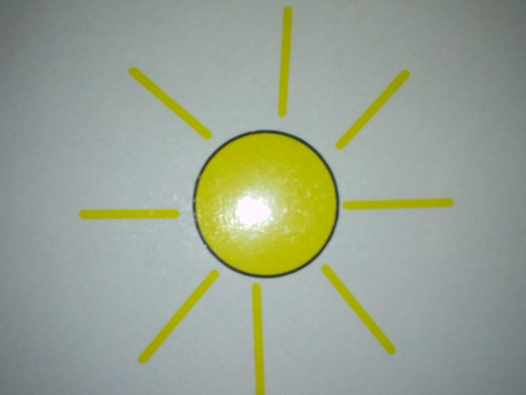 It’s sunny.
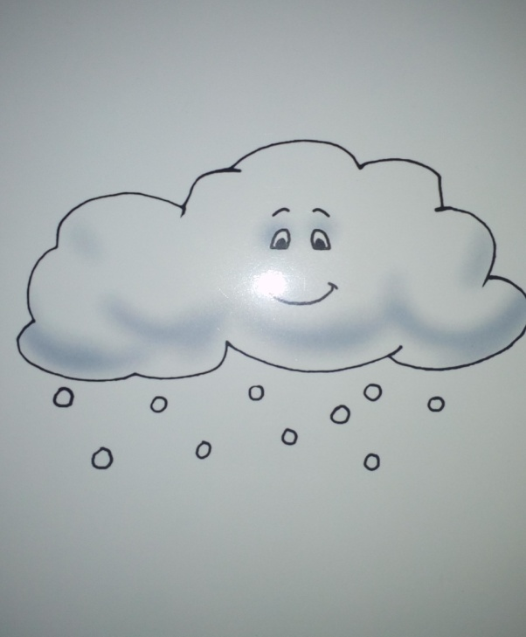 It’s snowy.

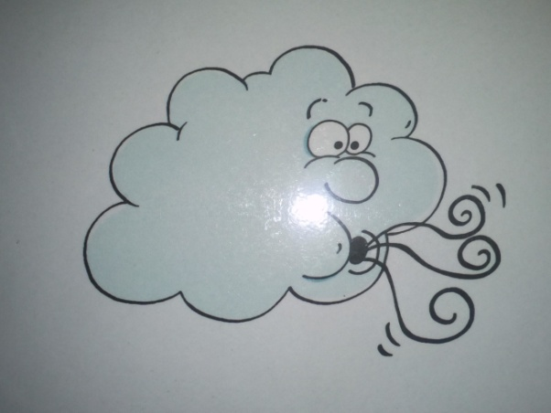 It’s windy.

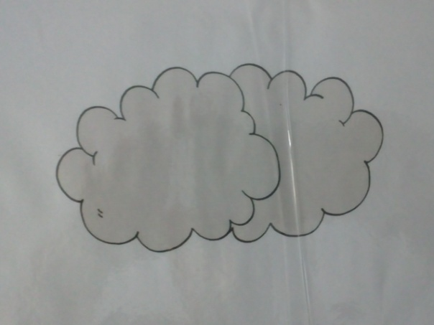 It’s cloudy.
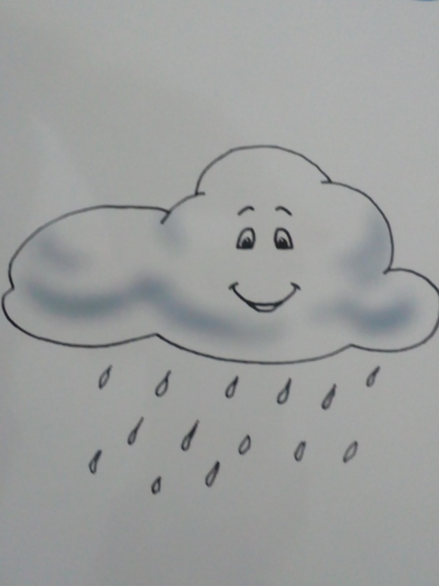 It’s rainy.

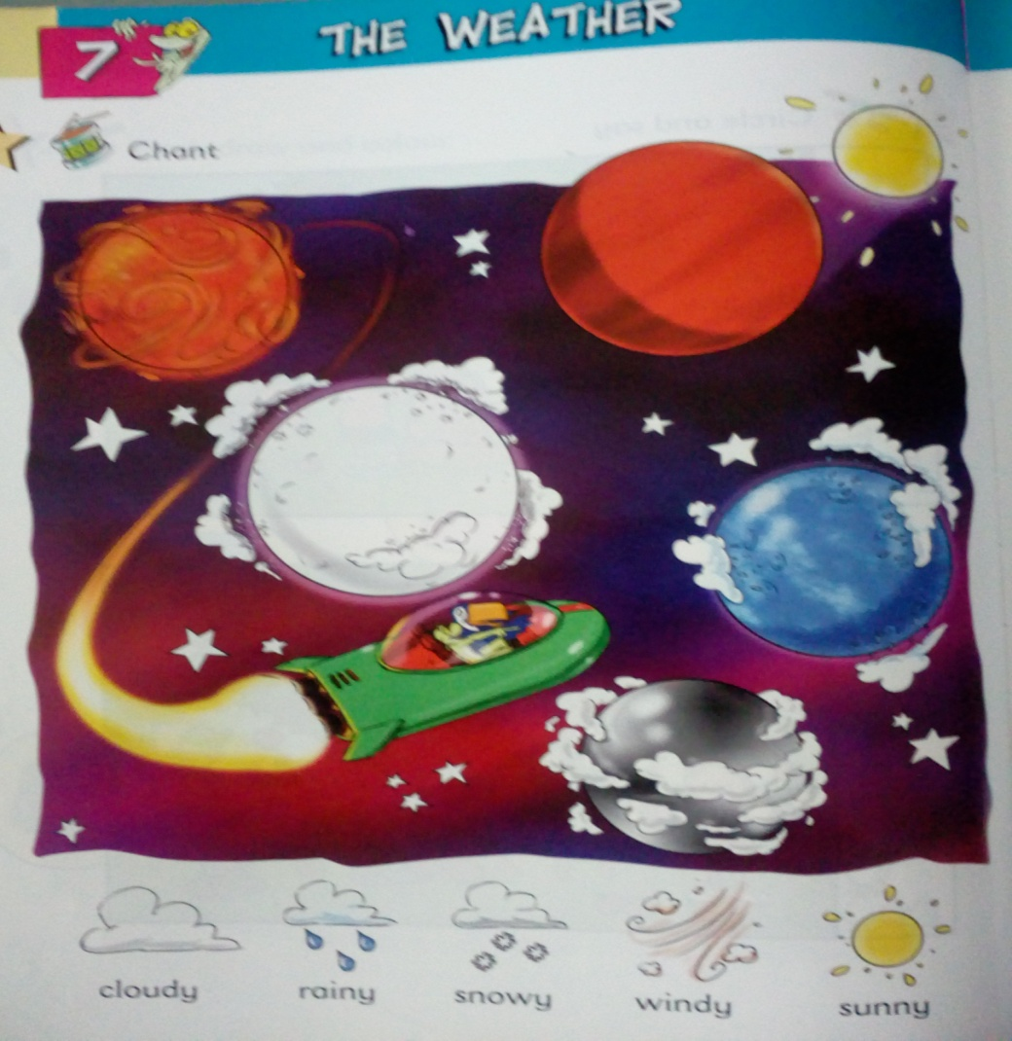
- Let’s go to the silver planet.
- No, no, no. It’ cloudy, cloudy all the time.
- Let’s go to the blue planet.
- No, no, no. It’s rainy, rainy all the time.
- Let’s go to the white planet.
- No, no, no. It’s snowy, snowy all the time.
- Let’s go to the orange planet.
- No, no, no. It’s windy, windy all the time.
- Let’s go to the red planet.
- Yes, it’s sunny, sunny all the time!
- Let’s go and play. Hurray!

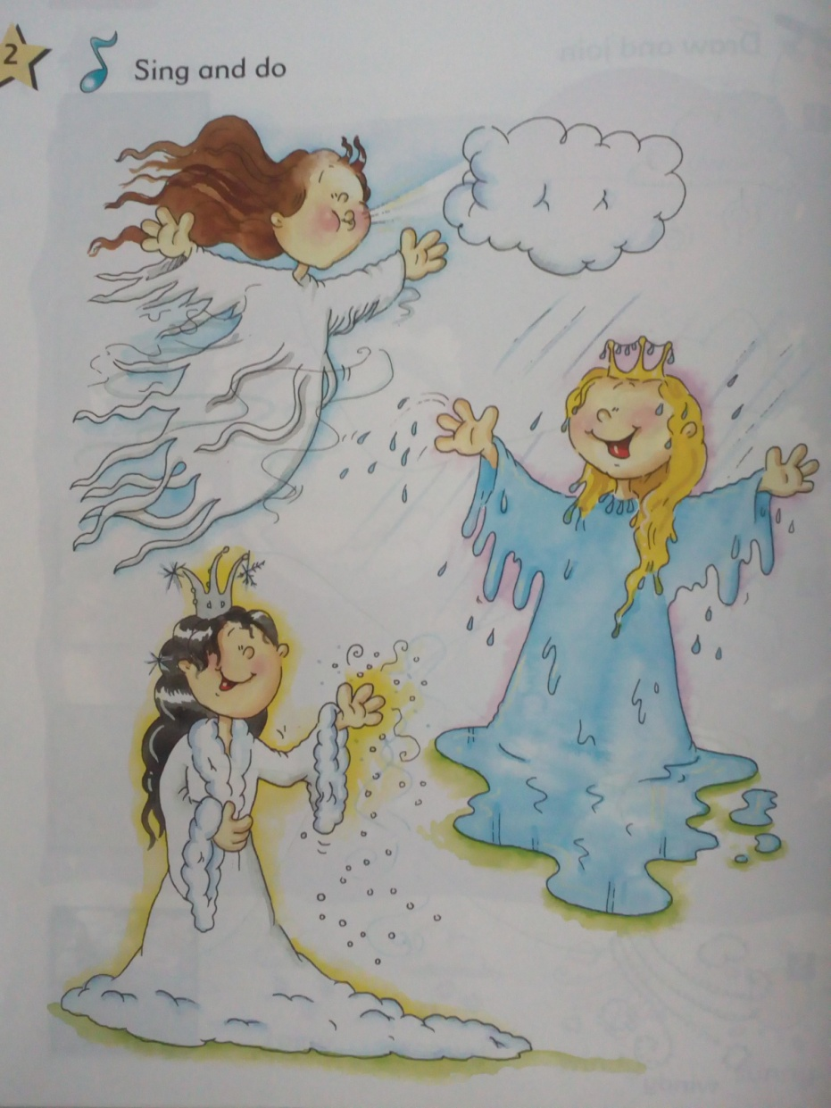
- What’s the weather like? Tell me, please.
- Miss Wind: Listen to me: whoo, whoo. It’s windy.
- What’s the weather like? Tell me, please.
- Miss Rain: Listen to me: drip drop, drip drop. It’s rainy.
- What’s the weather like? Tell me, please.
- Miss Snow: Listen to me: crunch, crunch. It’s snowy.
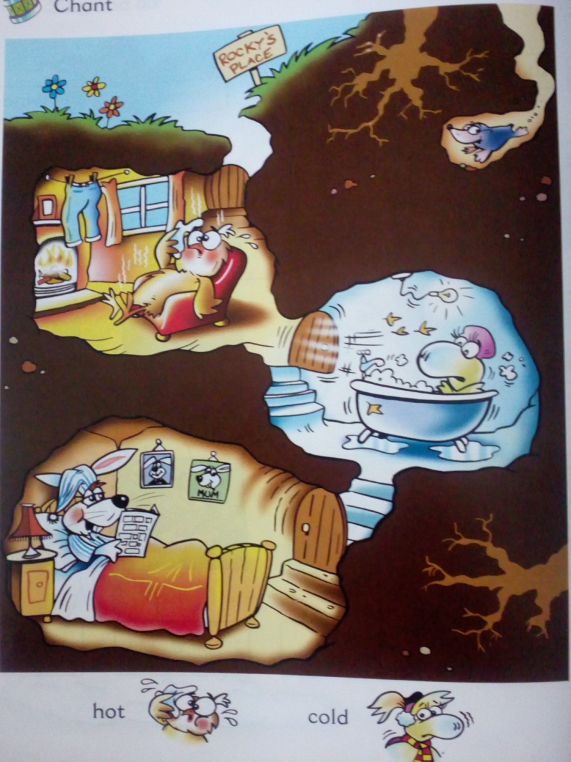

- It’s hot in the living room.
- Open the window, please.
- It’s cold in the bathroom.
- Close the door, please.
- It’s hot in the living room. It’s cold in the bathroom. I’m OK in my bedroom. I’m OK in my bed!

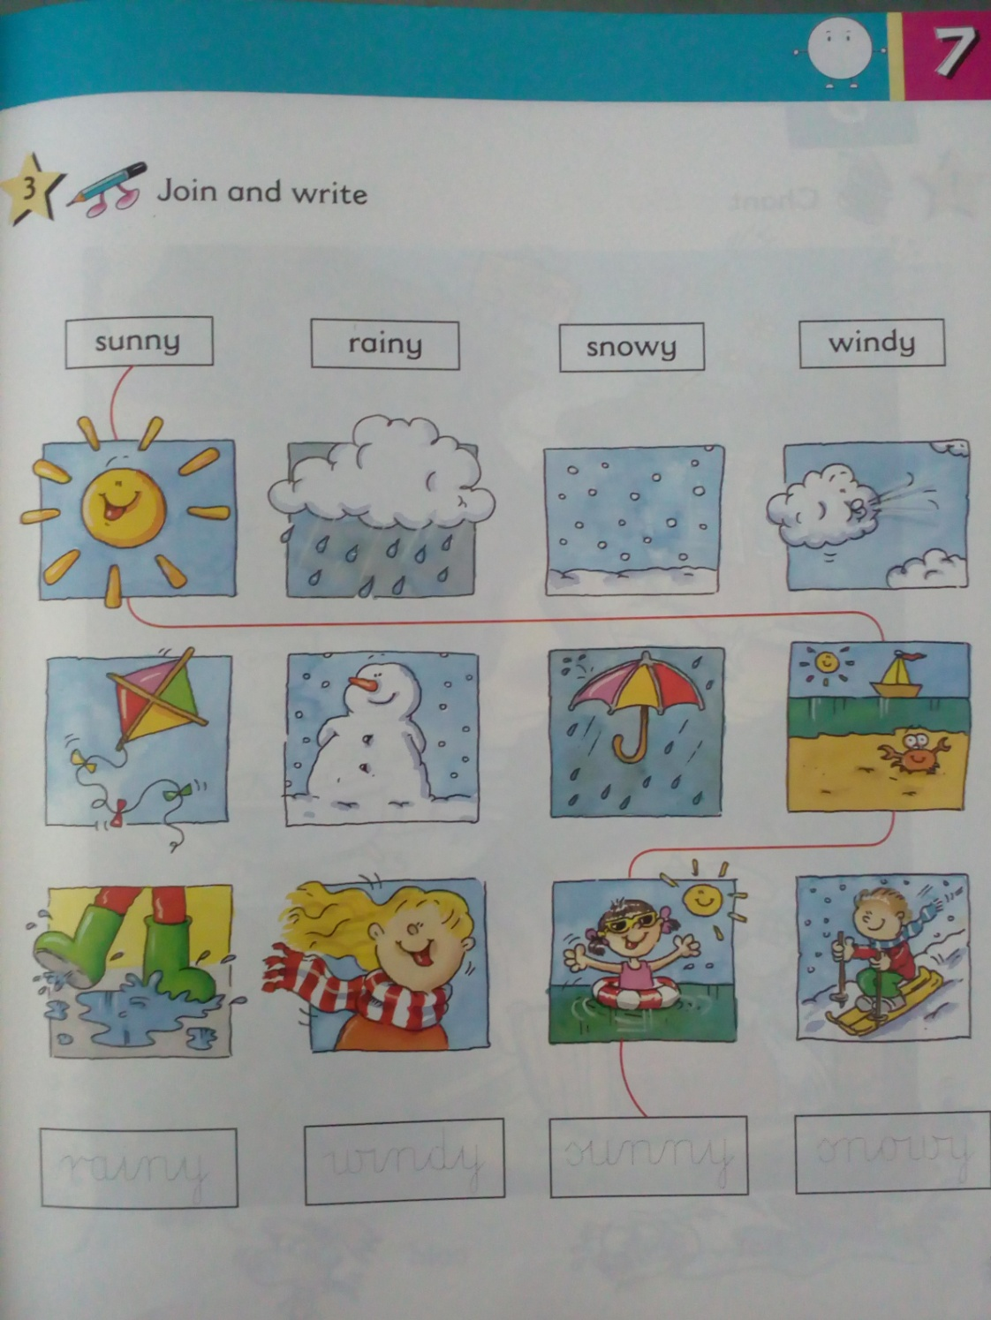

Połącz obrazki i wyrazy.

Posłuchaj:

https://www.youtube.com/watch?v=QVe-ew7bDic

https://www.youtube.com/watch?v=KUSbazn3STo

https://www.youtube.com/watch?v=CXKj7bm4Ops

Opacowane na podstawie: Eko and Friends 1, wyd. Longman

