On a farm: Eddie, the earthworm. 28th May 2020
Listen to the story.
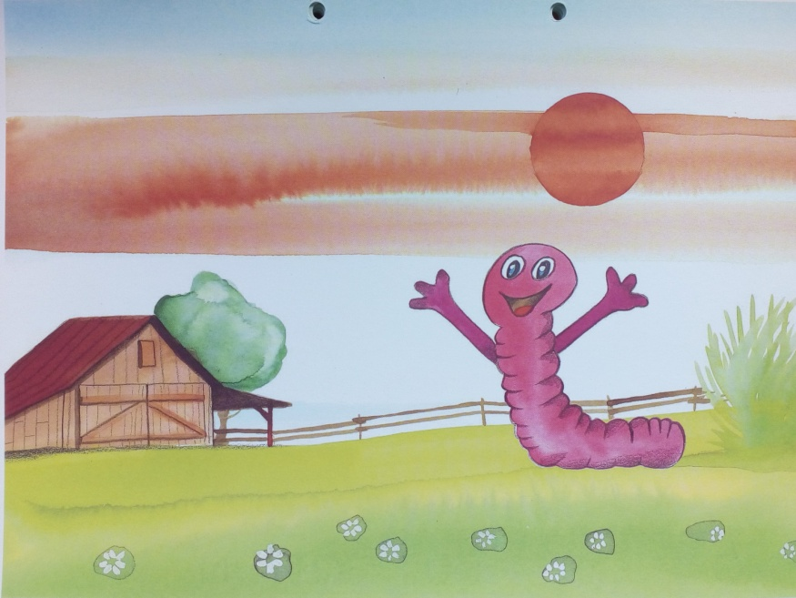
It’s a lovely morning on the farm.
This is Eddie, the earthworm.
“Hi, everybody.”
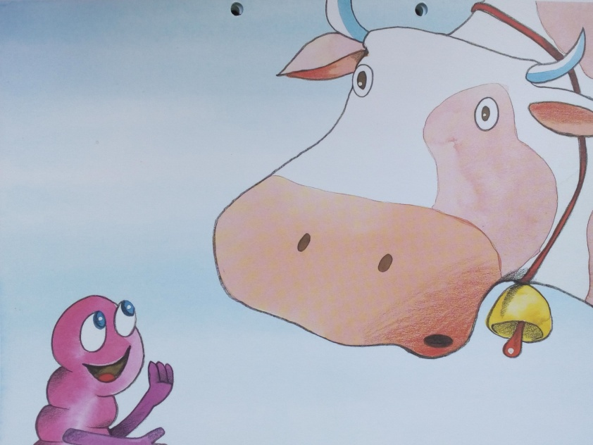
“Moo. Who are you?”
“Hi. I’m Eddie, the earthworm.”
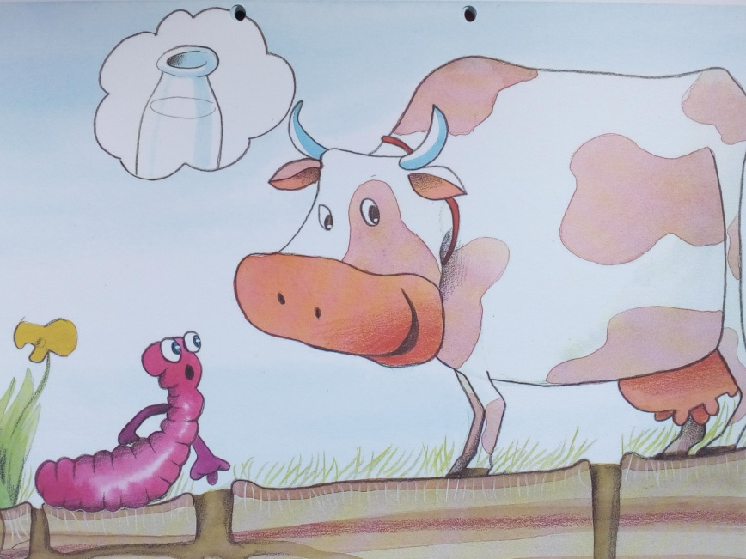
“I’m a cow. I give milk. What about you?”
“Erm, erm ... I live underground.”

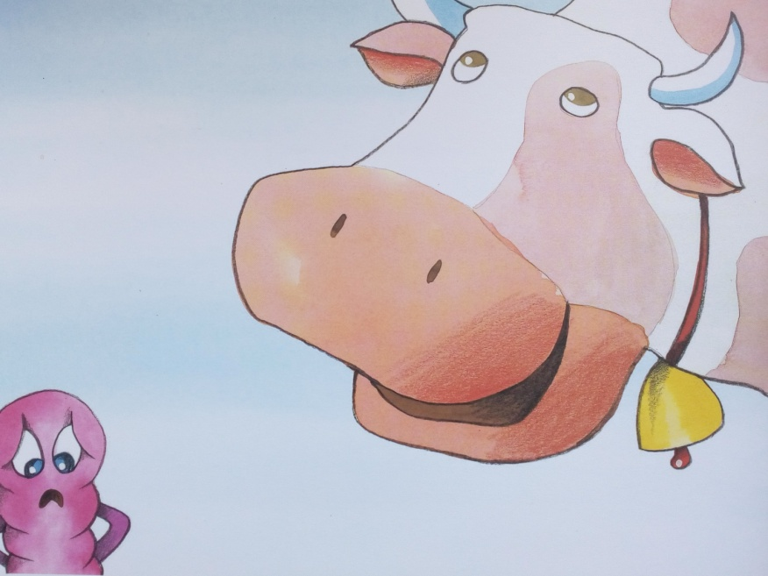
“Underground? Stupid. Moo.”
Eddie is sad.
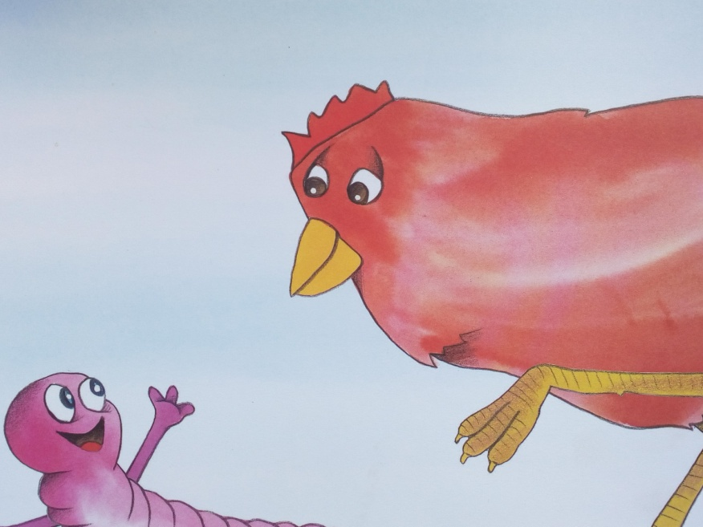
“Who are you?”
“Hi. I’m Eddie, the earthworm.”

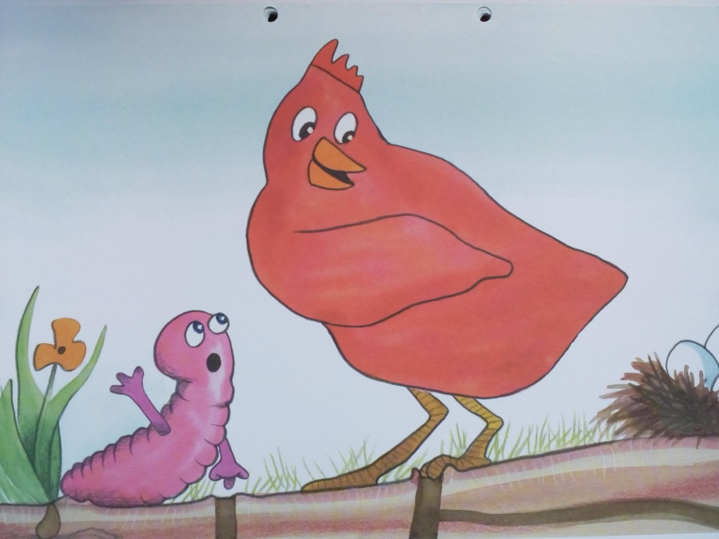
“I’m a hen. I lay eggs. What about you?”
“Erm, erm ... I live underground.”
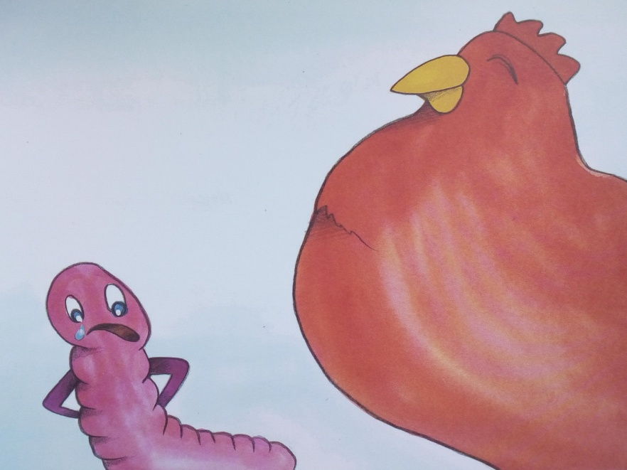
“Underground? Stupid.”
Eddie is very sad.

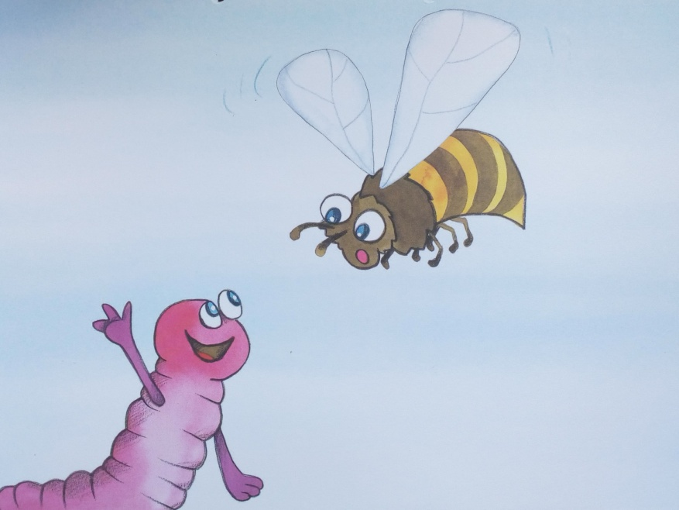
“Who are you?”
“Hi. I’m Eddie, the earthworm.”
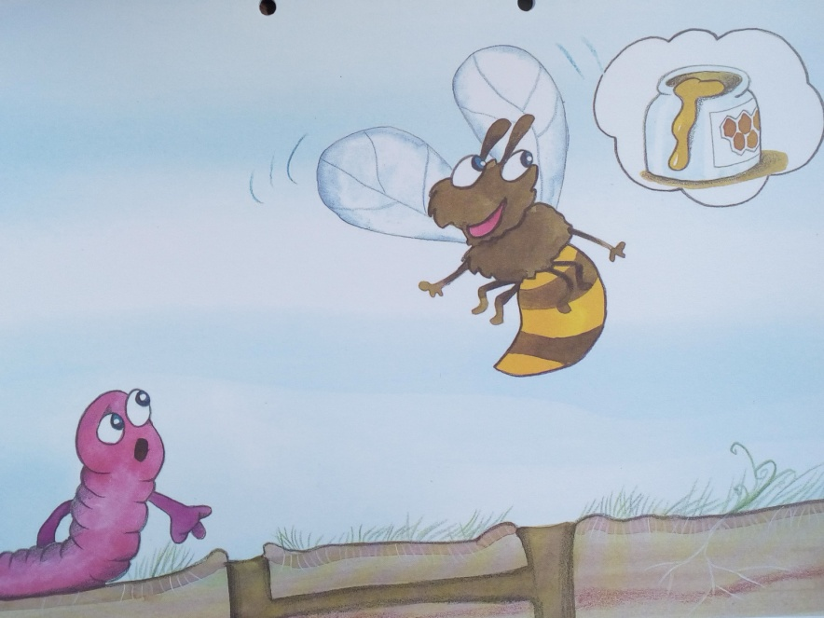
“I’m a bee. I make honey. What about you?”
“I live underground”

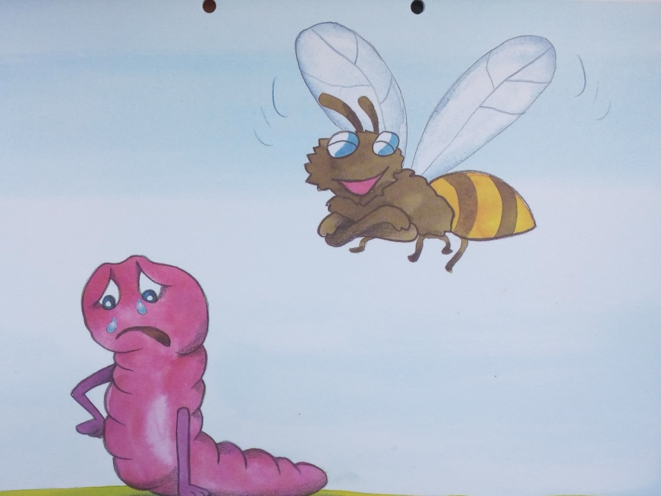
“Underground? Stupid.”
Eddie is very, very sad.
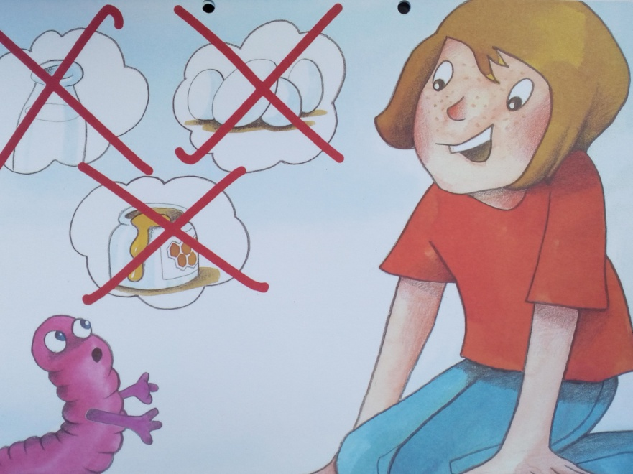
“Hello, Eddie. You look sad. What’s the problem?”
“I can’t give milk. I can’t lay eggs and I can’t make honey.”

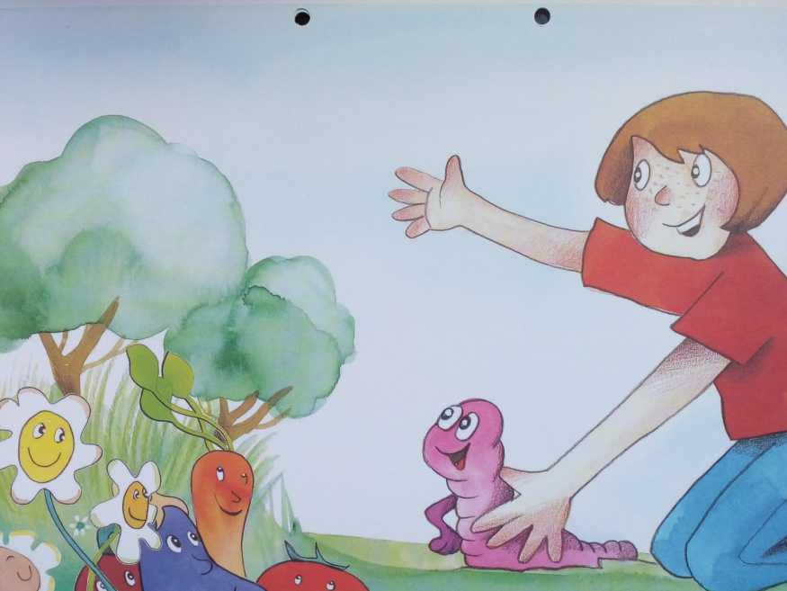
“Eddie, you’re the king of the garden.”
“Really?”
“Yes. The flowers love you, the vegetables love you and the trees love you.”
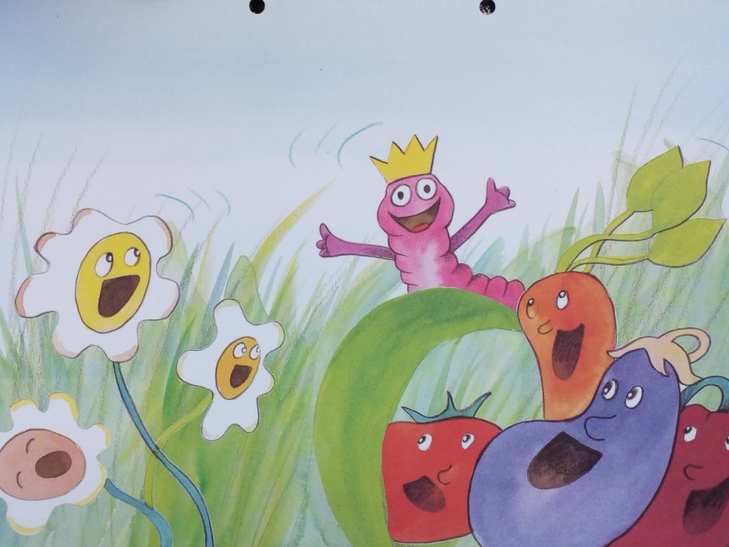
“Eddie is the king of the garden.”
“Eddie, everybody loves you.”
Eddie is happy again.
“Oh, thank you. Thank you very much.”

THE END

Opracowane na podstawie: Playway to English 2, wyd. Cambridge University Press

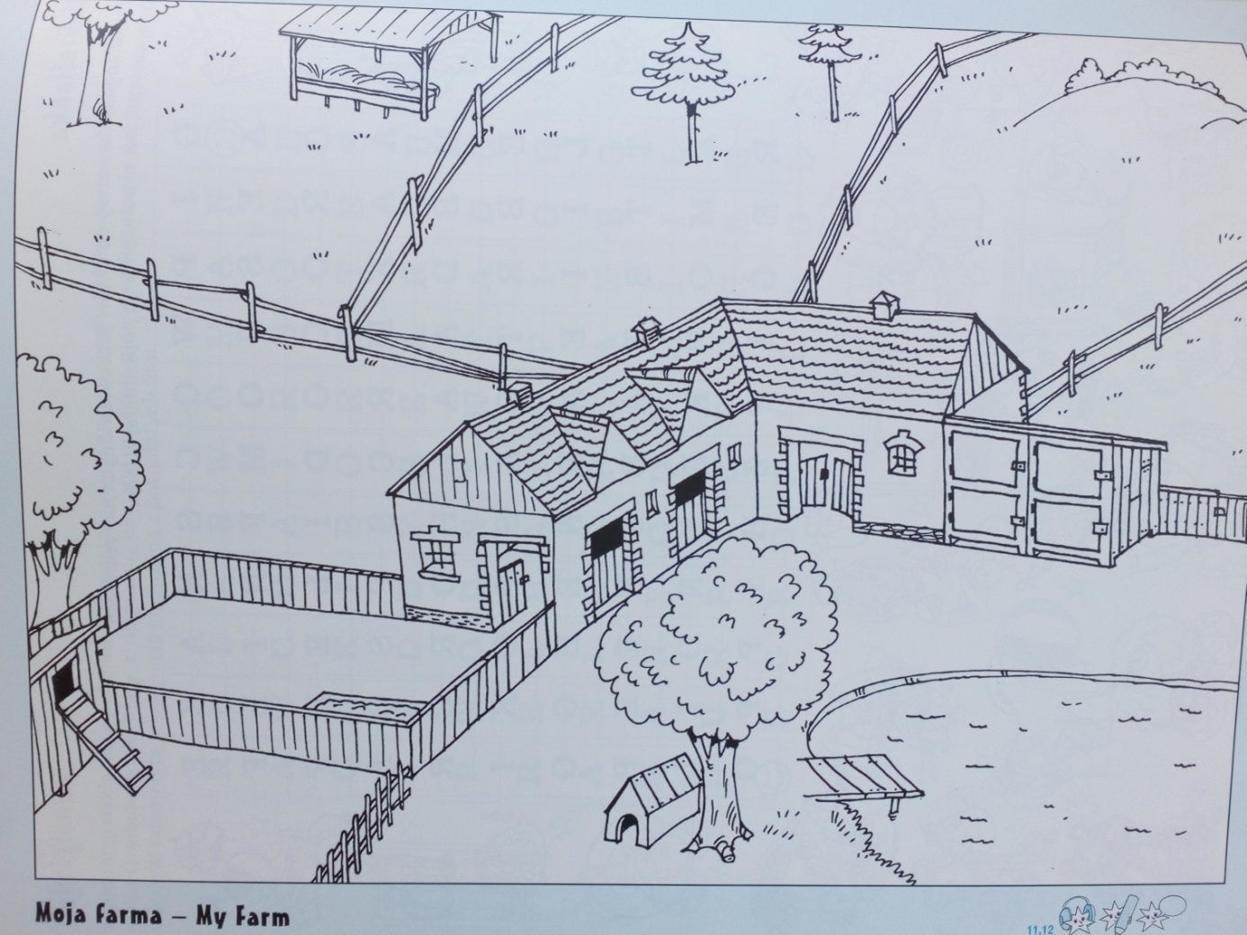
Jakie zwierzęta znajdują się na tej farmie? Narysuj.

