Materials 26th May 2020
What are things made of?
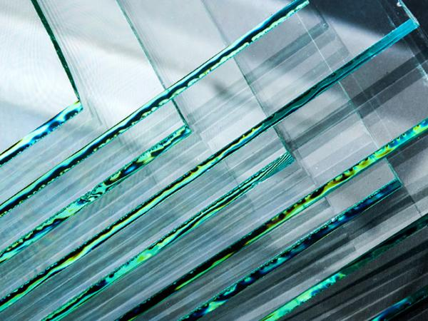
glass
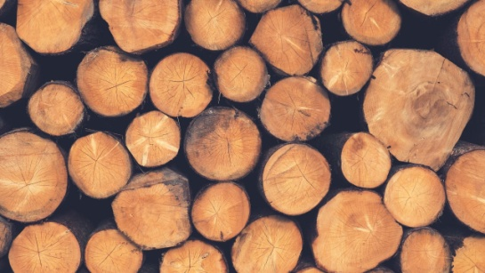
wood
paper
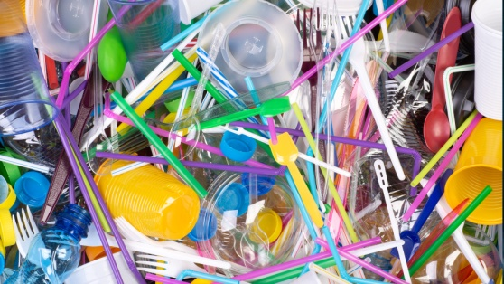
plastic

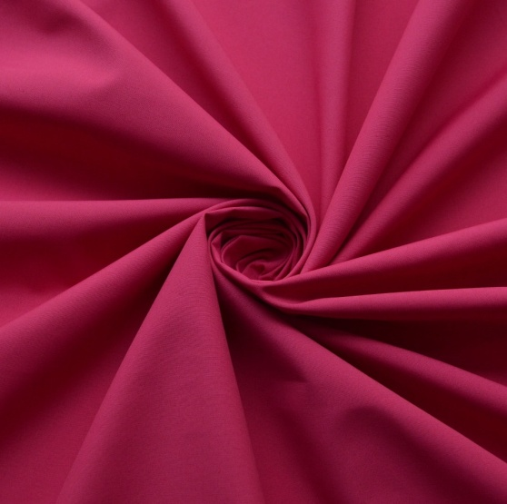
fabric
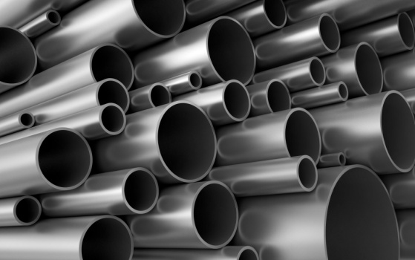
metal
--------------------------------------------------------------------------------------------------------------------------------------
Song https://www.youtube.com/watch?v=lK6C-XjD_dQ
https://www.youtube.com/watch?v=2SeKyEH9GRU
What’s made of glass?
A window is made of glass.
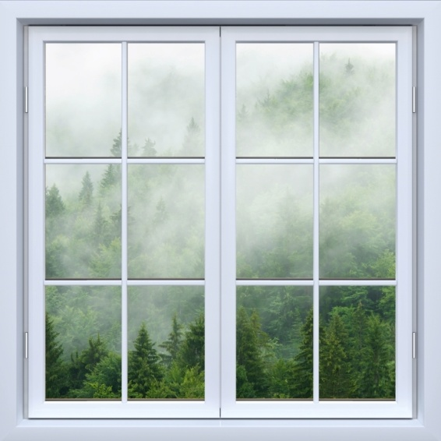
What’s made of wood?
A door is made of wood.
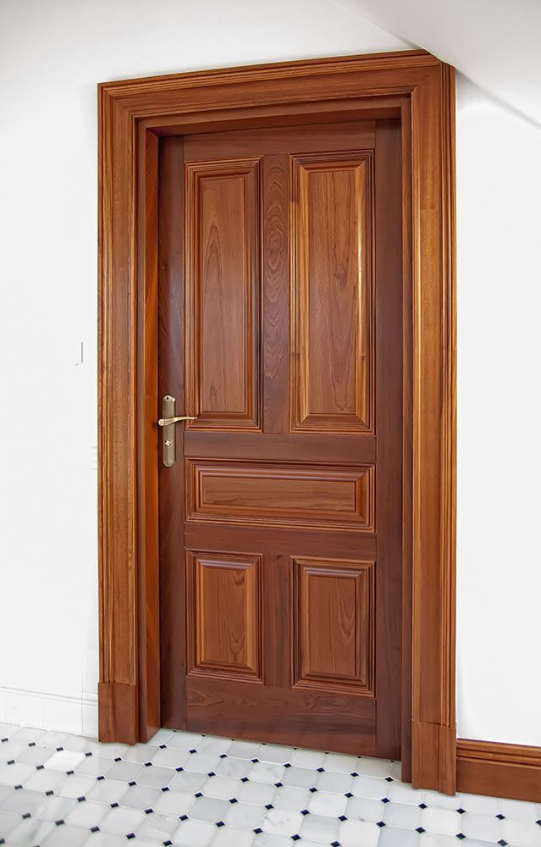
What’s made of paper?
A book is made of paper.
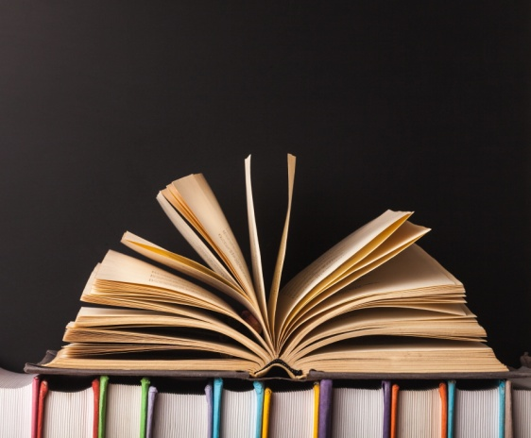
What’s made of plastic?
A pen is made of plastic.
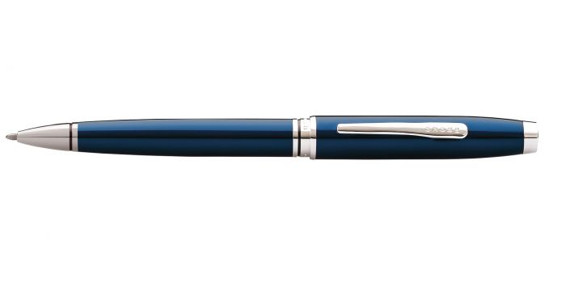
What’s made of fabric?
A T-shirt is made of fabric.
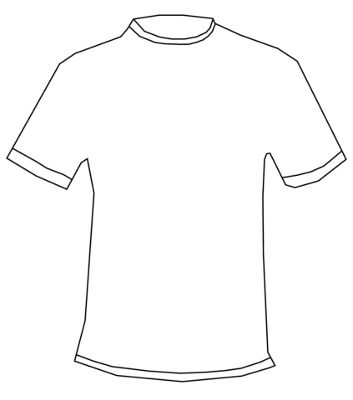
What’s made of metal?
A paper clip is made of metal.
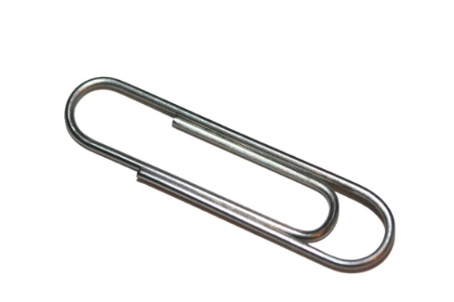

Learn about recycling. Does paper go in the yellow bin or the blue bin?
