Means of transport 19th May 2020
How can we travel?
We can travel by car, by bus, by plane or ...

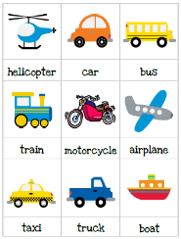

Listen to the song:
https://www.youtube.com/watch?v=cjyRJc5lZb0
https://www.youtube.com/watch?v=GeLC-WwW5zU

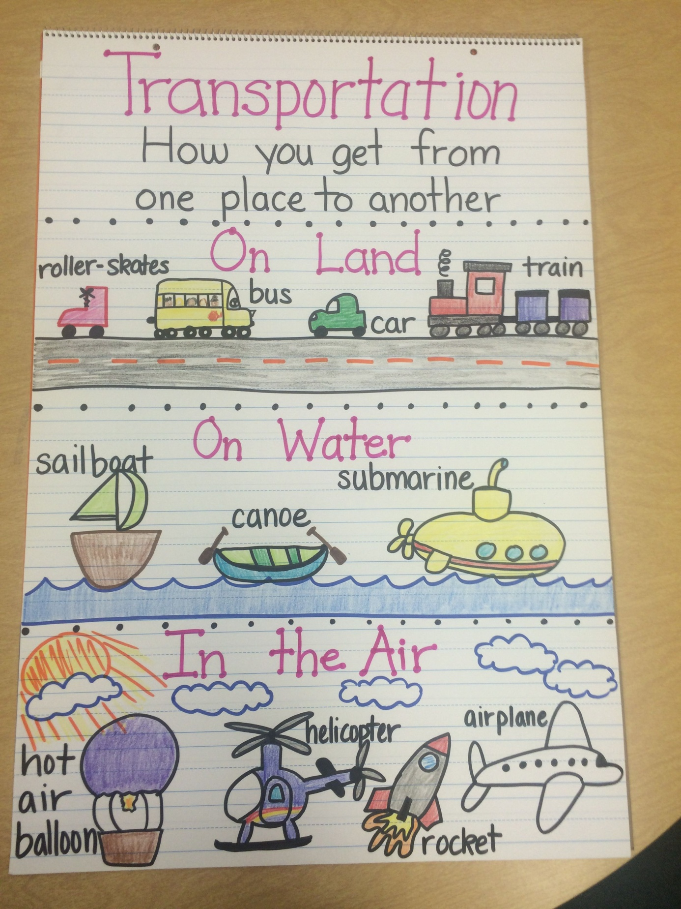

Propozycje prac plastycznych:
