Hide and seek 13th May 2020
These animals live in a meadow.
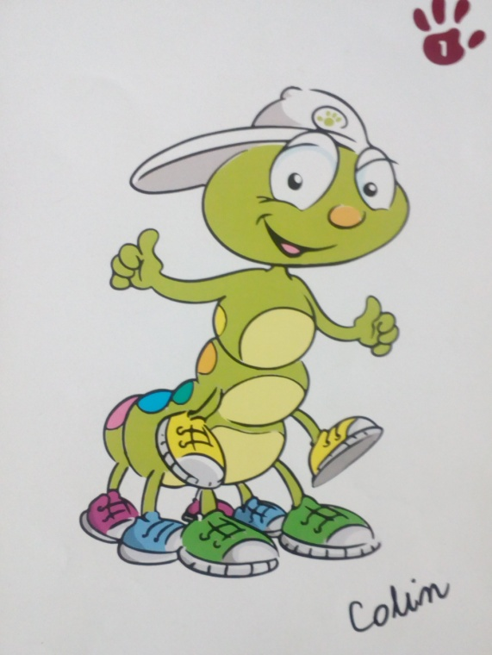
Colin the caterpillar
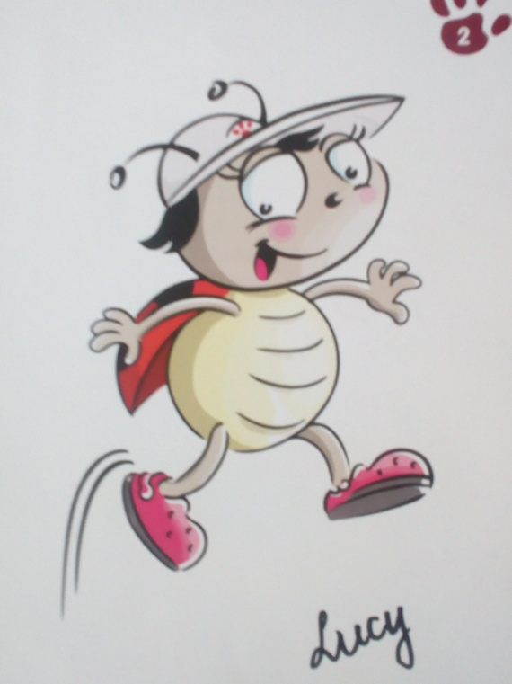
Lucy the ladybird
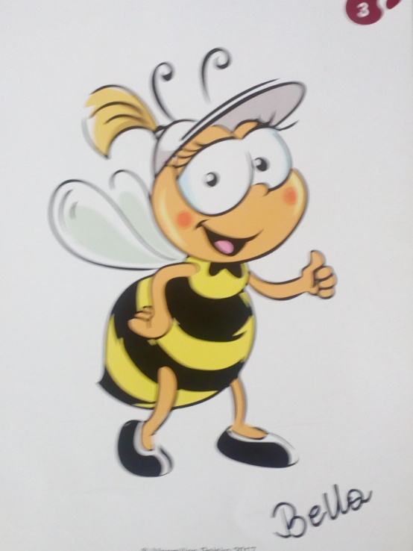
Bella the bee
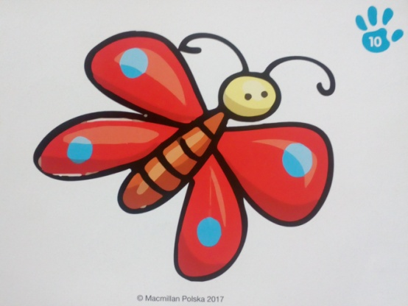
Butterfly
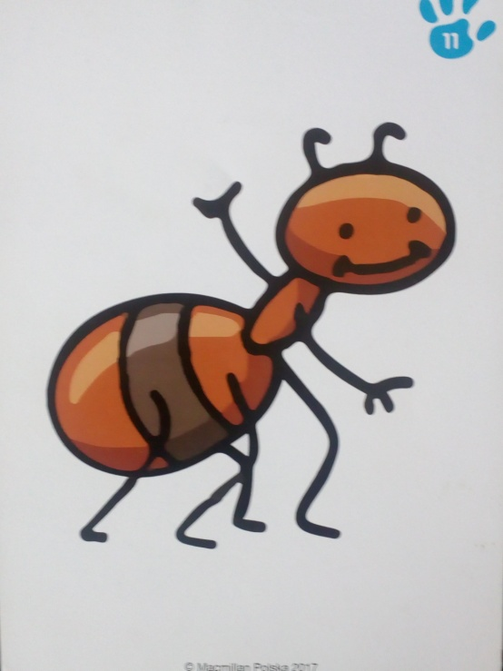 Ant
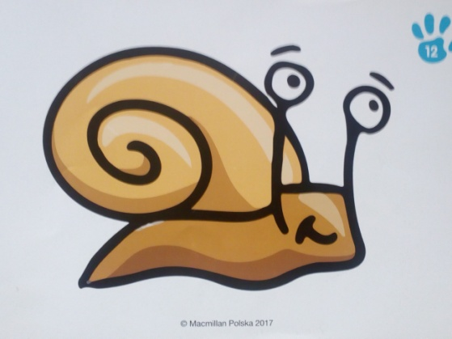
Snail
Listen to the story.
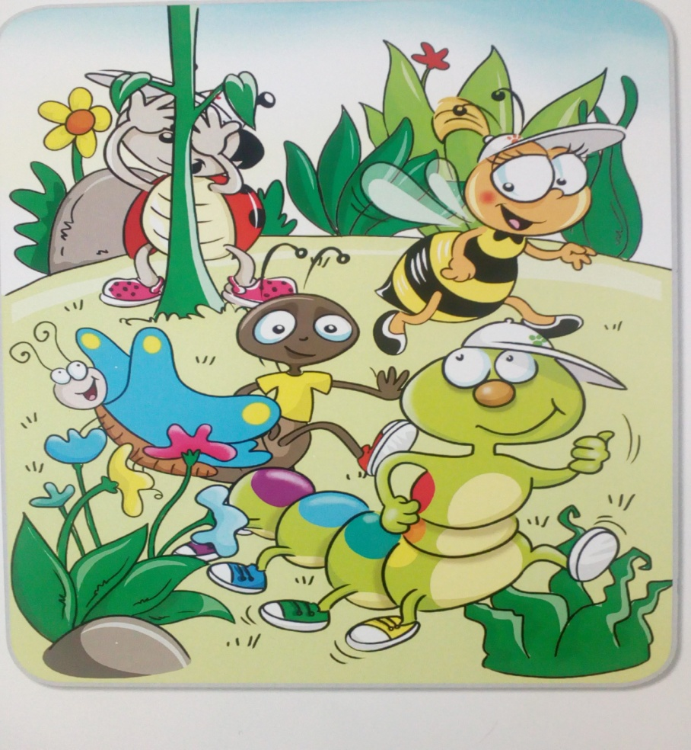
Colin: Let’s play hide and seek!
All: Yes. Hooray!
Snail: Close your eyes, Lucy!
Lucy: Yes. One, two, three, four, five. Are you ready?
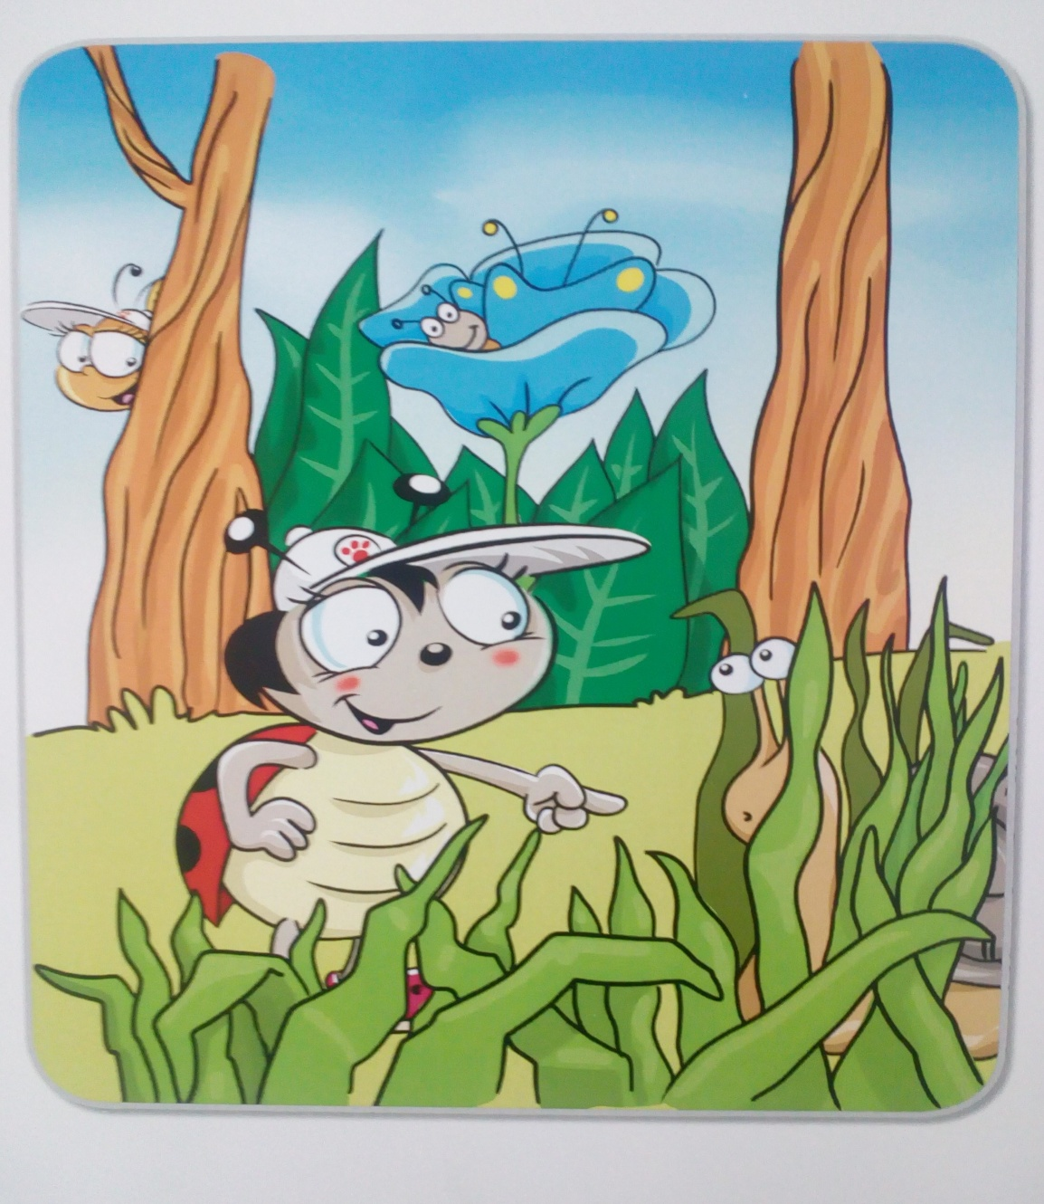

Lucy: Where’s the snail? Here!
Snail: Oh!
Lucy: Where’s the butterfly? Here!
Butterfly: Oh!
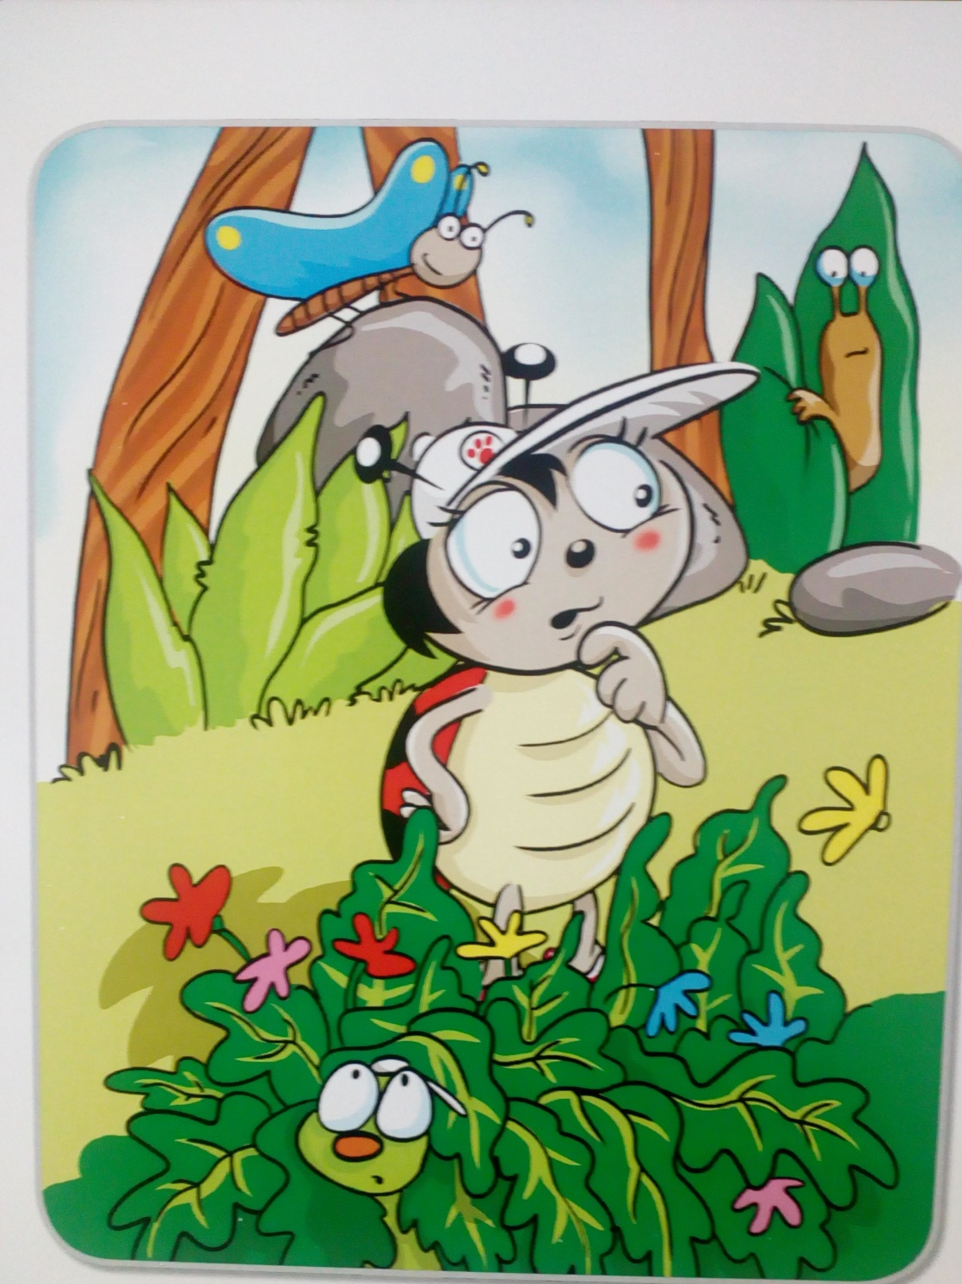

Lucy: Where is Colin?
Snail: I don’t know.
Lucy: Where is Colin?
Butterfly: I don’t know.
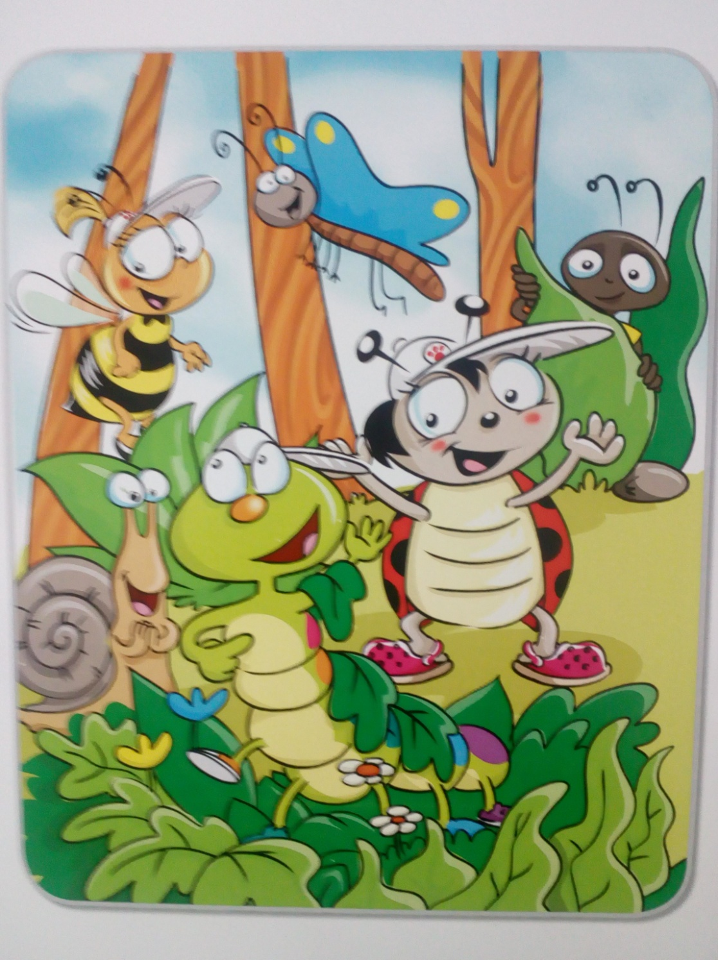

Lucy: Colin, Colin!
Colin: Here!
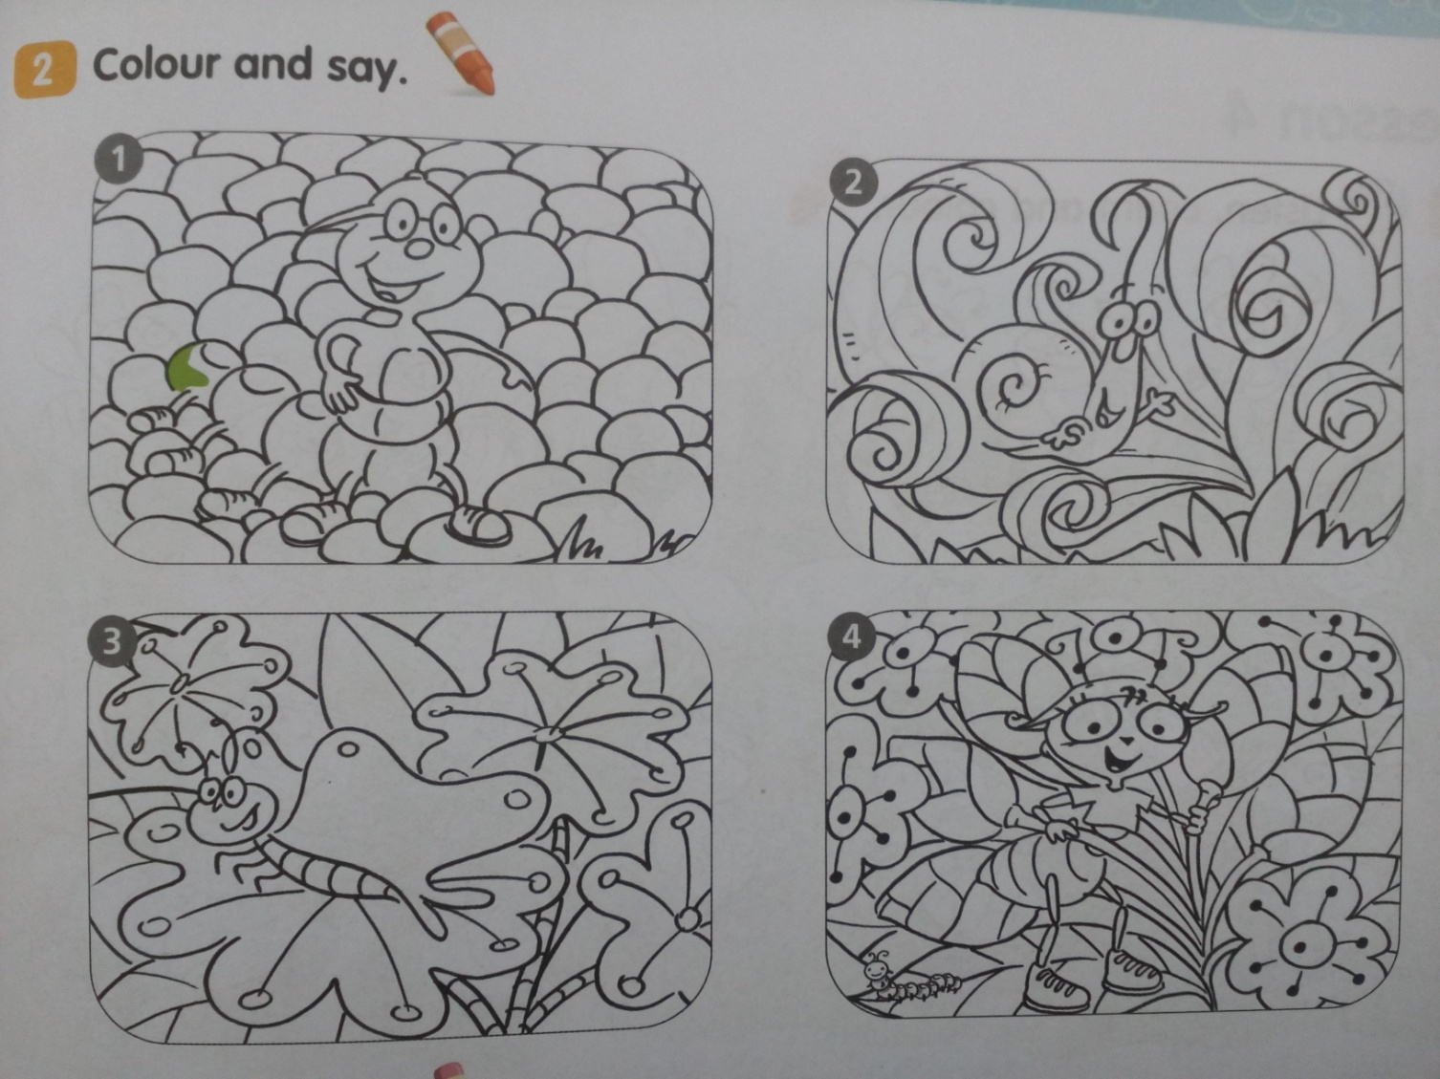
Znajdź zwierzęta. Nazwij je po angielsku. Pokoloruj obrazek.
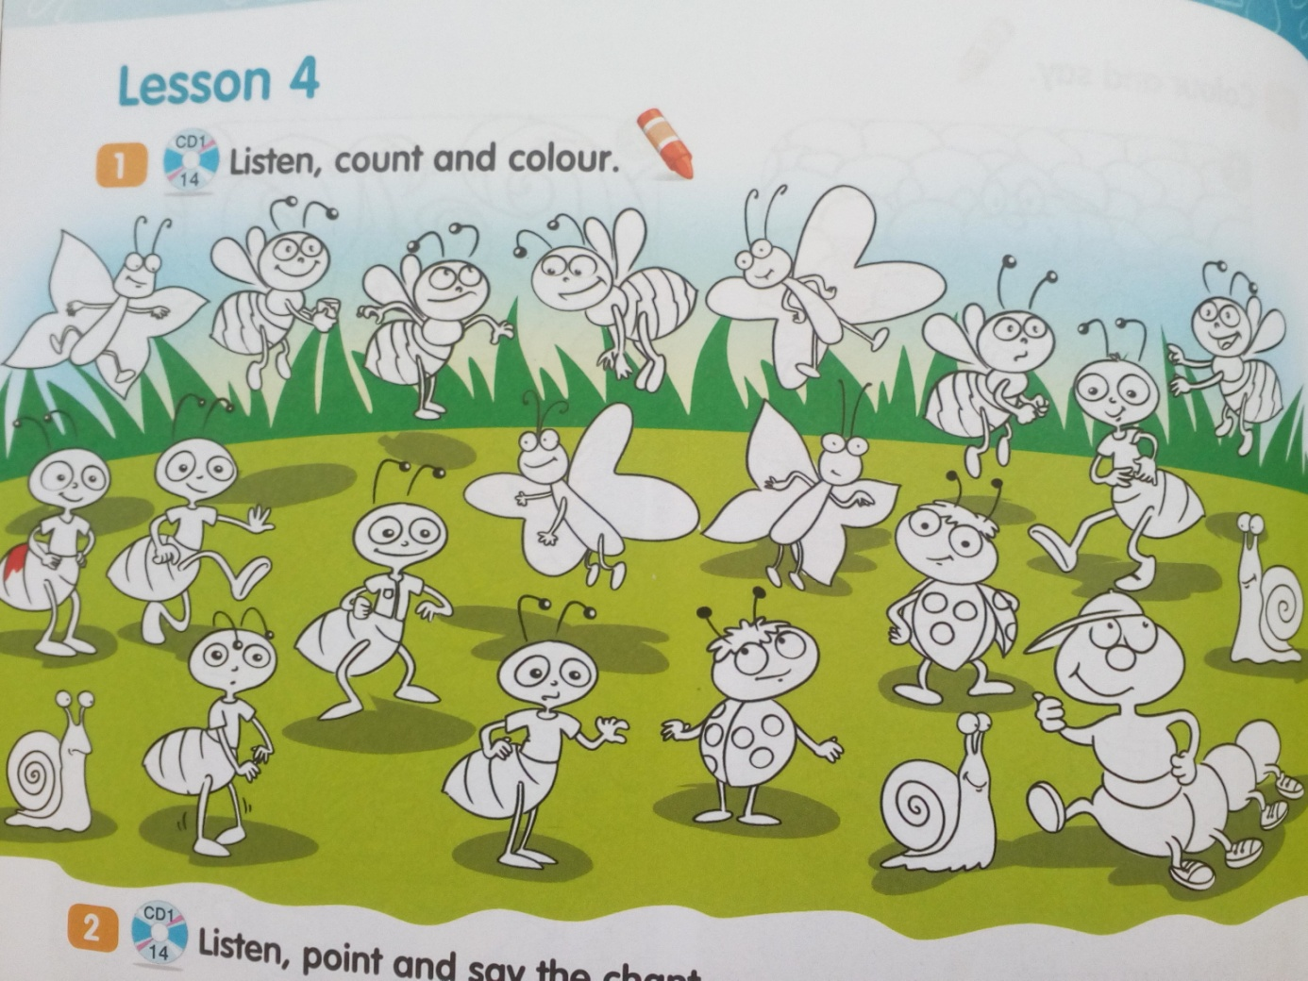
Policz zwierzęta. Powiedz: Five bees, three snails, itp.
Six little ants looking at me,
Red and black. Can you see?
Five little bees looking at me,
Black and yellow. Can you see?
Four little butterflies looking at me,
Green and yellow. Can you see?
Three little snails looking at me,
Red and green. Can you see?
Two little ladybirds looking at me,
Black and red. Can you see?
One green caterpillar. Where, oh where?
Where is Colin? Oh, here.
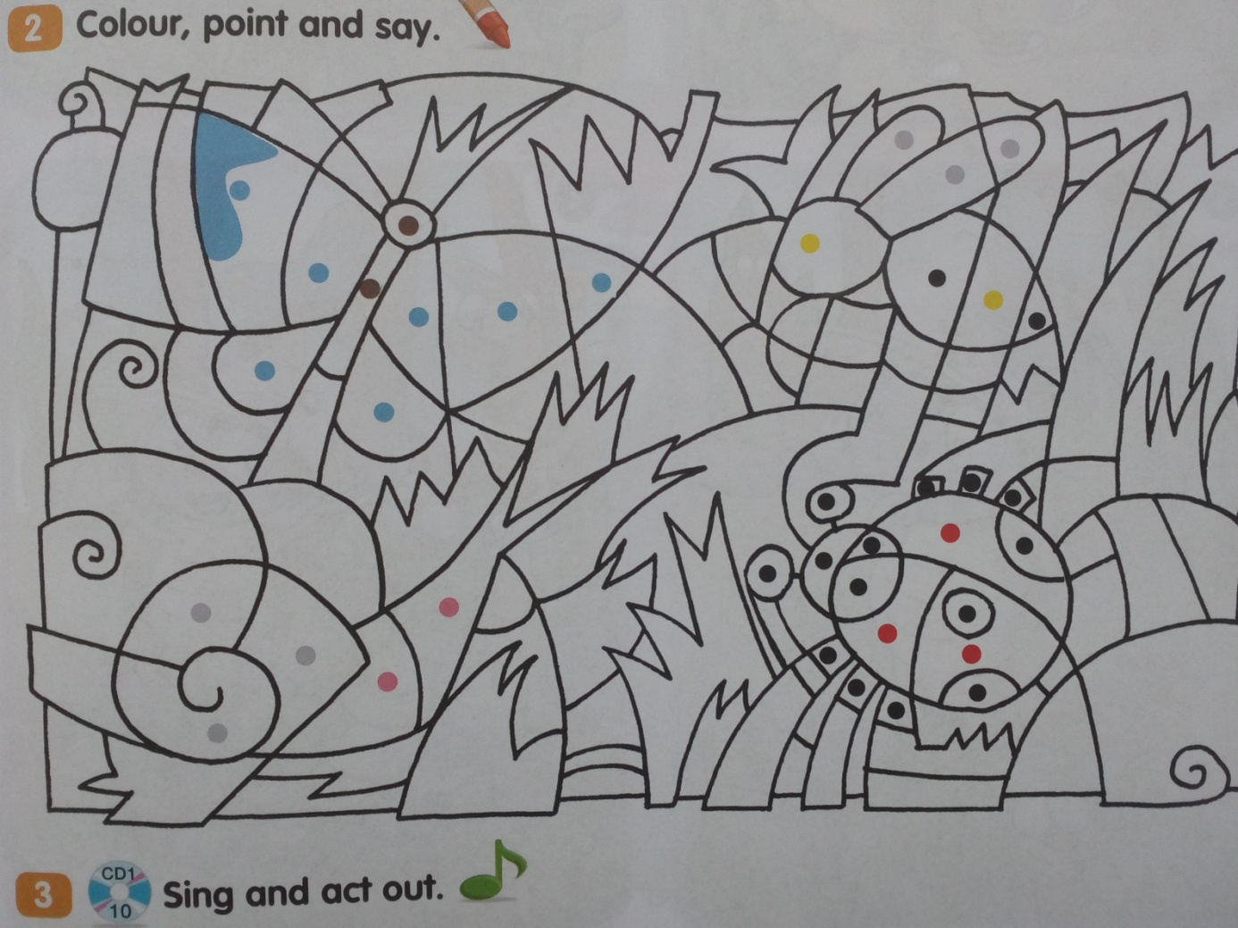
Pola oznaczone kropkami pokoloruj zgodnie ze wskazaniem. Tło pokoloruj na zielono.
Good luck!

Opracowane na podstawie: Bugs Team Starter, wyd. Macmillan

