Bees and honey 7th May 2020

Where is honey from?
Listen to the story.

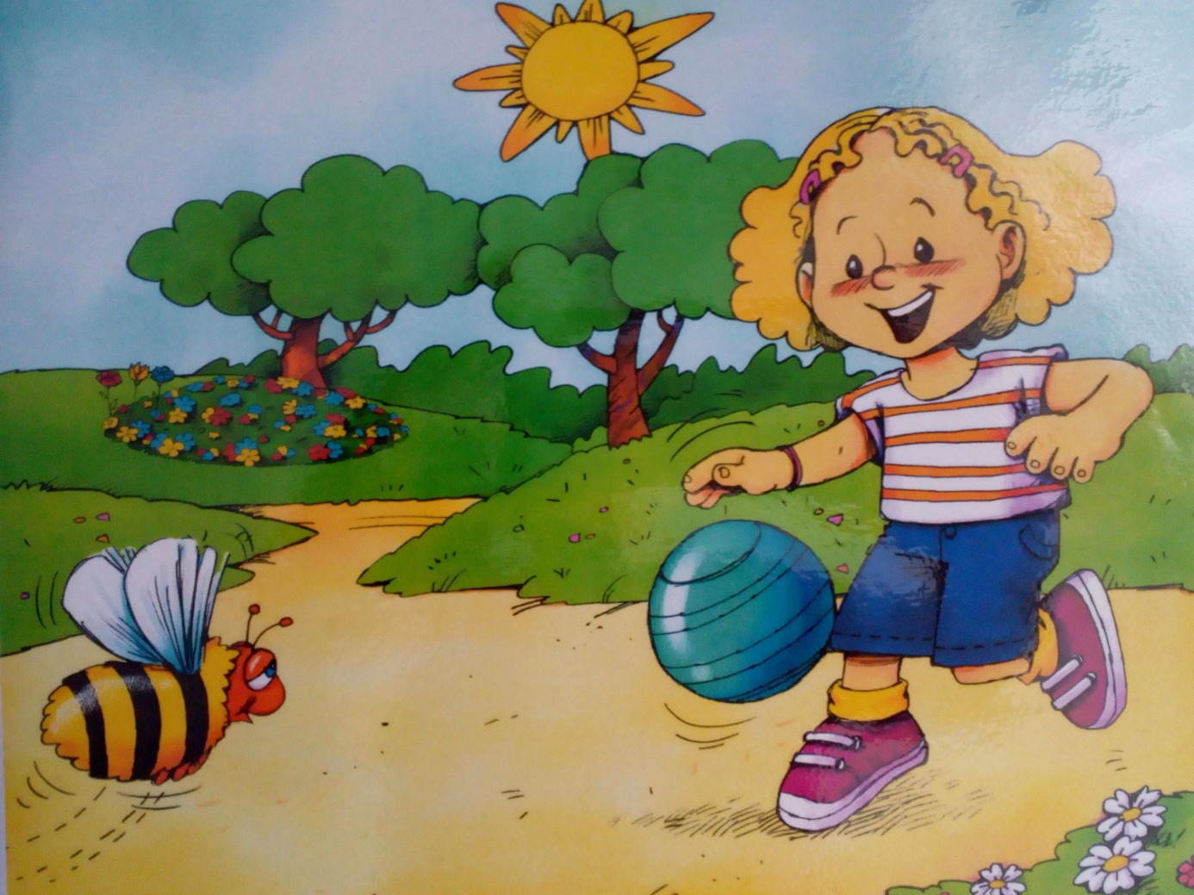
Bee: Buzz, buzz, buzz, buzz, buzz ...
Sara: Oh! A bee!
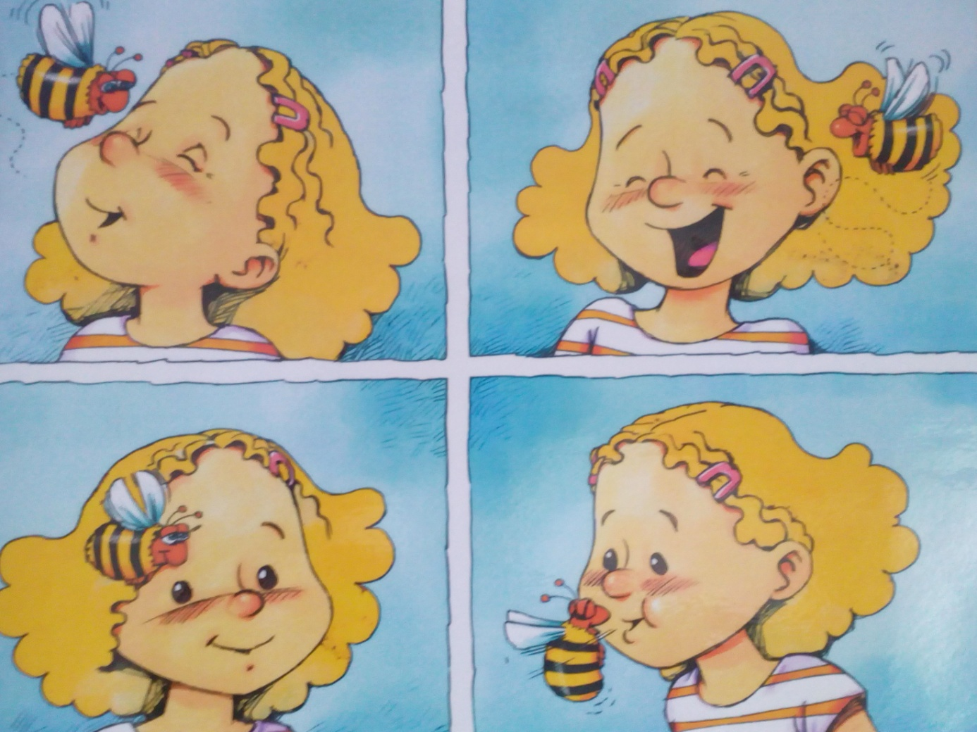
Bee: Buzz, buzz. Is this a flower?
Sara: No, it’s my nose!
Bee: Buzz, buzz. Is this a flower?
Sara: No, it’s my ear.
Bee: Buzz, buzz. Is this a flower?
Sara: No, it’s my eye.
Bee: Is this a flower?
Sara: No, it’s my mouth.
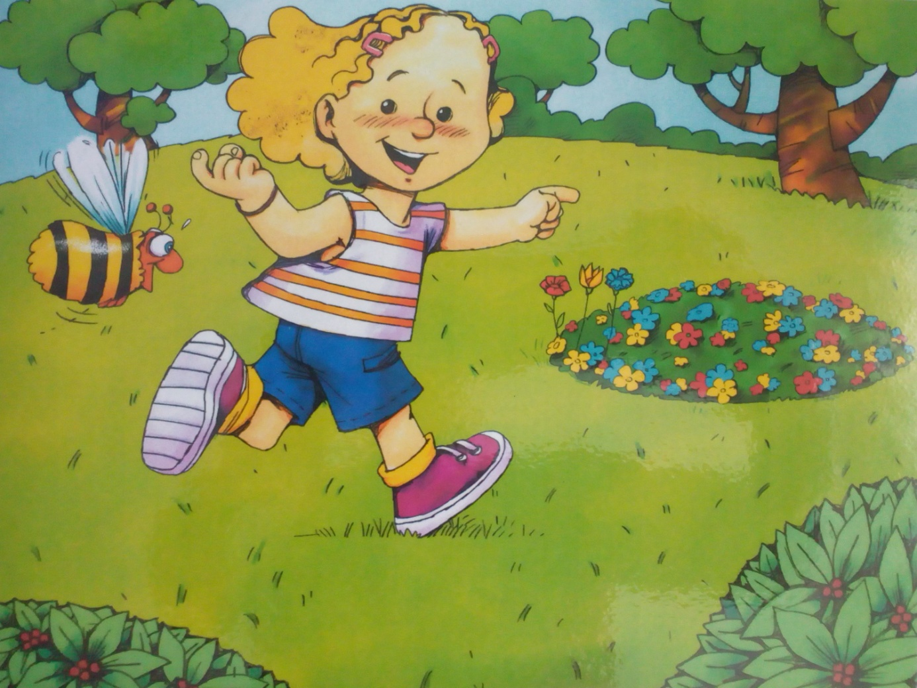
Sara: Follow me, little bee! Follow me little bee!
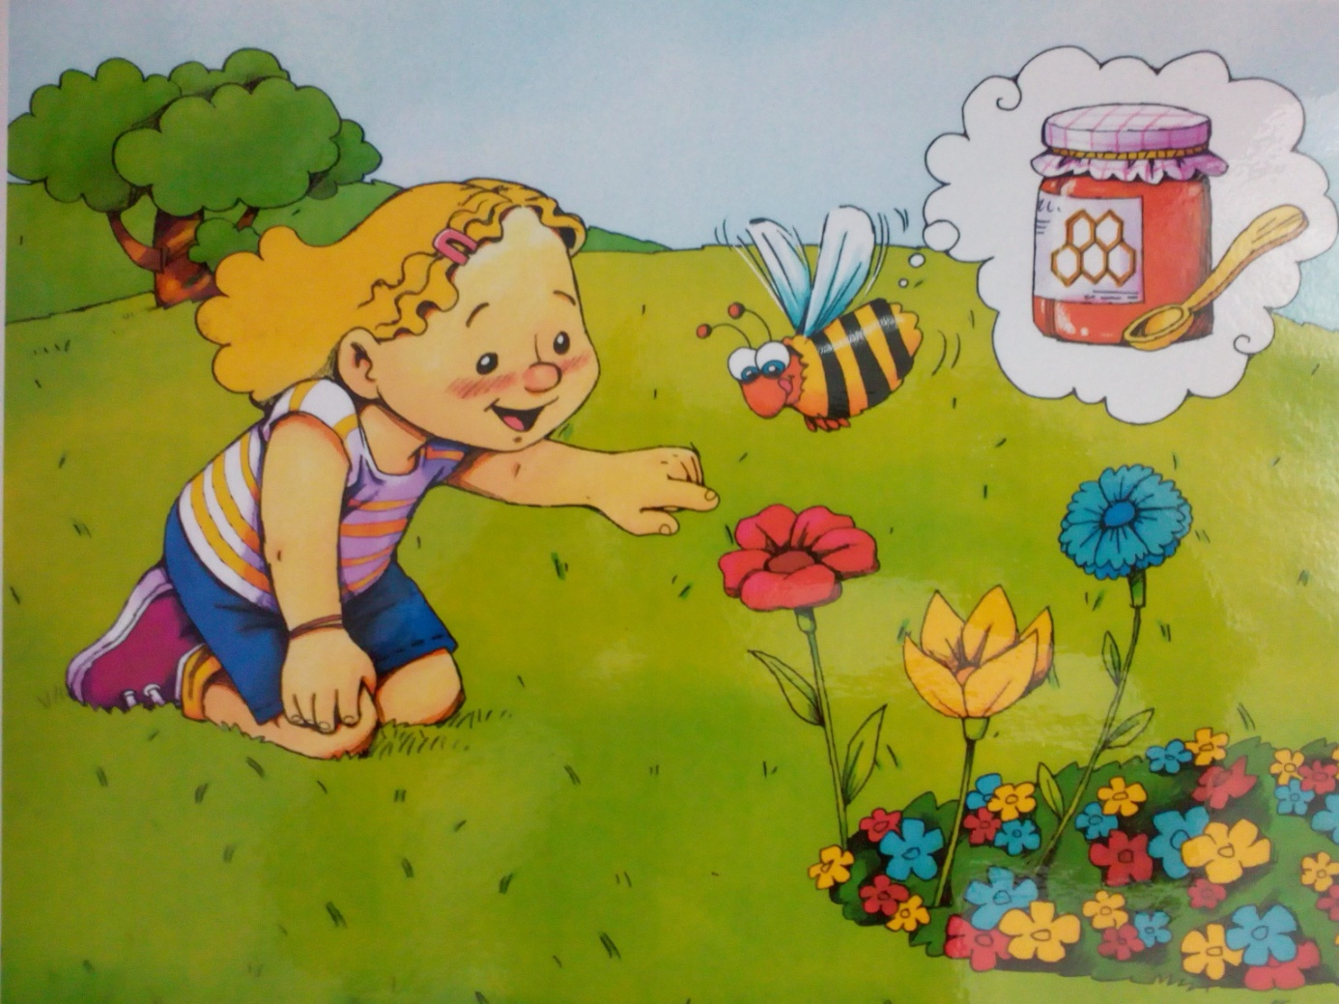
Sara: This is a flower.
Bee: Thank you. Now I can make honey!
Sara: Mmm. I love honey!
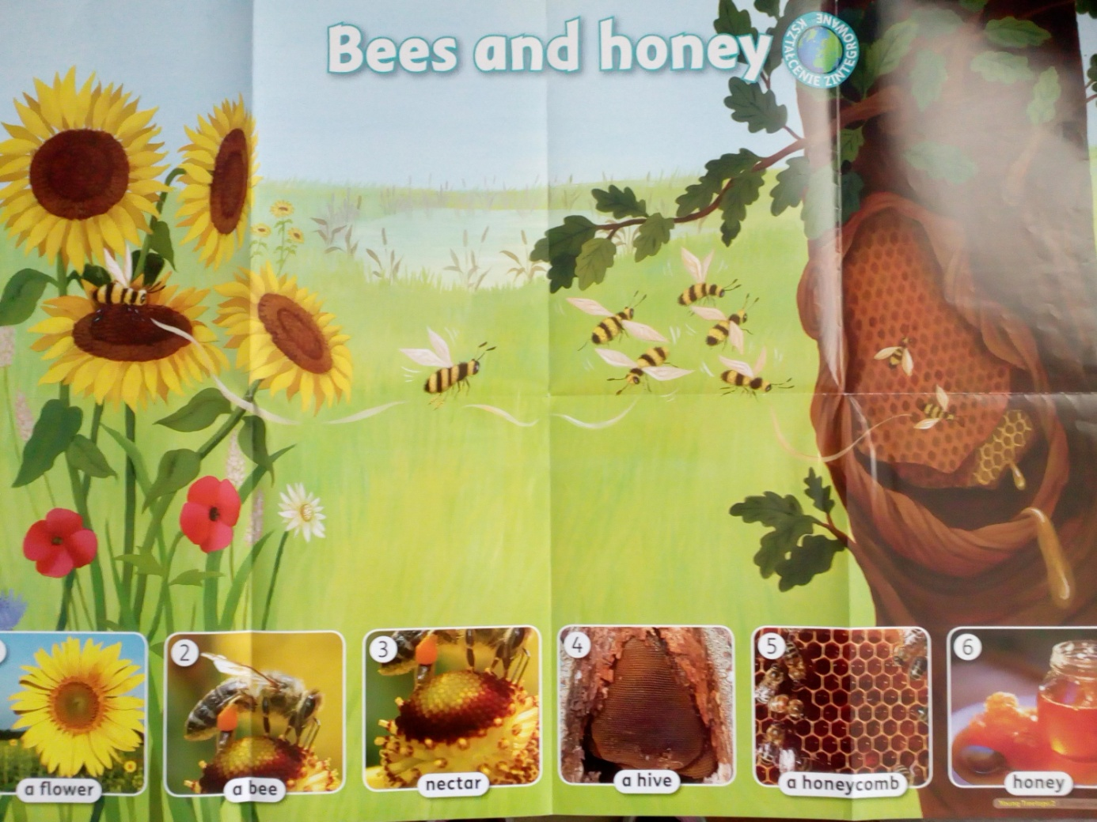
Bees need flowers to make honey.
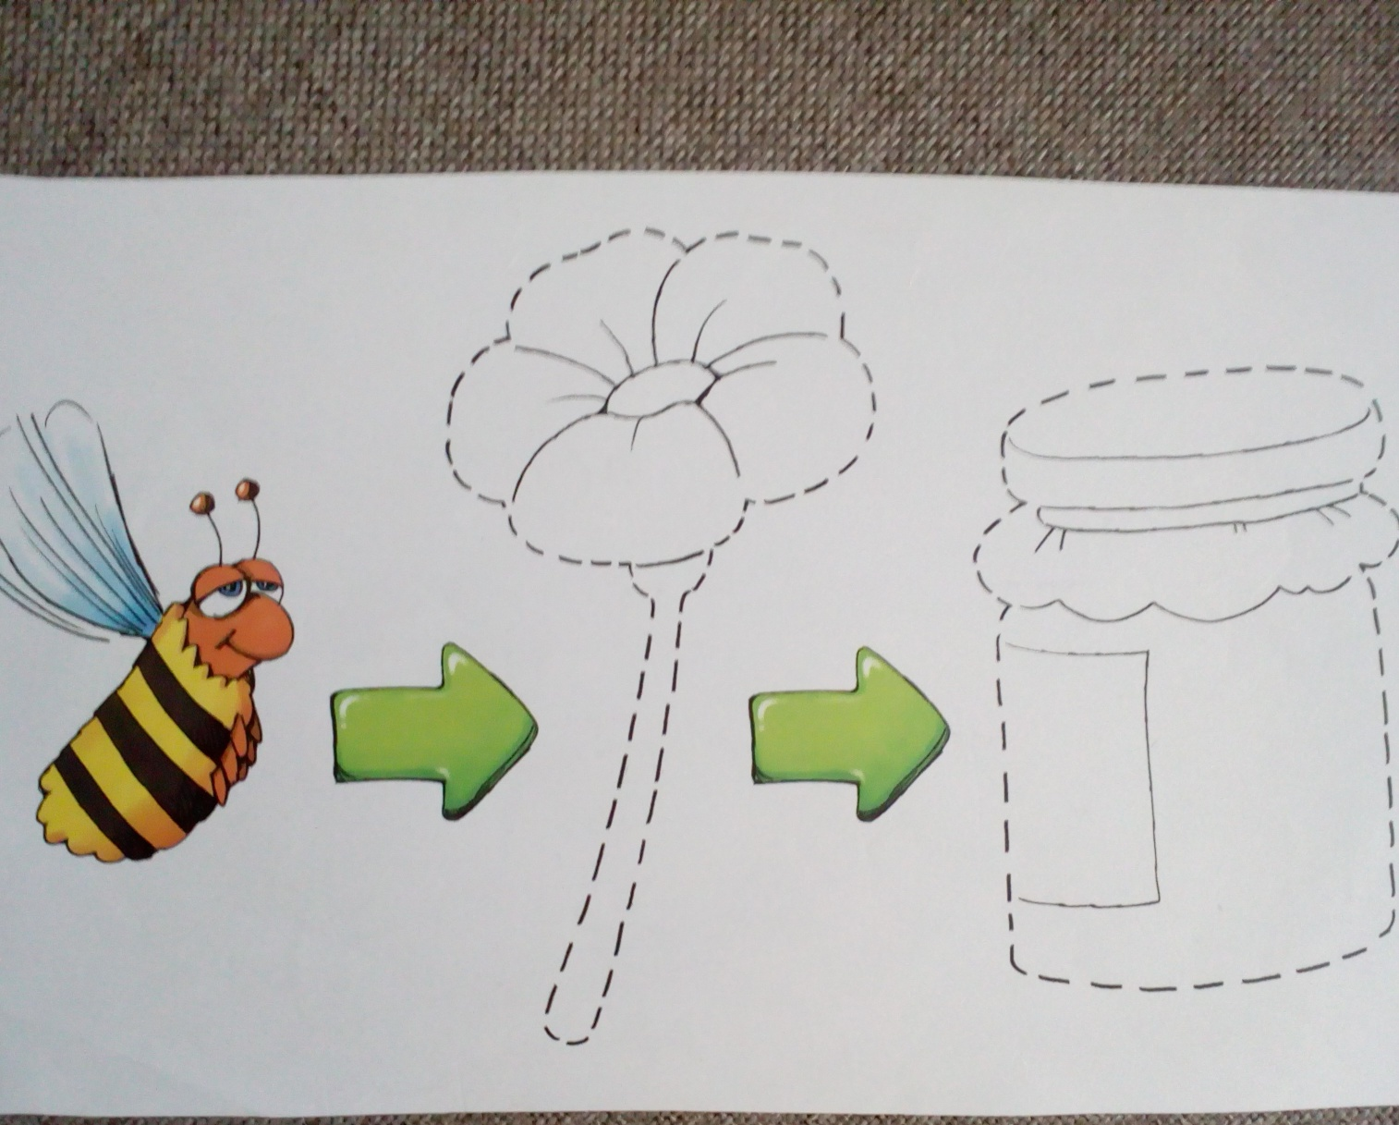
Draw the flower and honey.
Colour the flower and honey.
Say: Bee – Flower - Honey
Narysuj po śladzie i pokoloruj kwiatek oraz słoik miodu. Powtórz: ”Bee – Flower – Honey”

Opracowane na podstawie „Robby Rabbit”, wyd. Macmillan

