Sea animals 29th April 2020

Do you know animals that live in the sea?

Look at the pictures.

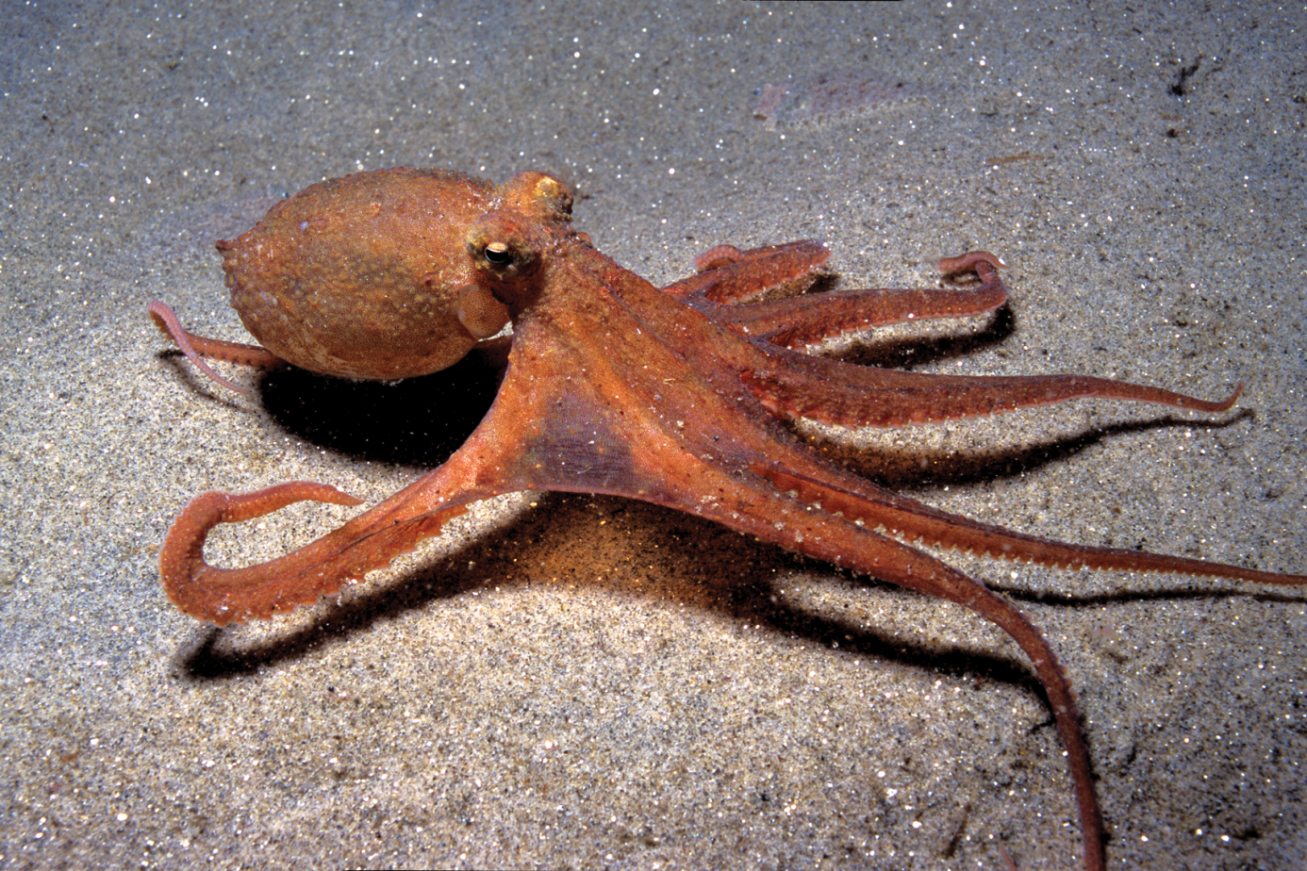
This is an octopus.
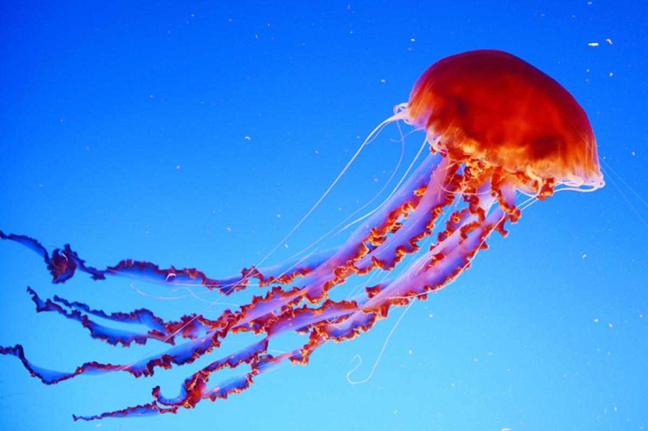
And this is a jellyfish.

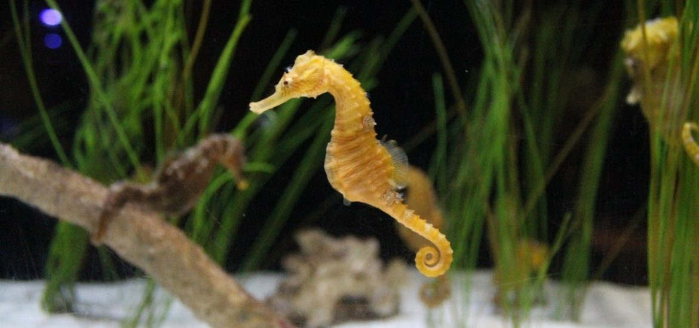
A seahorse looks funny.

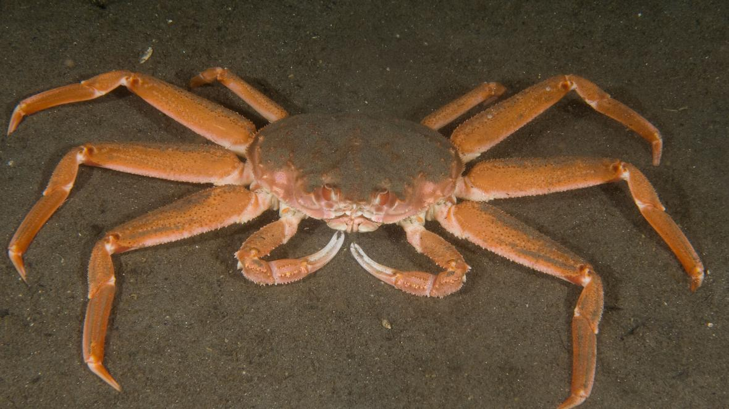
A crab has got many legs.

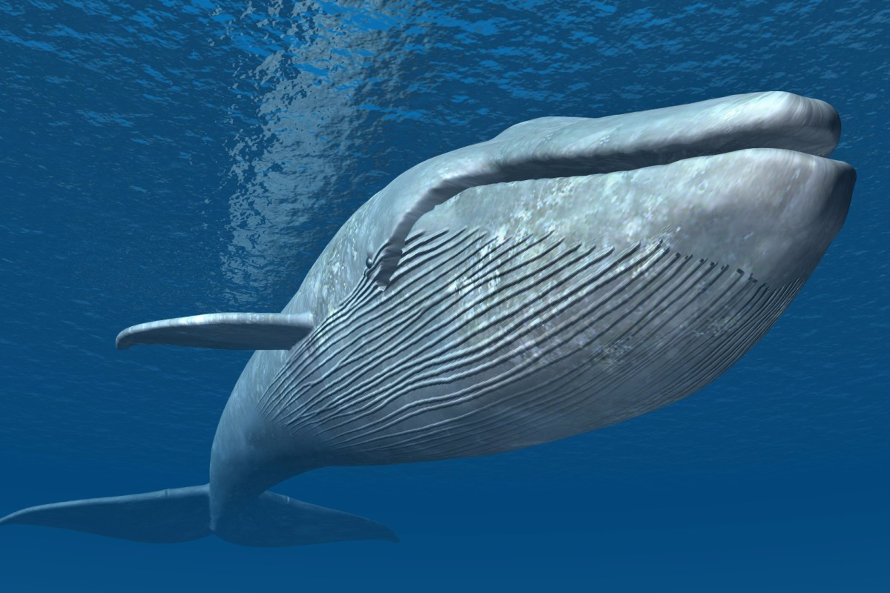
A whale is very big.

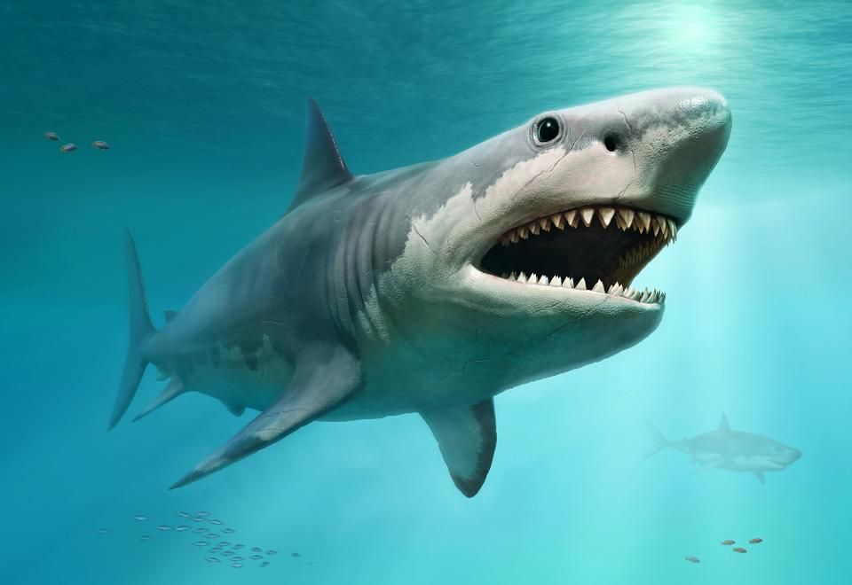
A shark can be dangerous.
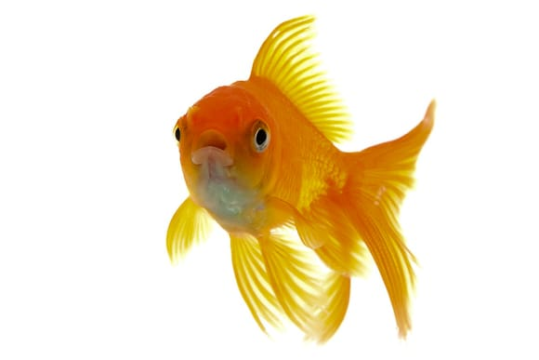
You can keep a fish at home.

I can see a fish and sharks in the sea.
I can see a jellyfish in the sea.
I can see an octopus in the sea.
There’s a whale, there’s a crab in the sea.
How many seahorses can you see in the sea?
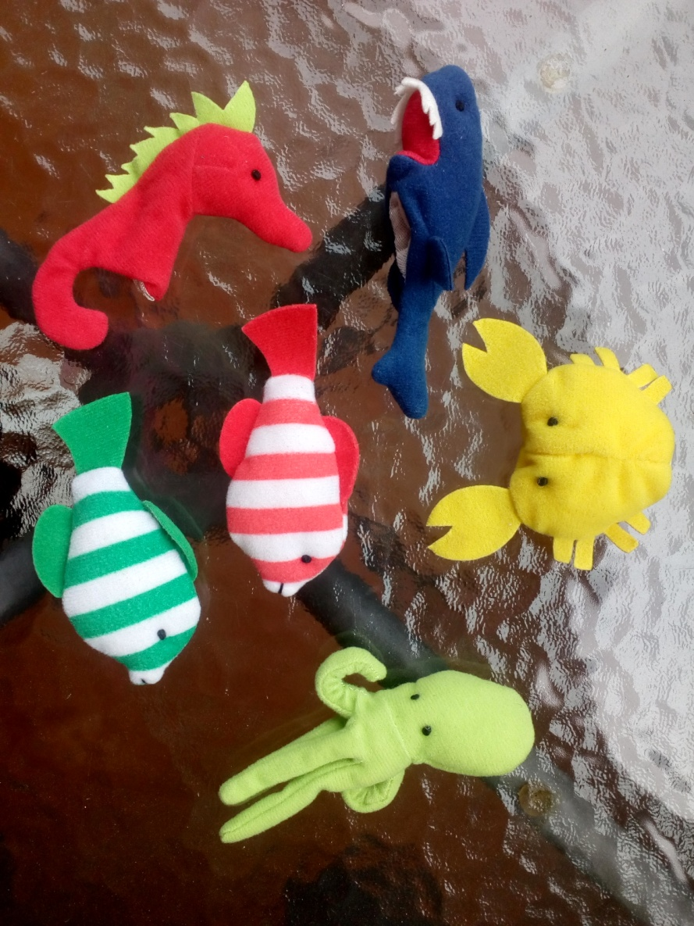
How many sea animals can you see?
Point to the crab.
Point to the seahorse.
What colour is the shark?
What colour is the octopus?

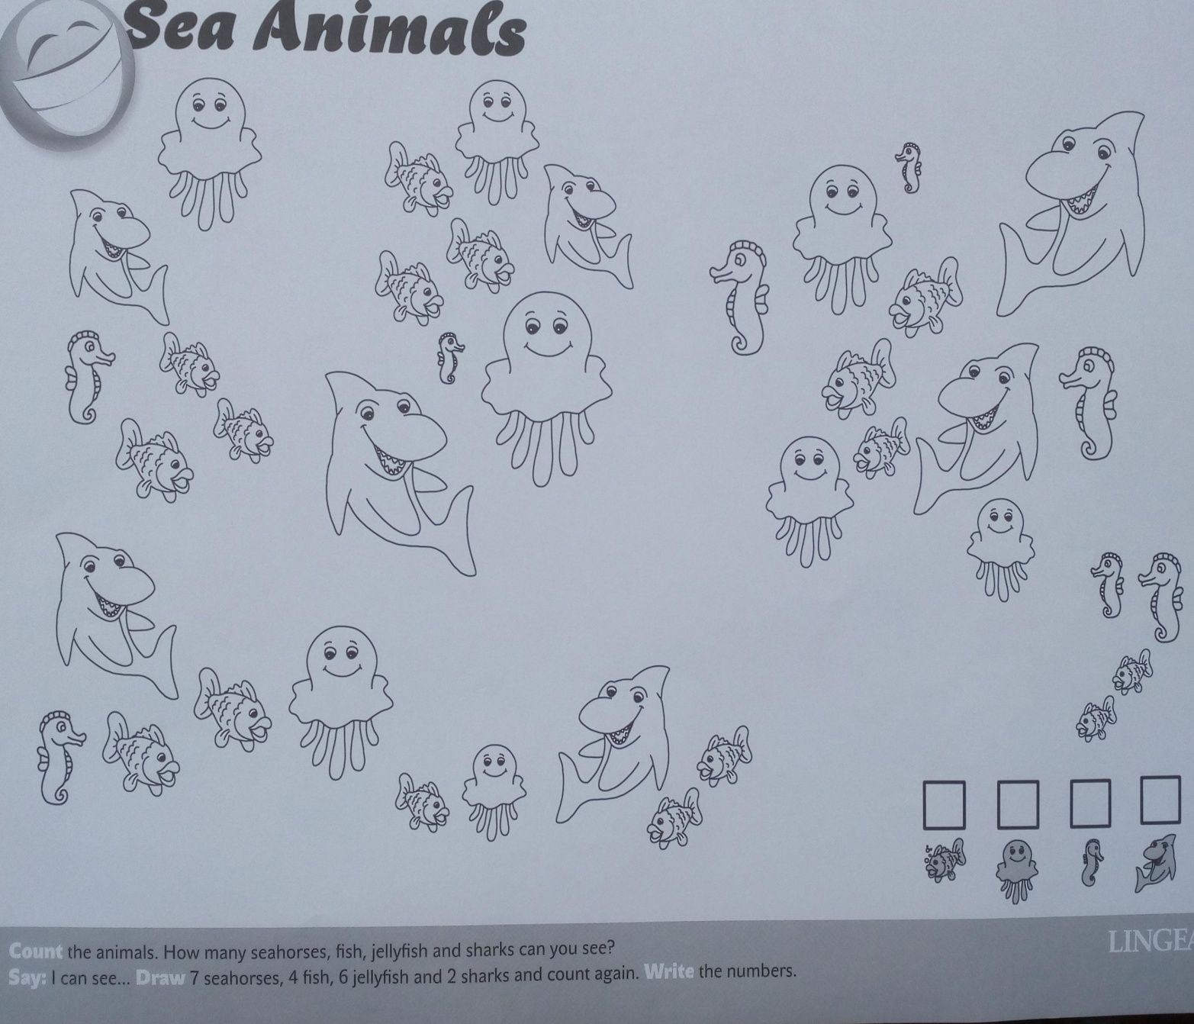

Policz po angielsku rekiny i ośmiornice. Pokoloruj zwierzęta. Narysuj akwarium, w którym znajdzie się wybrane przez Ciebie zwierzę.
Powodzenia!

