School things 28th April 2020
Powtarzamy nazwy przyborów szkolnych.
Bugs Team, Bugs Team, one, two, three!
Look at the pictures and say with me: schoolbag, pencil, crayon, glue, scissors, book.
Listen to the story.
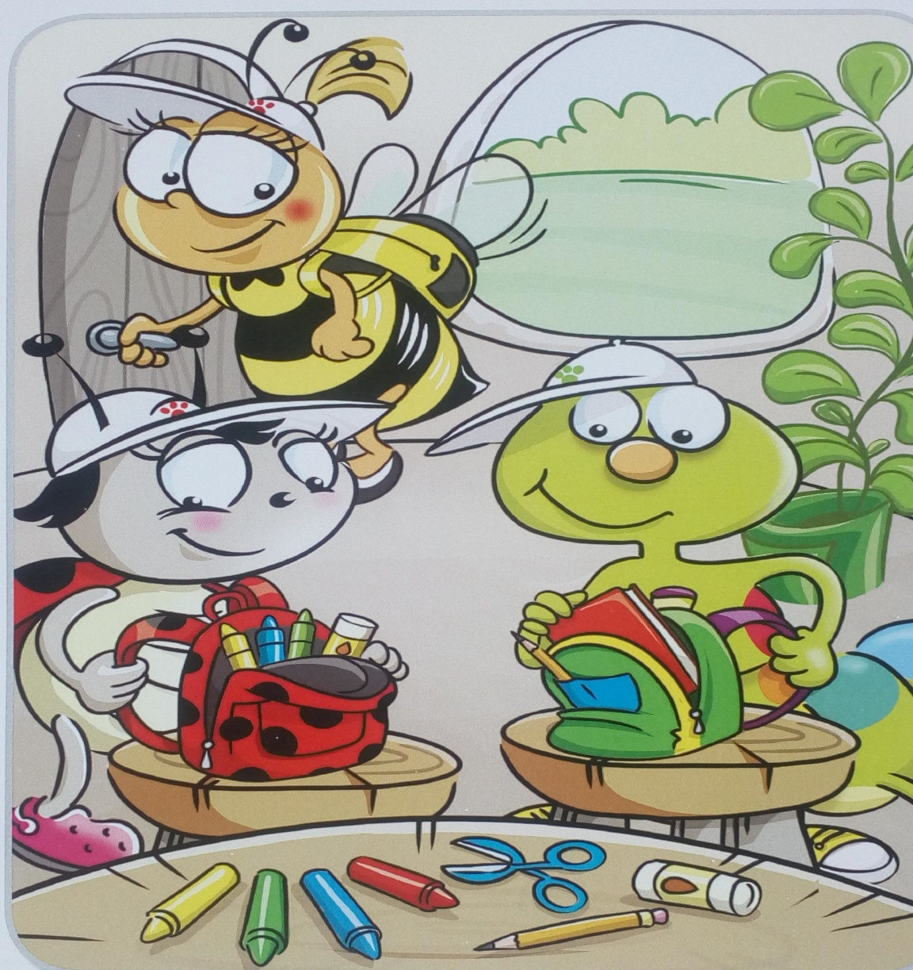

Bella: Hey, Bugs, are you ready?
Lucy and Colin: No, not yet!
Colin: I’ve got a book and a pencil, but I haven’t got any scissors!
Lucy: I’ve got some glue and three crayons, but I haven’t got a red crayon.
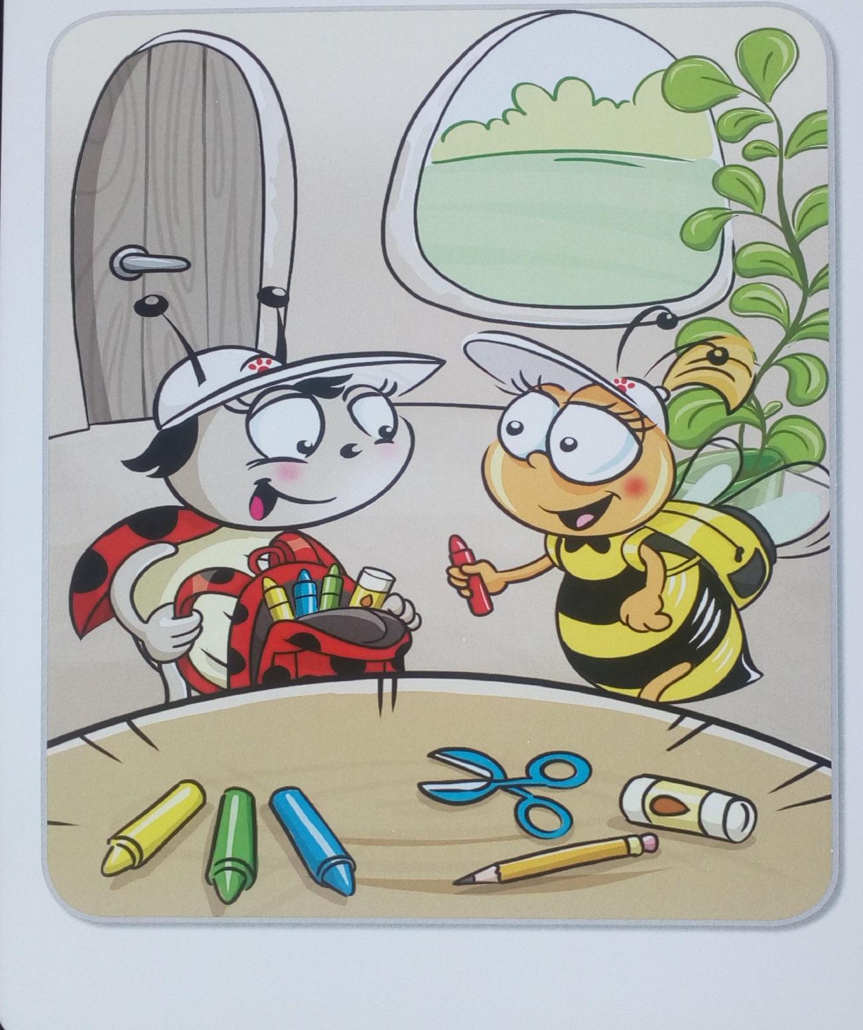
Bella: Look! There are some crayons and scissors here!
Lucy: Can I have a red crayon, please?
Bella: Here you are.
Lucy: Thank you!
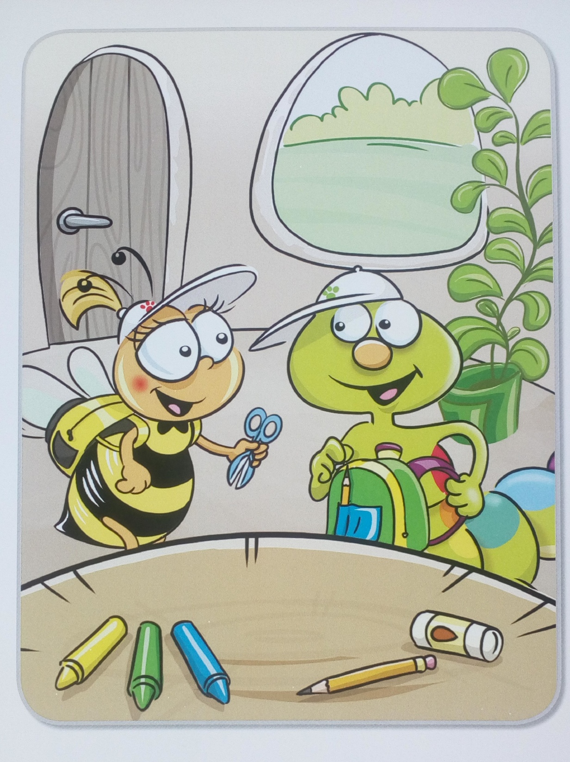
Colin: Can I have some scissors, please?
Bella: Here you are.
Colin: Thank you!

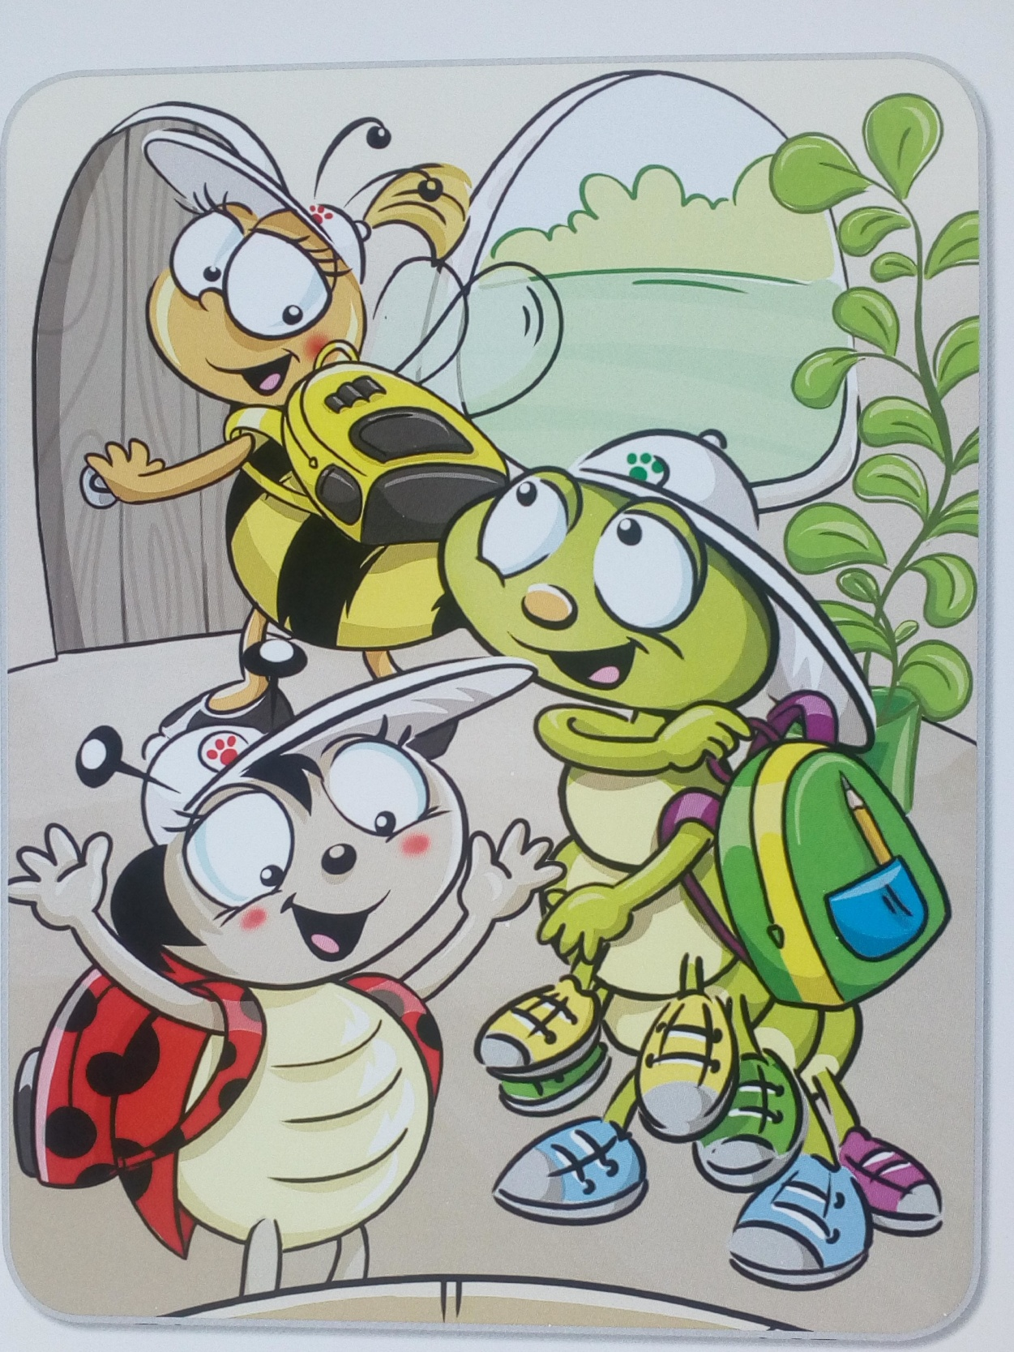
Bella: Are you ready now?
Colin and Lucy: Yes!
Bella: Take your schoolbags. Let’s go to school!
Colin and Lucy: Hurray!

New things:
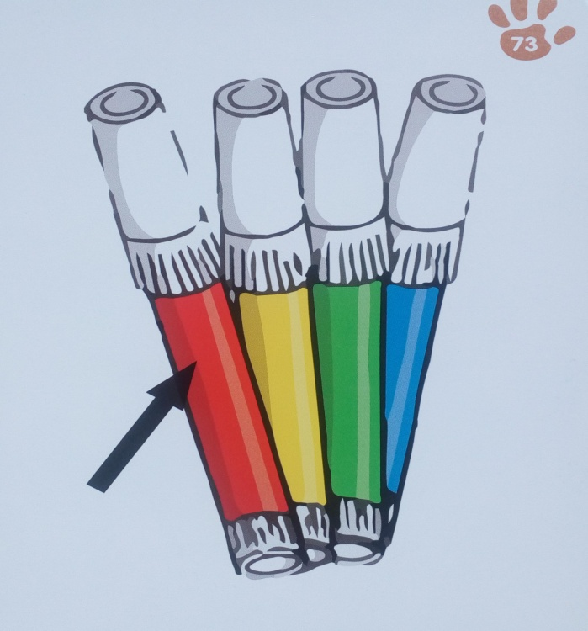
markers
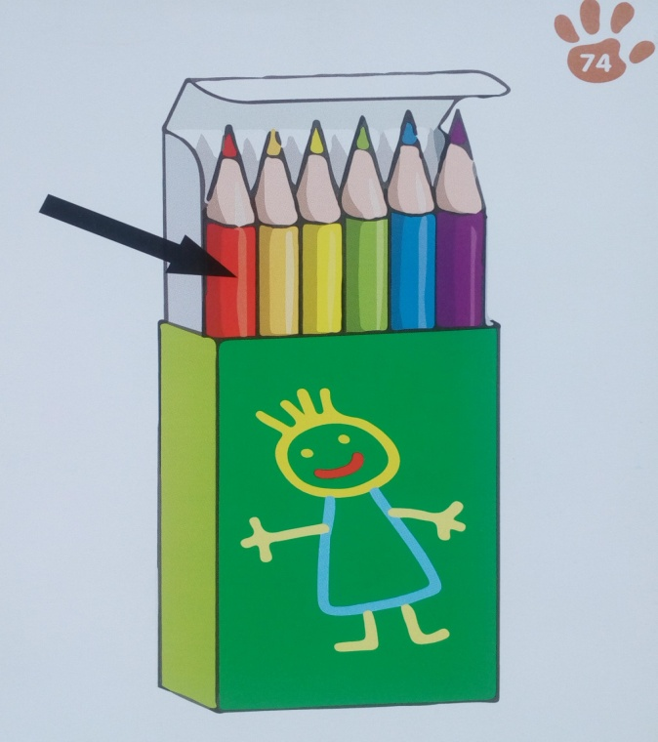
coloured pencils

Listen and match. Say the chant.
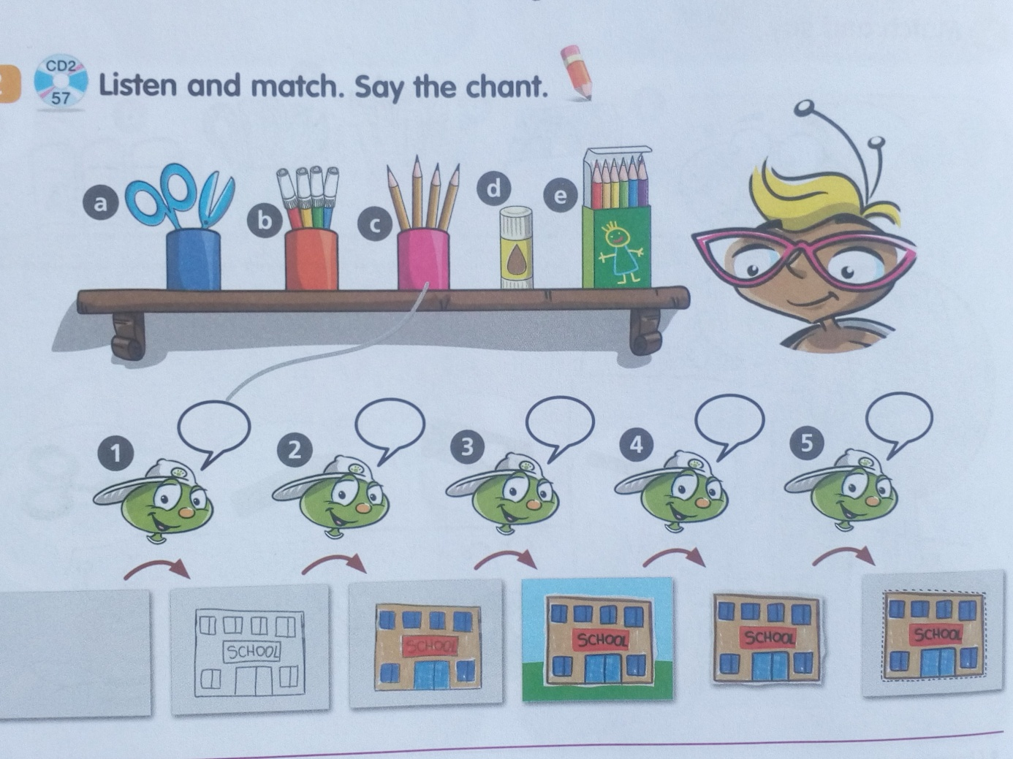
What school objects can you see?
Colin wants to draw a school. What objects does he ask his teacher for? Listen and match.
Teacher, teacher, look at this!
Can I have a pencil, please?
Teacher, teacher, look at this!
Can I have some coloured pencils, please?
Teacher, teacher, look at this!
Can I have some markers, please?
Teacher, teacher, look at this!
Can I have some scissors, please?
Teacher, teacher, look at this!
Can I have some glue, please?
Teacher, teacher, look at this!
Do you like my picture?
Oh, yes.
Na zakończenie narysuj szkołę, do której chciałbyś/chciałabyś chodzić.
Opracowane na podstawie: Bugs Team Starter, wyd.Macmillan

