Hello, children! How are you?
Let’s talk about food again.
Topic: By the lake with Cheeky.
Powtarzamy słowa z poprzednich lekcji.
Recycled: tomatoes, eggs, cake, ice-cream, apples, sausages, bananas, milkshakes.
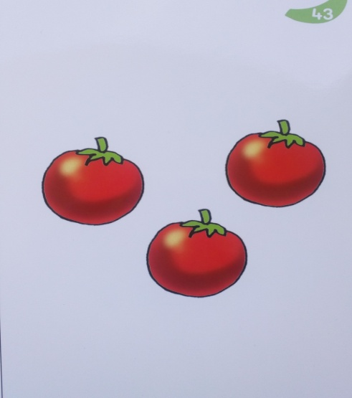
Tomatoes

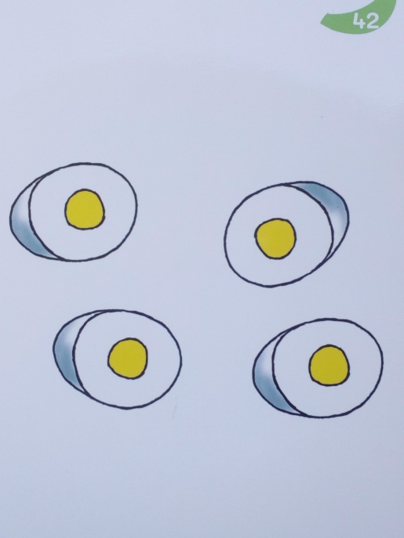
Eggs

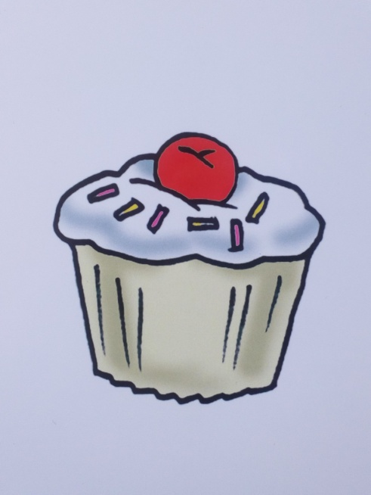
Cake
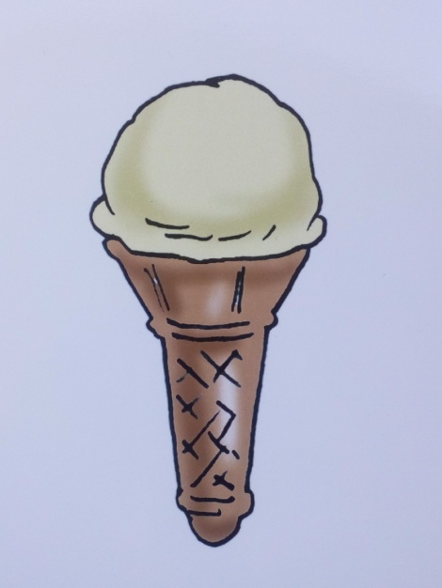
Ice-cream

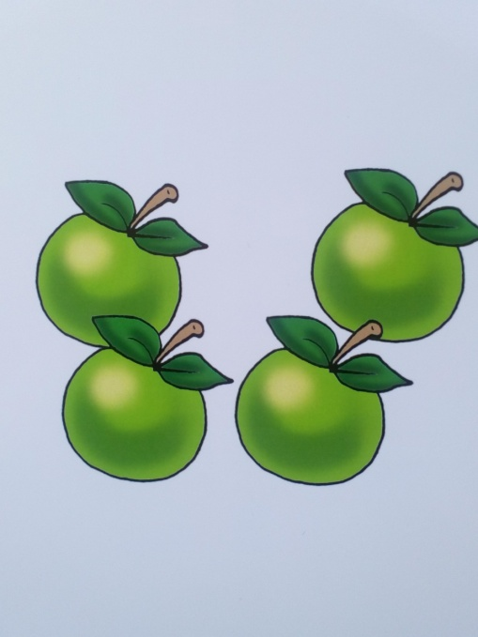
Apples
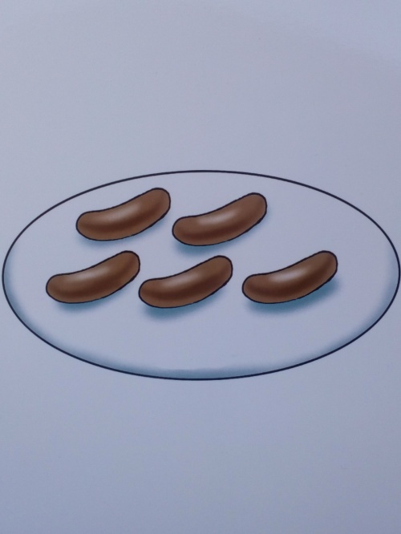
Sausages

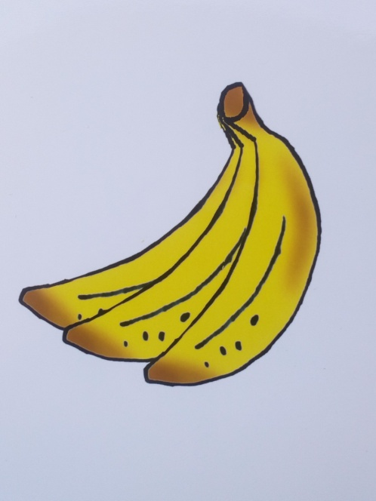
Bananas

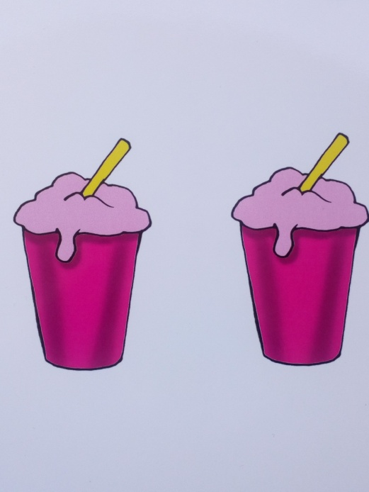

Milkshakes

Zabawa ruchowa
Do the actions:
Stand up. 1,2,3.
Turn around. 1,2,3.
Clap your hands. 1,2,3.
Eat sausages.
Eat eggs.
Eat tomatoes.
Eat bananas.
Drink milkshakes.
Sit down. 1,2,3.

Listen to the story:
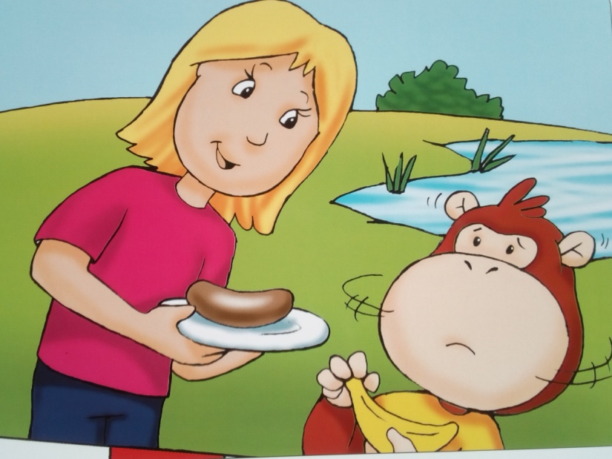

Mummy: Do you want a sausage, Cheeky?
Cheeky: Yuk! I don’t like sausages. I only like bananas.
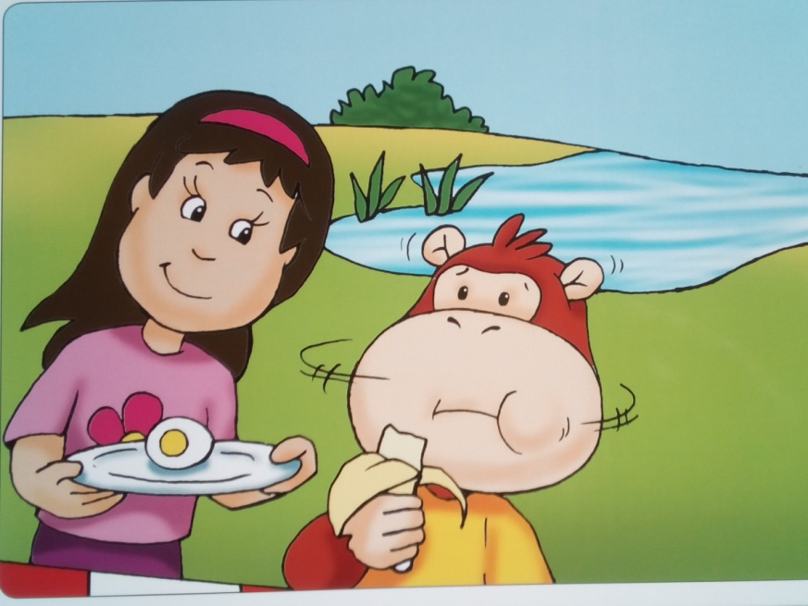
Ellie: Do you want an egg?
Cheeky: Yuk! I don’t like eggs. I only like bananas.
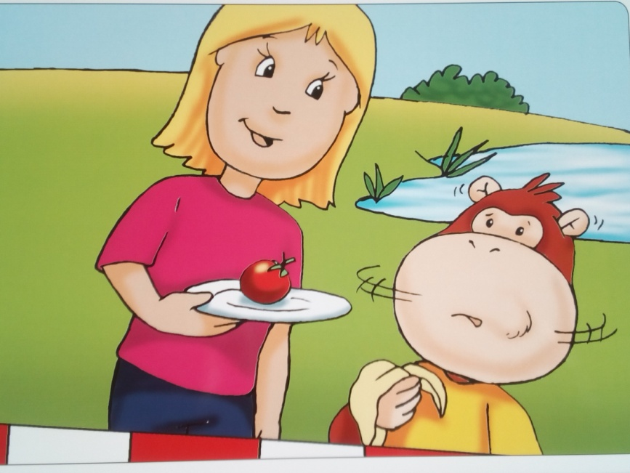
Mummy: Do you want a tomato? It’s very good for you.
Cheeky: I don’t like tomatoes. I only like bananas.
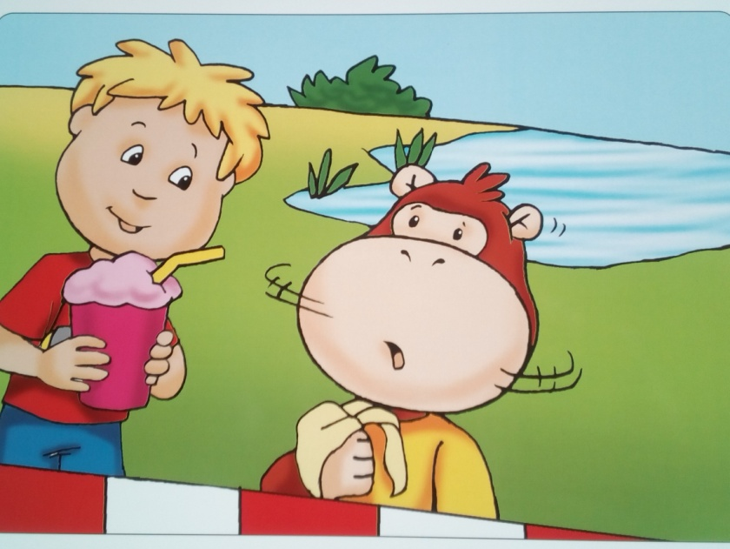
Tom: Do you want a milkshake, Cheeky?
Cheeky: I don’t like milkshakes. I only like bananas.
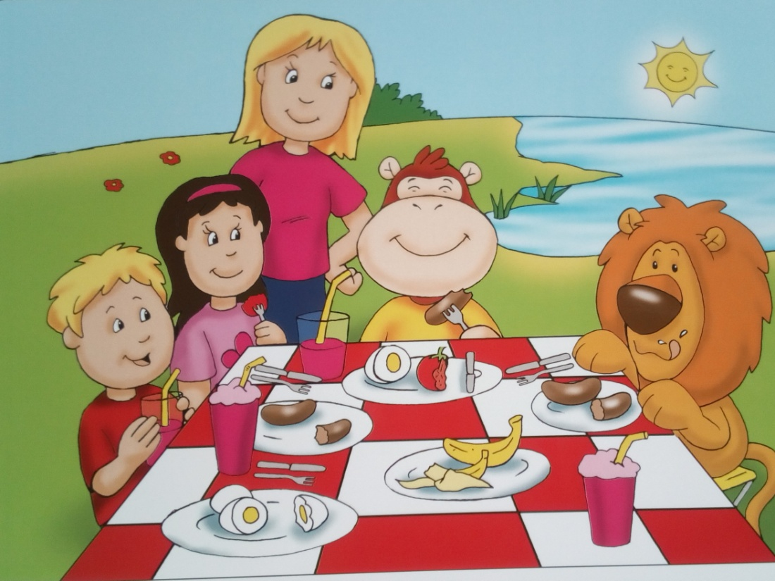
Cheeky: Do you like sausages, eggs, tomatoes and milkshakes, Rory?
Rory: Yes, they’re delicious! Try some.
Cheeky: Mmm! Delicious! The sausage is delicious. The egg is delicious. The tomato is delicious. And the milkshake is delicious, too!
Opracowane na podstawie: Cheeky Monkey 2, wyd. Macmillan

Piosenki w języku angielskim, przy których można się poruszać:

https://www.youtube.com/watch?v=r6cJB7k6eEk
https://www.youtube.com/watch?v=wCfWmlnJl-A
https://www.youtube.com/watch?v=jqz4z9aQRJY
Good luck!

