Topic: Goldilocks and the Three Bears – a story. 16.04.20
Look at the pictures.

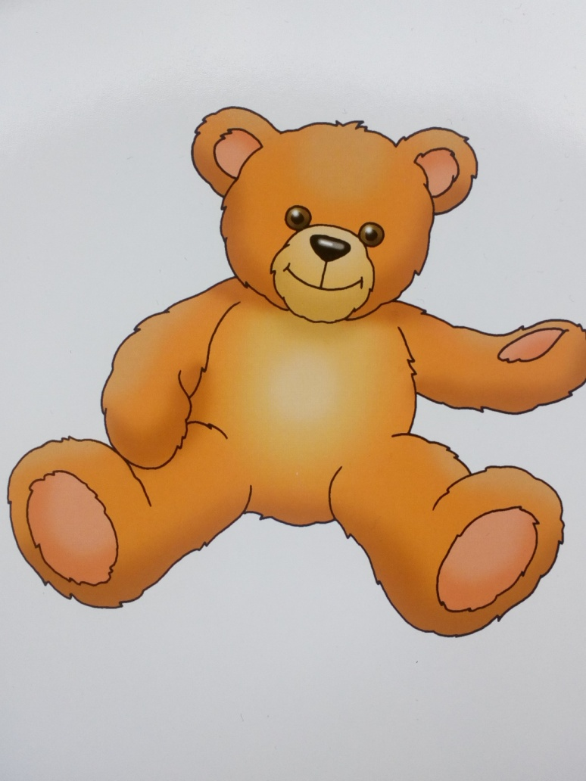
A bear
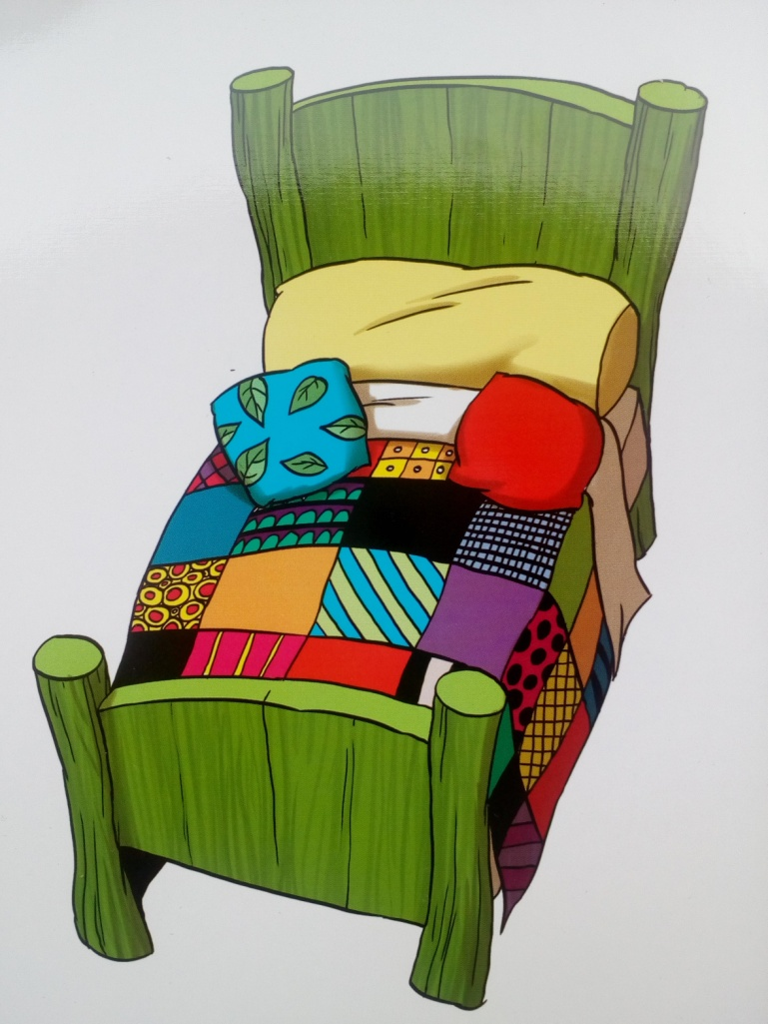
A bed

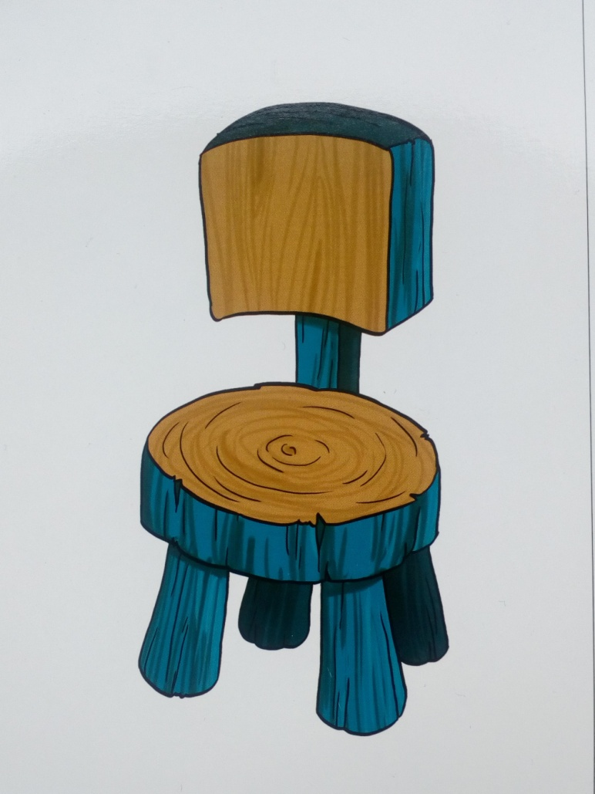

A chair
A bowl

Listen to the story:
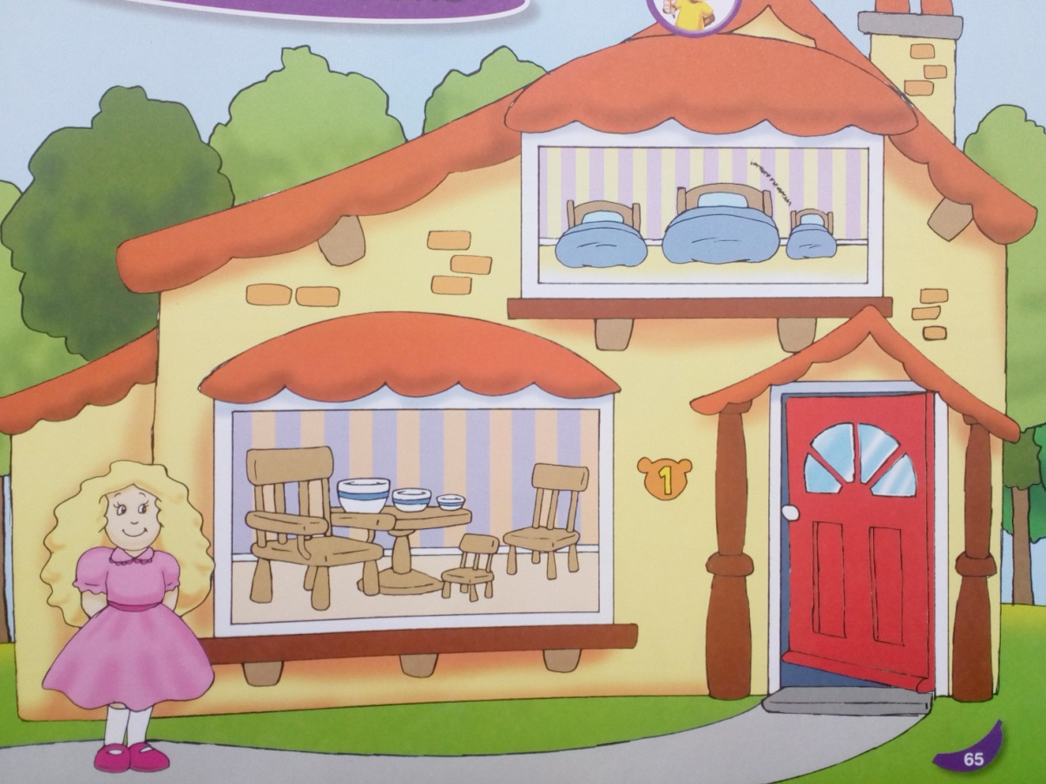
Goldilocks is a small girl. One day she is walking in the woods. She sees a Bears’ house. The door is open. She walks in.

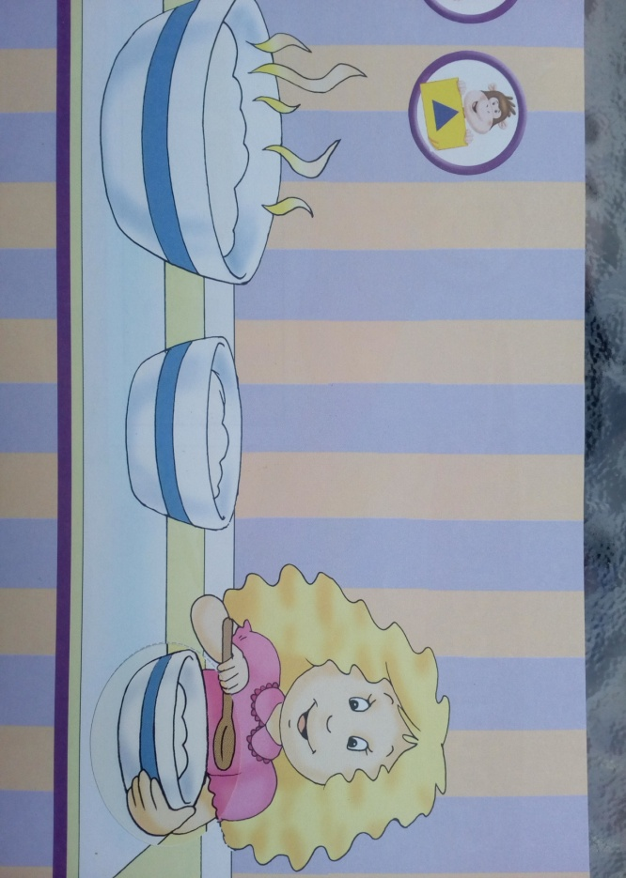There are 3 bowls on the table.
1,2,3. Yummy! I’m hungry.
Oh, it’s hot.
Yuk! It’s cold.
Mmm. Delicious. Goldilocks eats it all up.

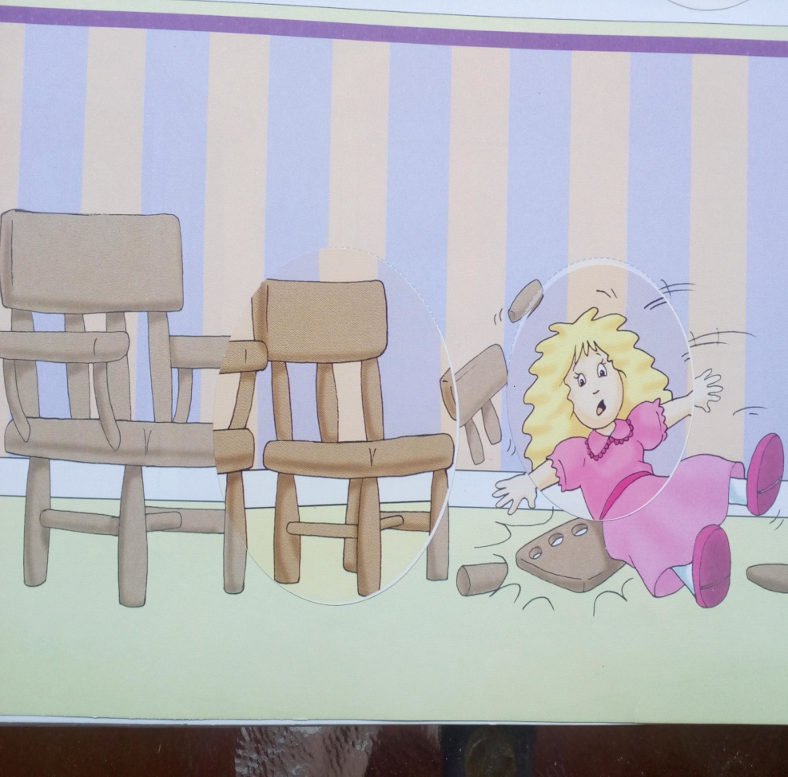
There are three chairs. 1,2,3. A big chair. Another chair. Oh, a small chair. Oh, dear! What have I done?

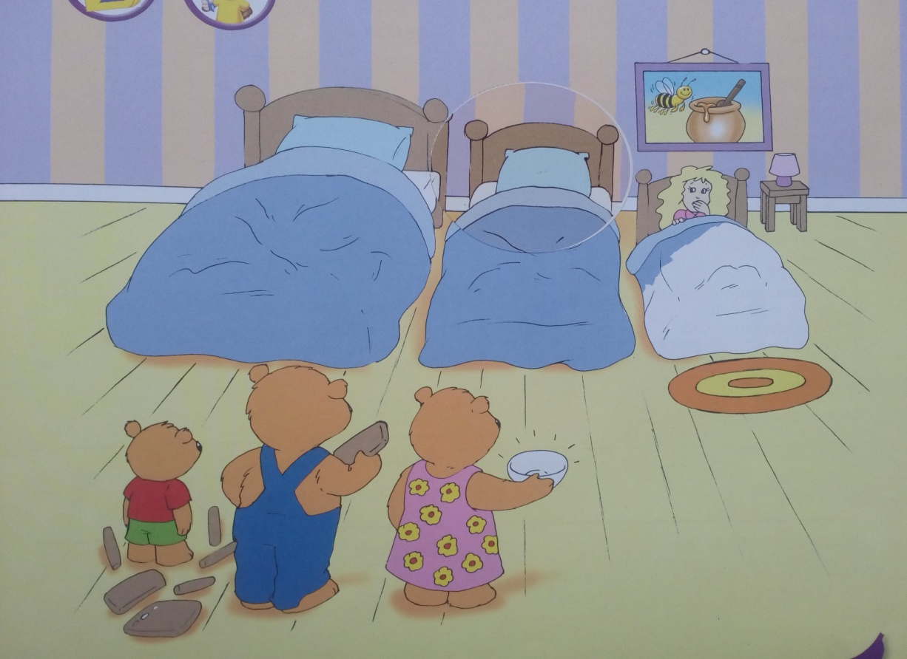
Goldilocks is tired. She walks upstairs. There are three beds. 1,2,3. A big bed. Another bed. A small bed. Perfect!
Look! Here’s Baby Bear, Mummy Bear and Daddy Bear.
Baby Bear: “There’s a girl in my bed!”
Goldilocks: “Oh, dear! Your chair, your bowl, sorry!”
The Three Bears: “It’s OK. Don’t worry. You can still be our friend.”
Goldilocks: “Thank you”
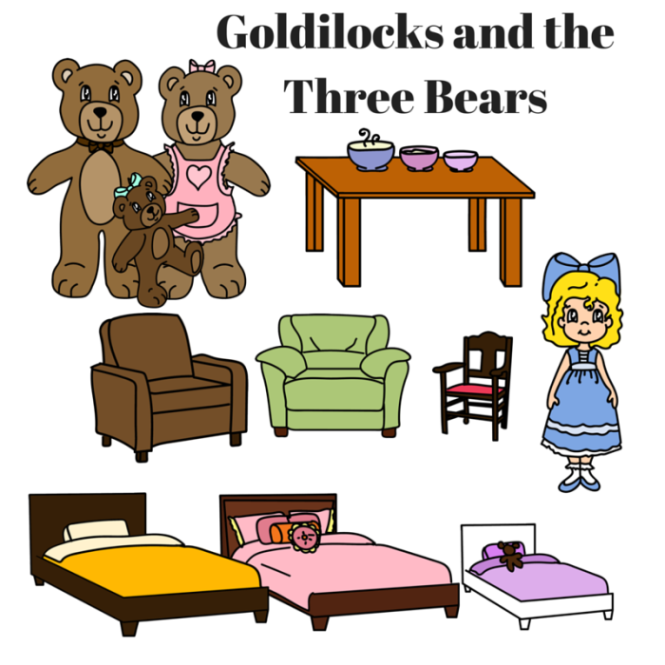
You can cut out the characters and present the story in the form of a theatre.
Możesz wyciąć postaci i przedstawić opowiadanie w formie teatrzyku.

Opracowane na podstawie: Cheeky Monkey 1, wyd. Macmillan

