Subject: Spring around us. 09.04.2020
Good afternoon, Kids! The weather is beautiful. Look out of the window. It’s spring time.
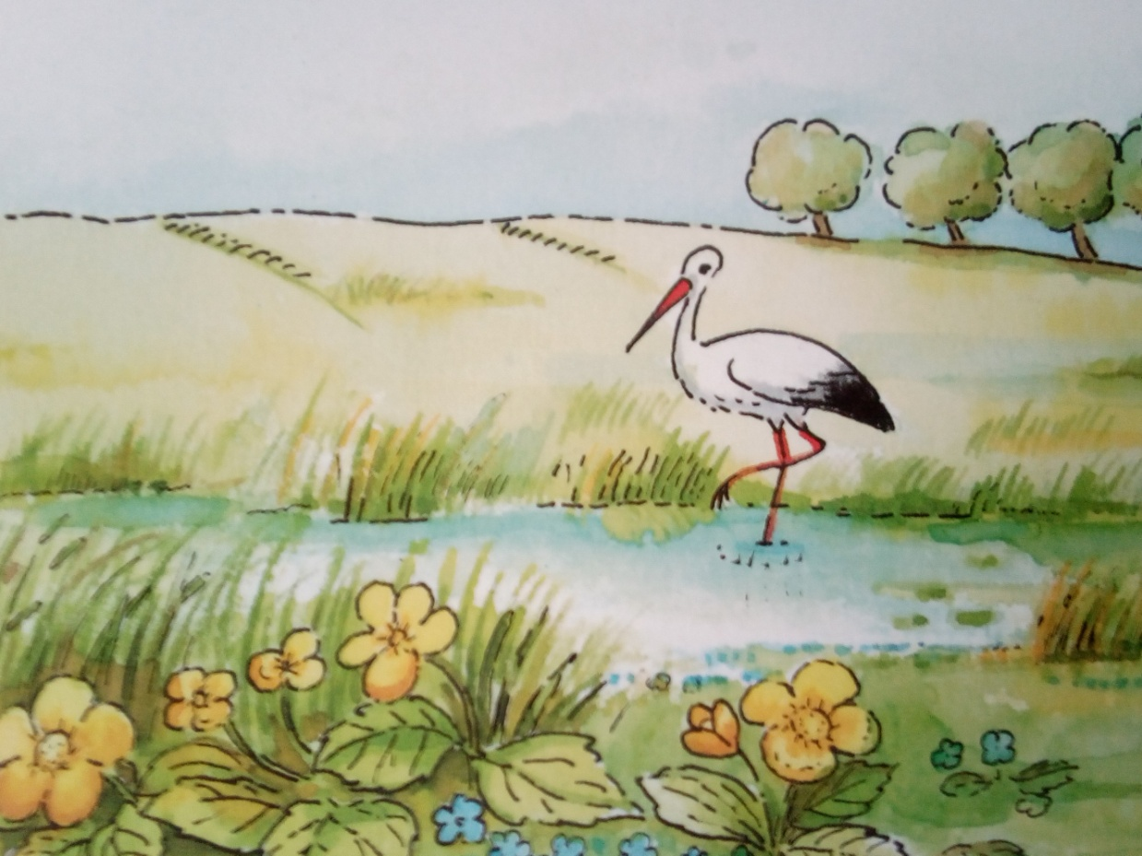
I can see a stork in the meadow.
And spring blooming flowers:
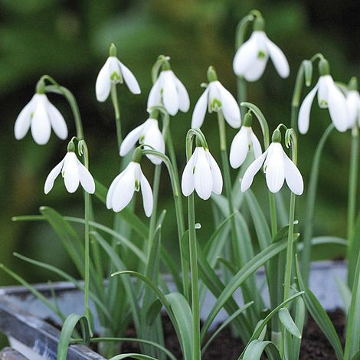
Snowdrops
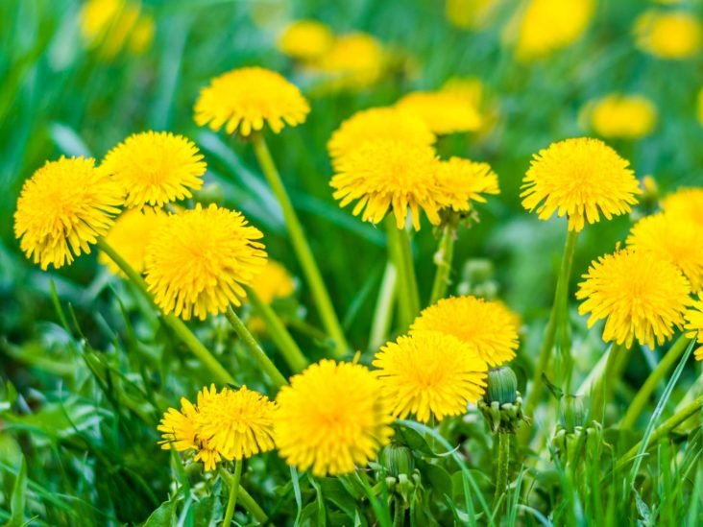
Dandelions
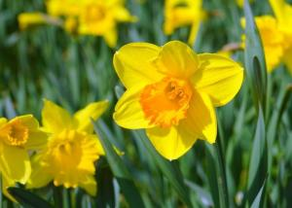
Daffodils

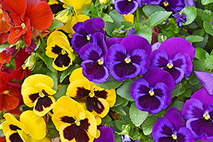
Pansies
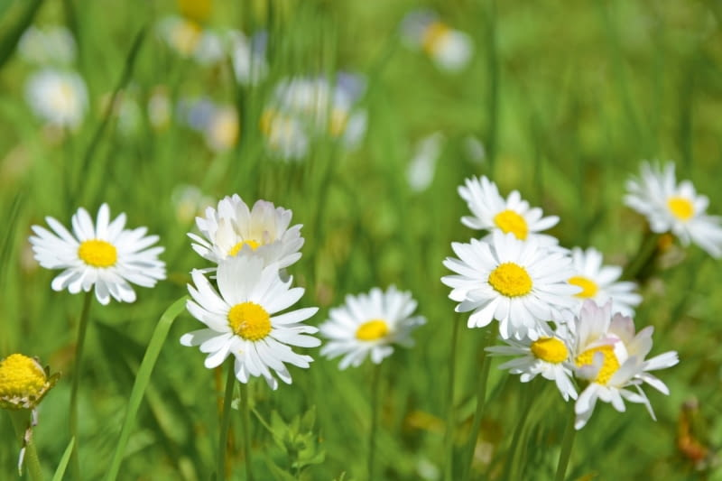
Daisies
We can also see young leaves.
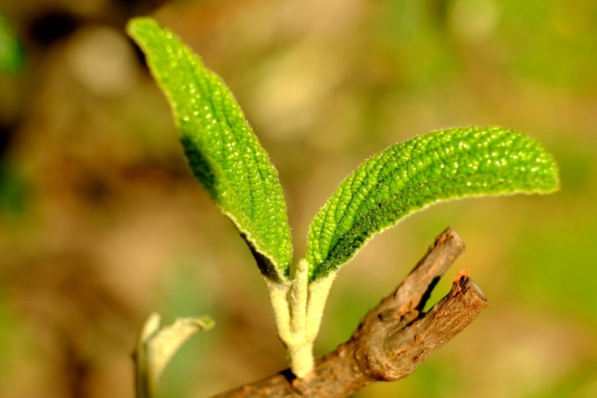
We’re waiting for birds in the nests.
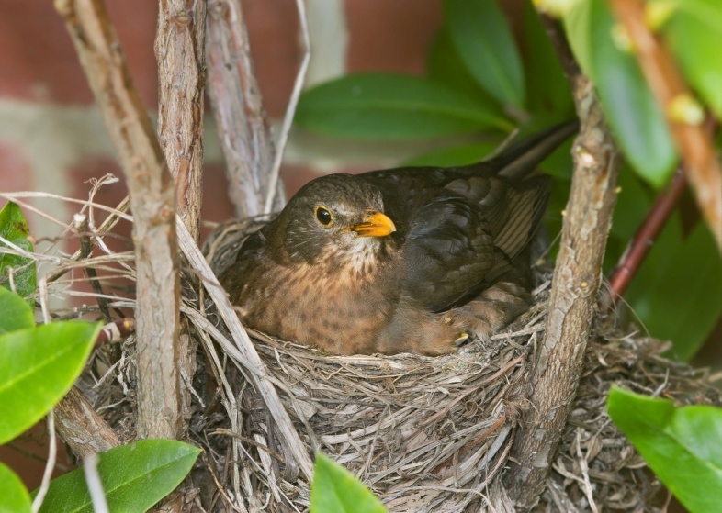
It’s a great time.

A rhyme:
Spring is coming, spring is coming,
Flowers are coming, too,
Pansies, lilies, daffodils,
Spring is nearly through.

And now a task for you:
Find 10 differences. (Znajdź 10 różnic)
Picture A
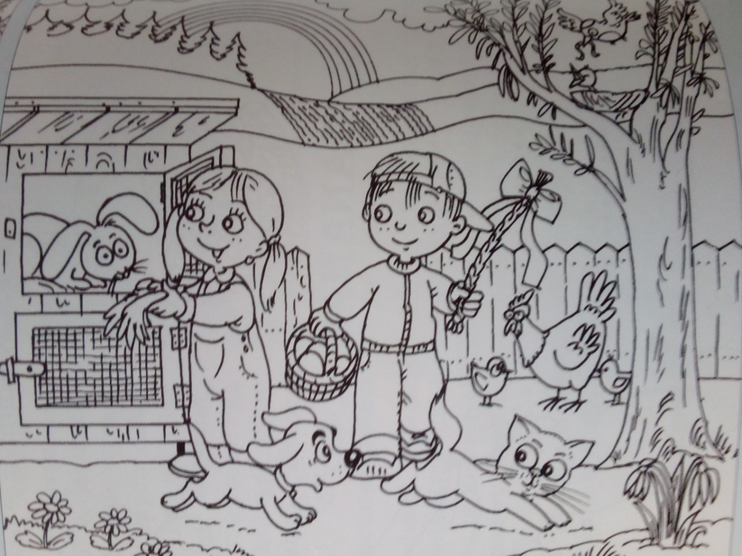

Picture B
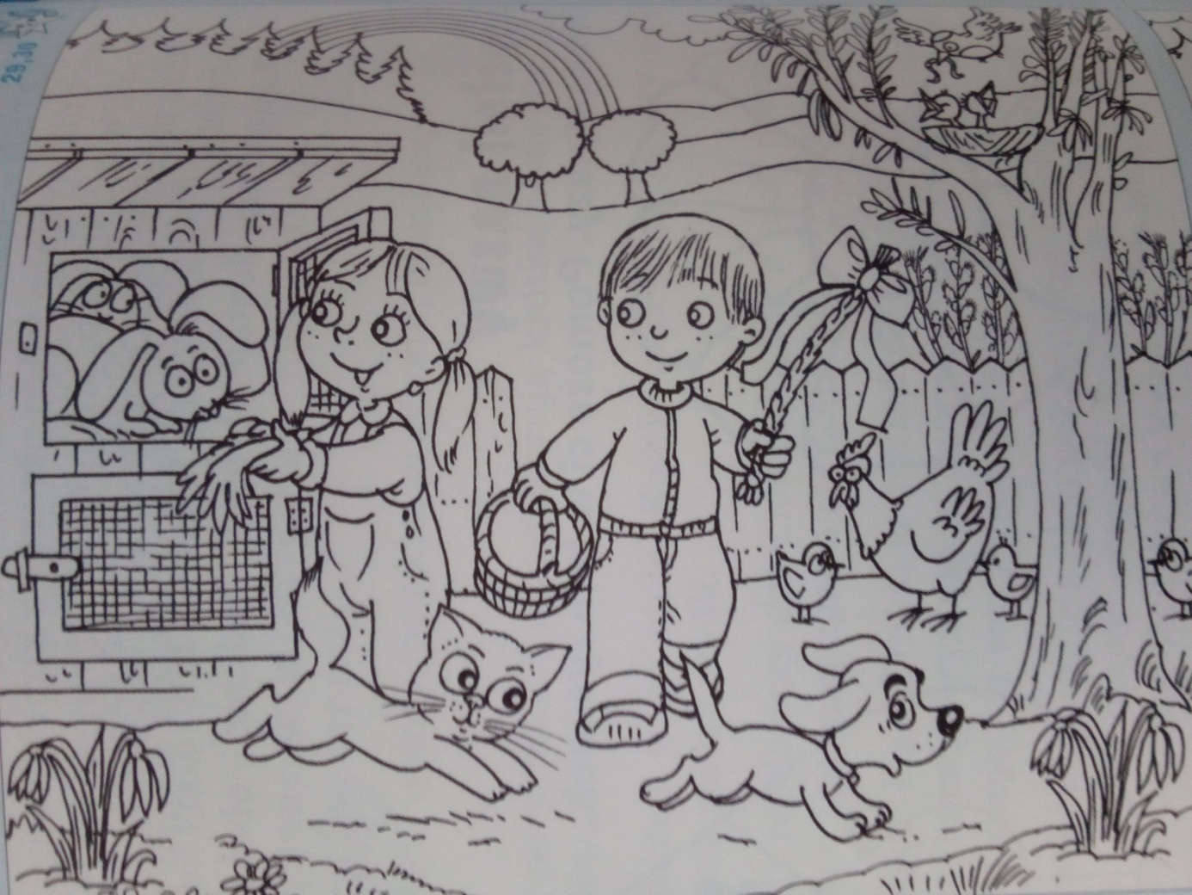
Colour the picture. (Pokoloruj obrazek)
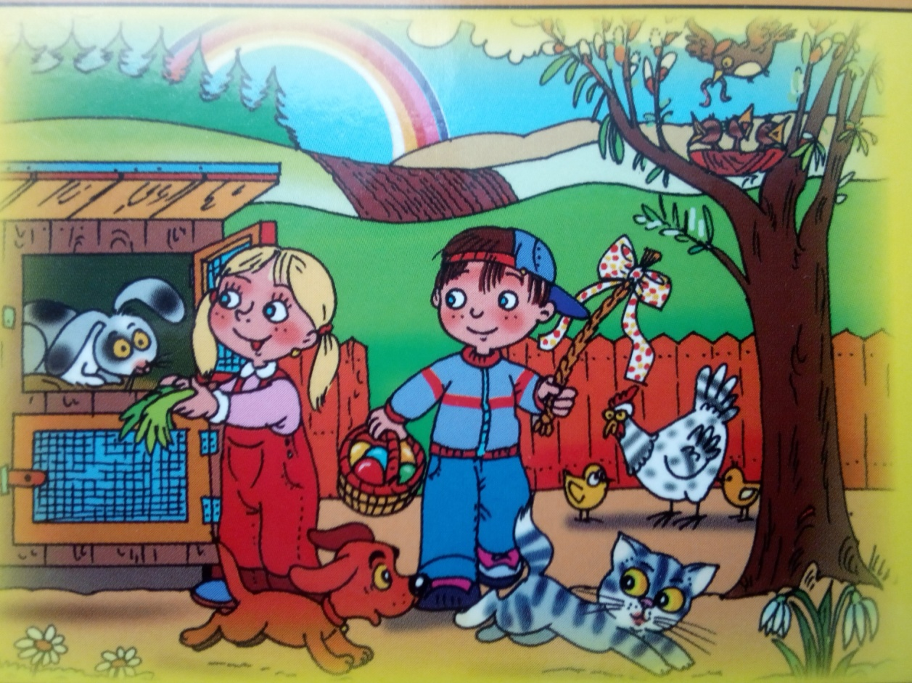
Make your Easter table decoration. (Spróbuj wykonać wielkanocną dekorację na stół.)

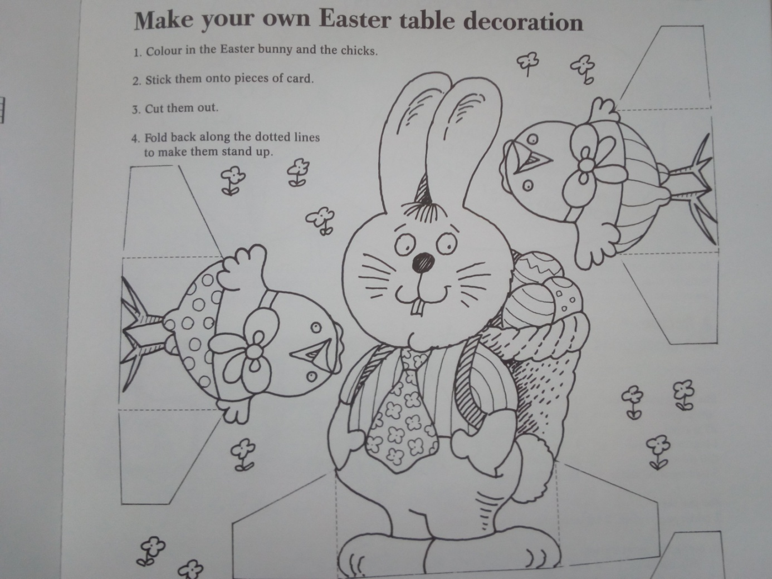
Happy Easter!
Opracowane na podstawie: Playing English, wyd. REA s.j. oraz Around the year, wyd. Lektor, Klett

