Temat: Easter 07-04-20
Dzisiejsza lekcja dotyczyć będzie Wielkanocy.
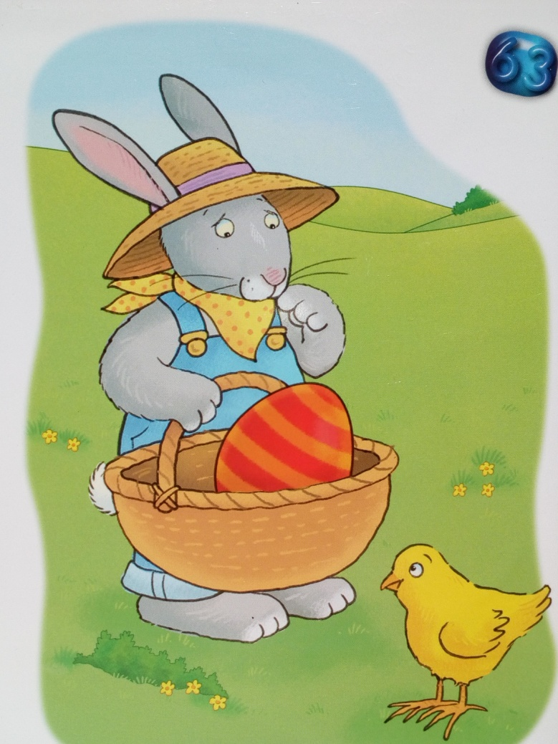

Look! This is an Easter bunny. He’s got an Easter egg in his basket. He’s looking at a little chick.
Count Easter eggs.
Policz wielkanocne jajka.
What colour are the eggs? How many yellow eggs can you see?
Rymowanka:
Easter egg, Easter egg,
White and yellow, red and black.
Easter egg, Easter egg,
White and brown, blue and black.
Easter egg, Easter egg,
Orange, white and black.
Happy Easter, Happy Easter,
Happy Easter to you!
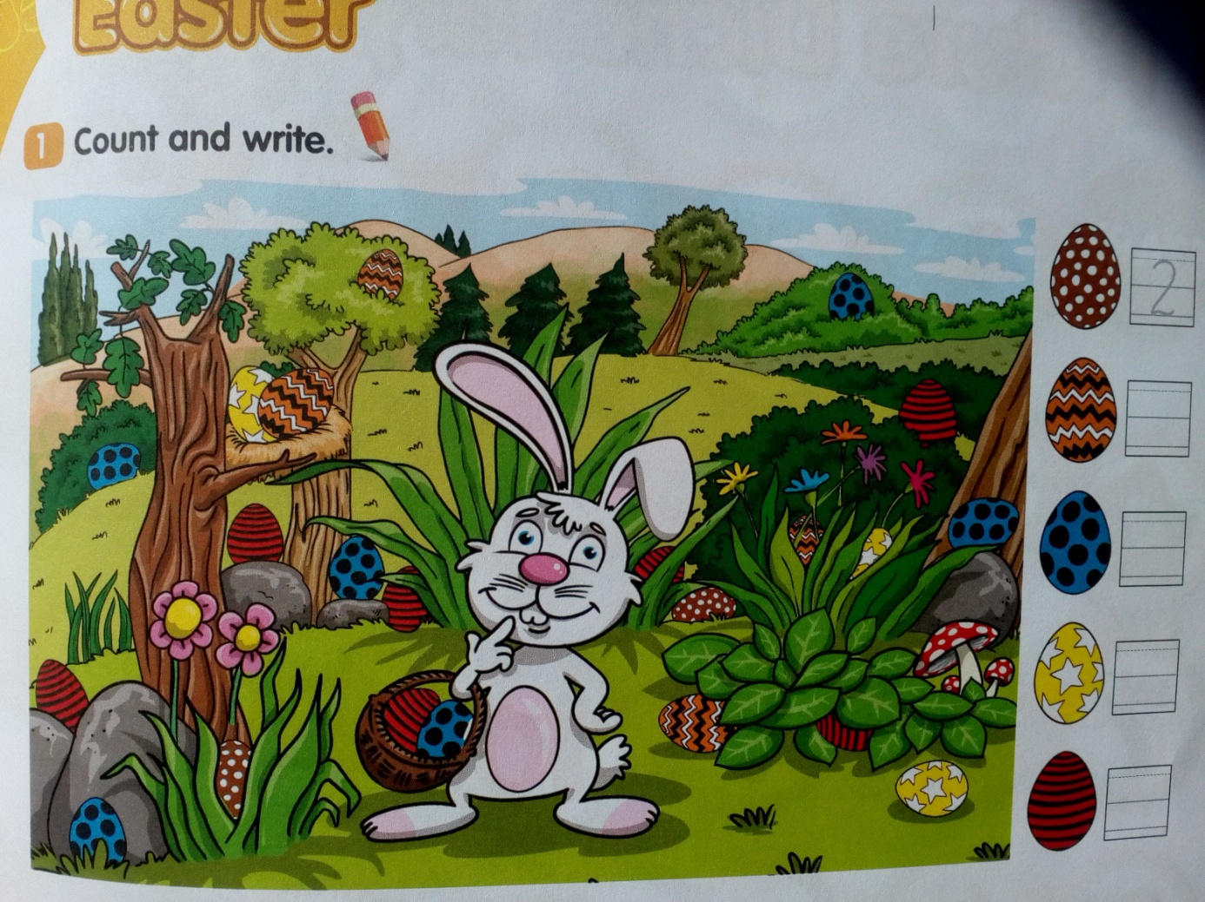
Pokoloruj odpowiednio wszystkie pola oznaczone tym samym numerem.
Colour the egg.
1 – Green
2 – Orange
3 – Brown
4 – Yellow
5 – Purple
6 – Blue
7 – Red
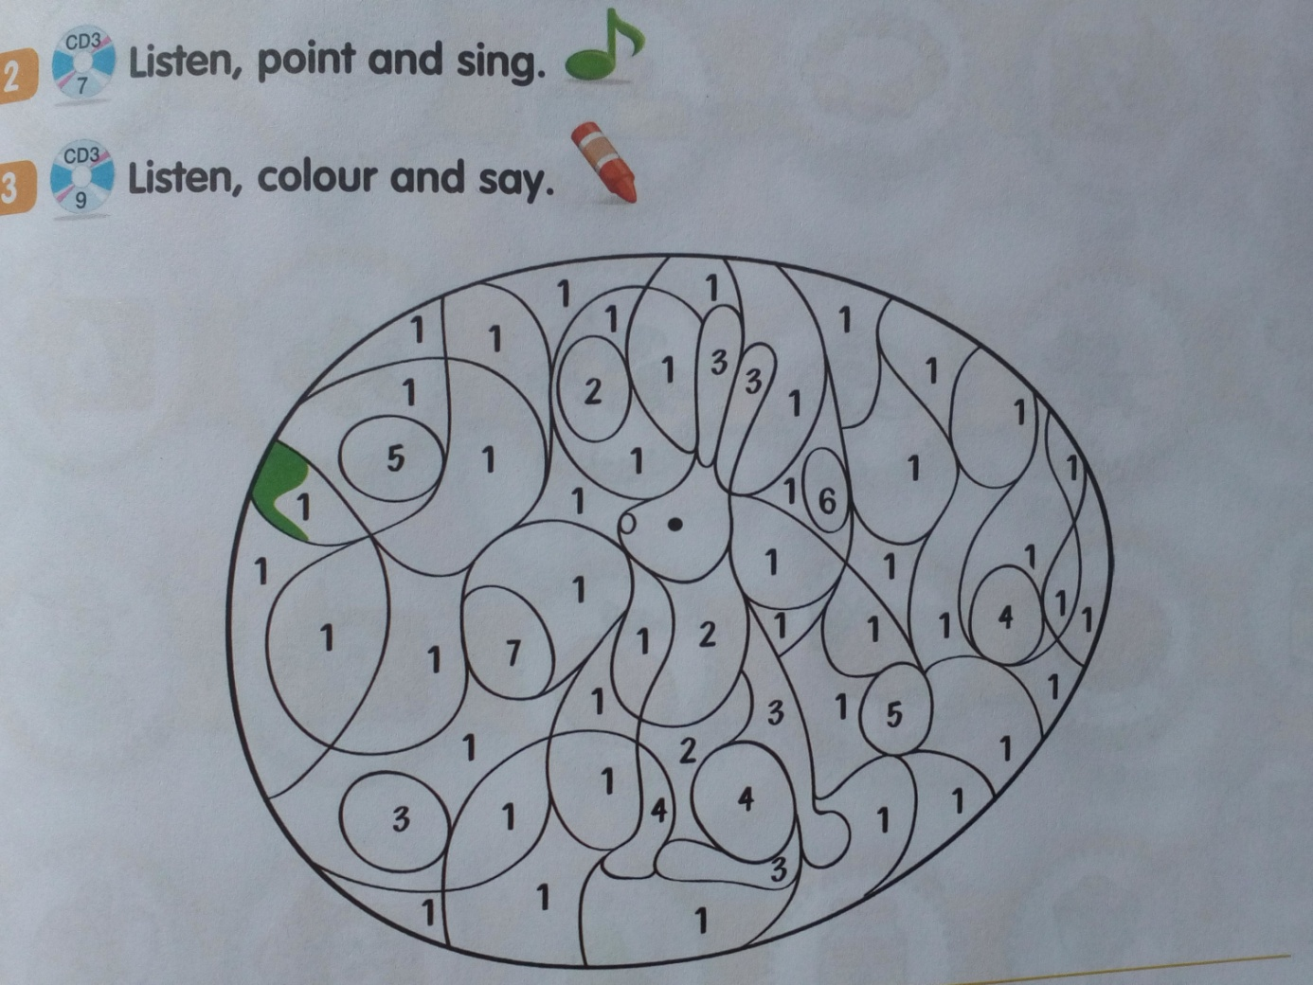
Happy Easter!

Na podstawie Bugs Team Starter, wyd. Macmillan

