31-03-2020
Temat: Utrwalenie nazw zawodów.
Hello, Kids. How are you? Do you remember the names of jobs?
Ćwiczenie 1
Posłuchaj instrukcji, połącz obrazki i powtórz:
1. I want to be a teacher.
2. I want to be a cook.
3. I want to be a doctor.
4. I want to be a firefighter.
5. I want to be a singer.
6. I want to be a police officer.
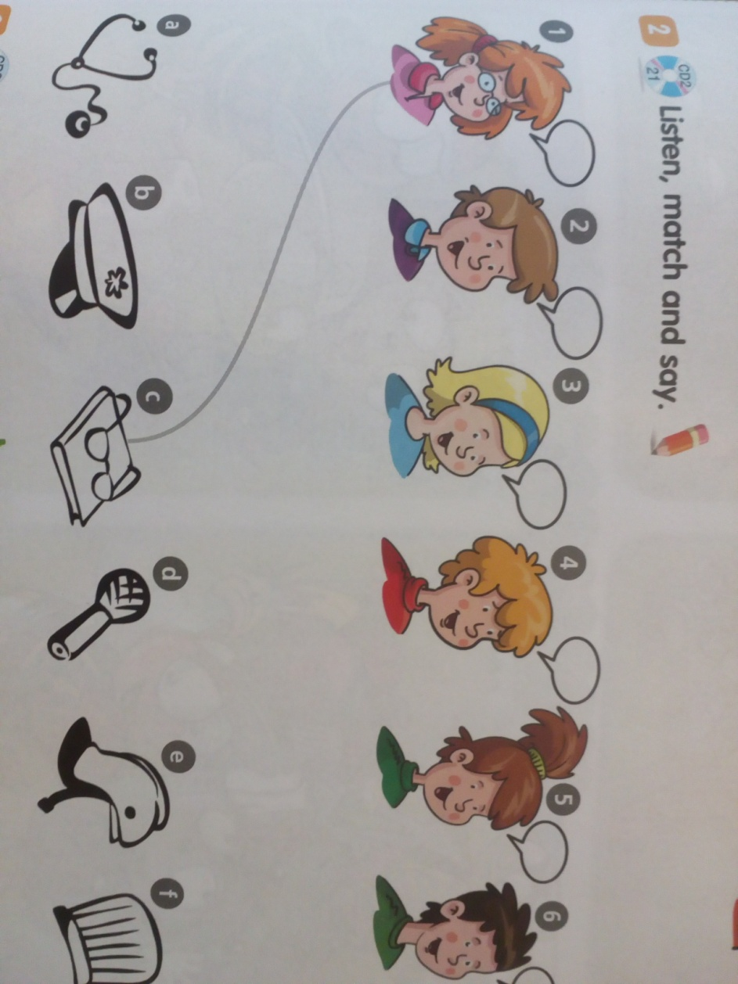
Ćwiczenie 2
Posłuchaj i ponumeruj.
My mummy is a teacher.
My daddy is a cook.
I want to be a farmer.
Look at me, look!
My mummy is a doctor.
My daddy is, too.
I want to be an artist.
What about you?

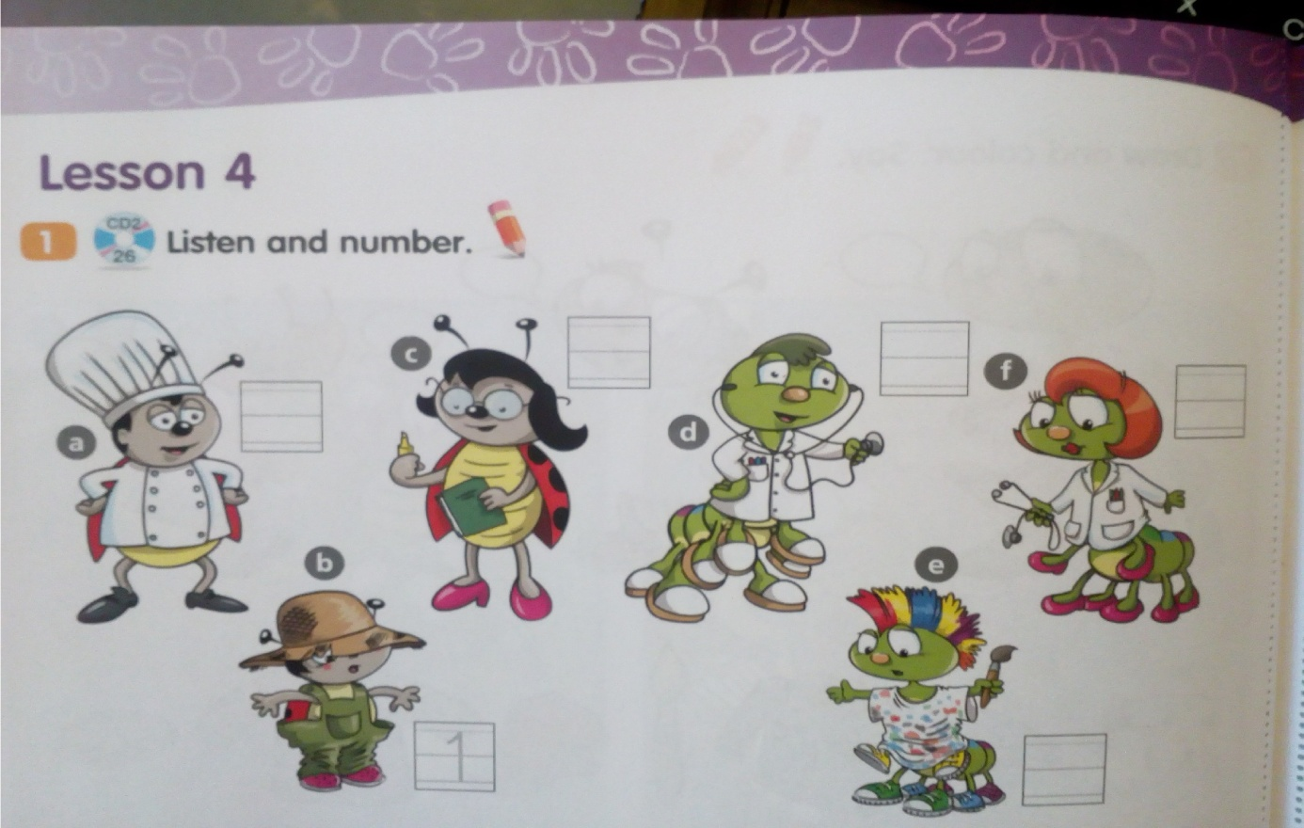
Ćwiczenie 3
Obejrzyj filmiki. Powtarzaj słówka za lektorem.
https://www.youtube.com/watch?v=BfegL6UbX-0
https://www.youtube.com/watch?reload=9&v=G5UHA2sf-IE
https://www.youtube.com/watch?v=v-HZNelHoLk

