Scenariusz lekcji języka angielskiego
Data: 14.04.2021
Temat: The little seed.
Ex. 1 Listen to the story.
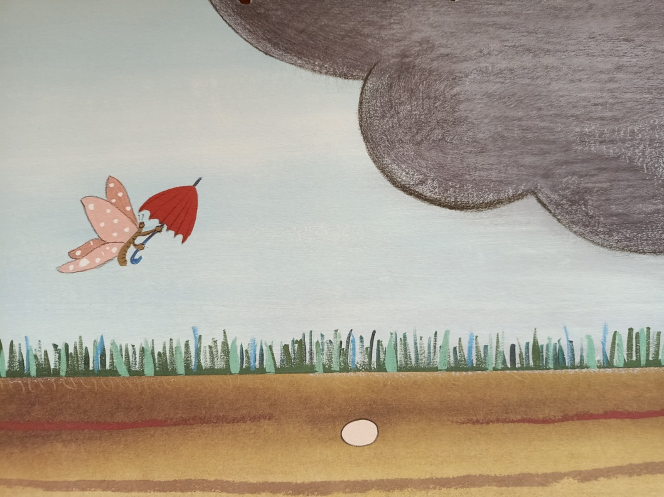
Look at the clouds
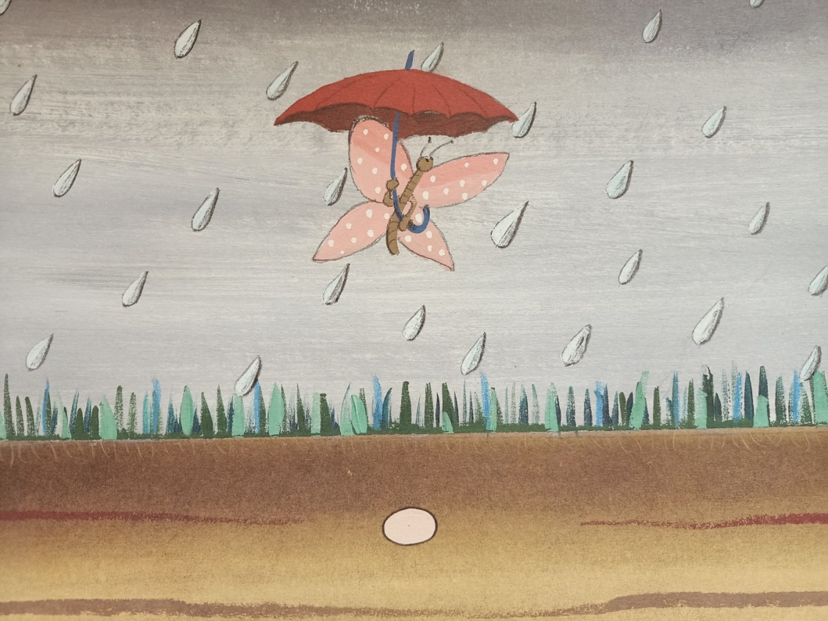
It’s raining.
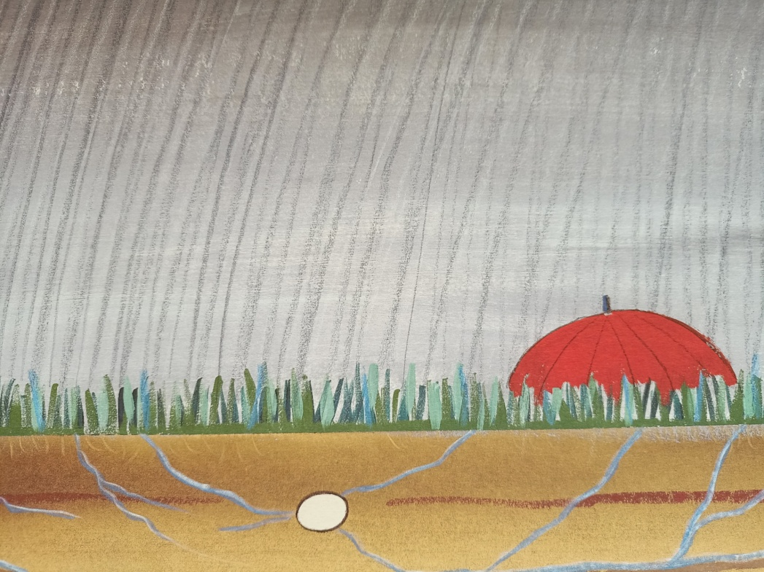
It’s raining and raining.
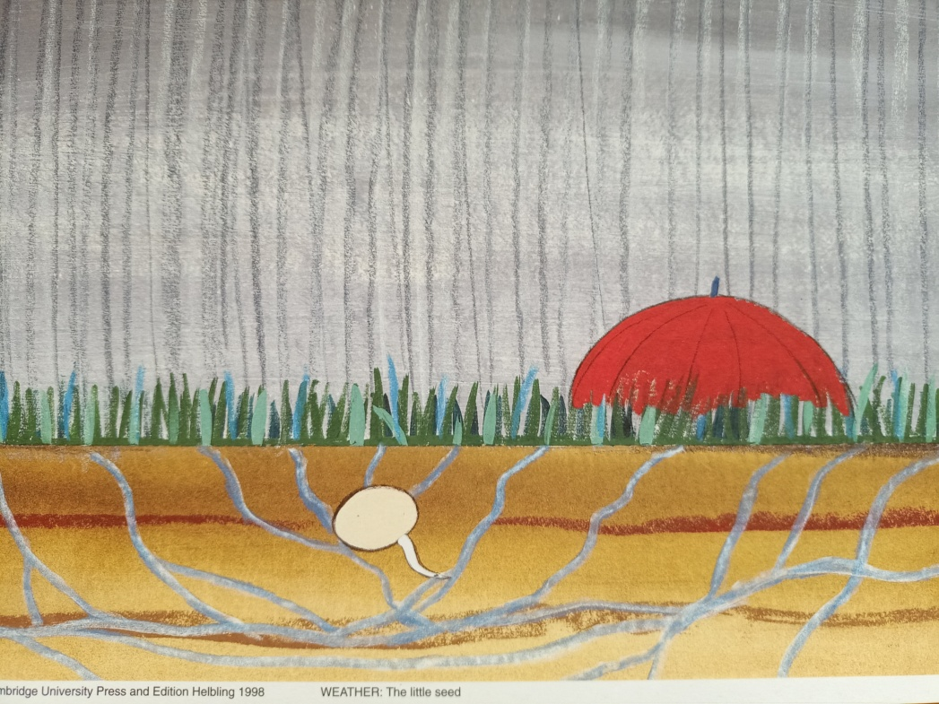
The little seed grows. It grows and grows.

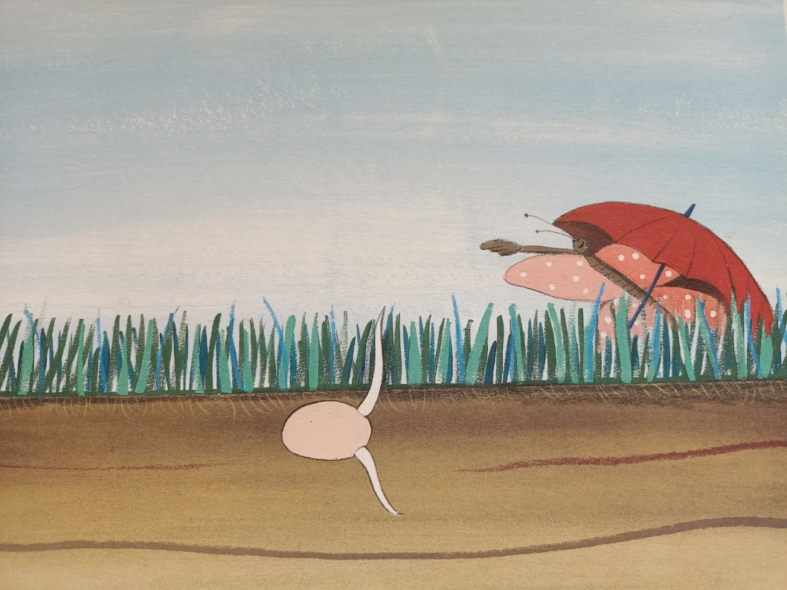
The rain stops.
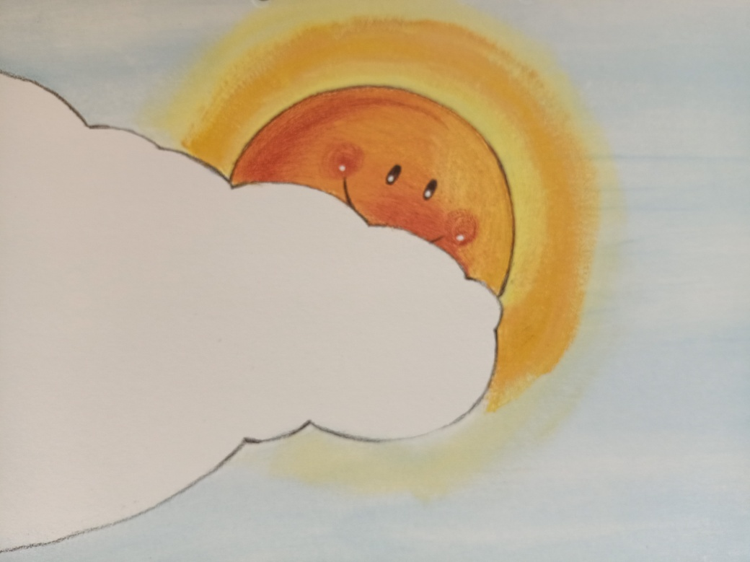
Look. Here comes the sun.

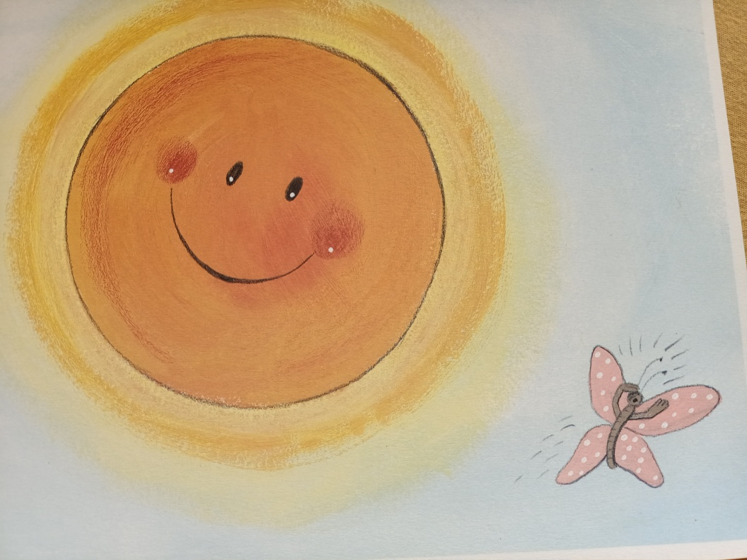
It’s warm.
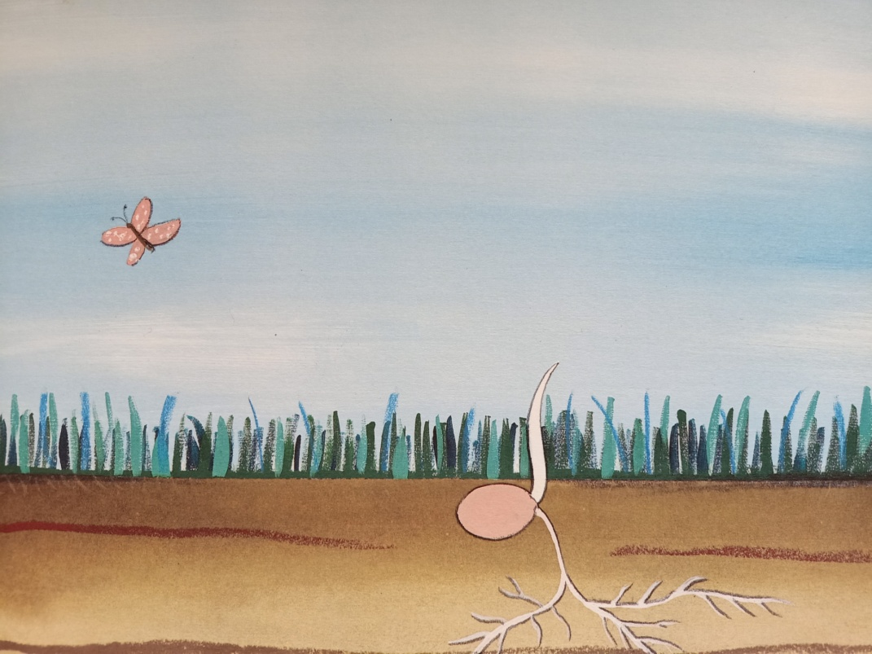
The little seed grows.

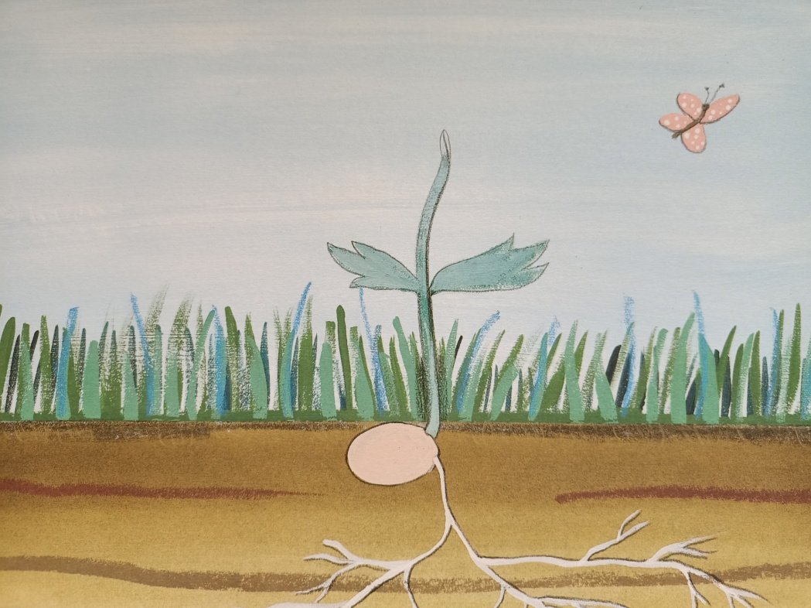
It grows and grows.
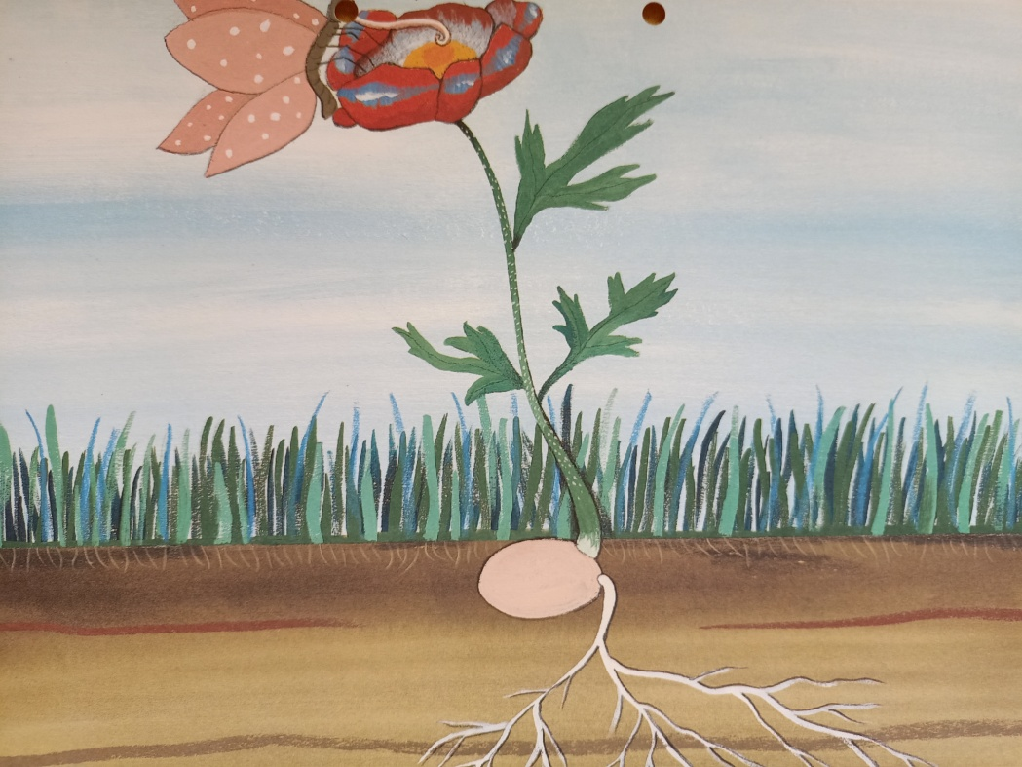
Aaaah! Look at the wonderful flower.
Ex. 2 Listen to the song:
https://www.youtube.com/watch?v=tfAB4BXSHOA
Ex. 3 Listen to the story:
https://www.youtube.com/watch?v=wfnqxkN_M_M
Opracowane na podstawie “Playway to English 2”, wyd. CUP

