Scenariusz lekcji języka angielskiego
Data: 15.04.2021
Temat: The grasshopper and the frog.
Ex. 1 Listen to the story.
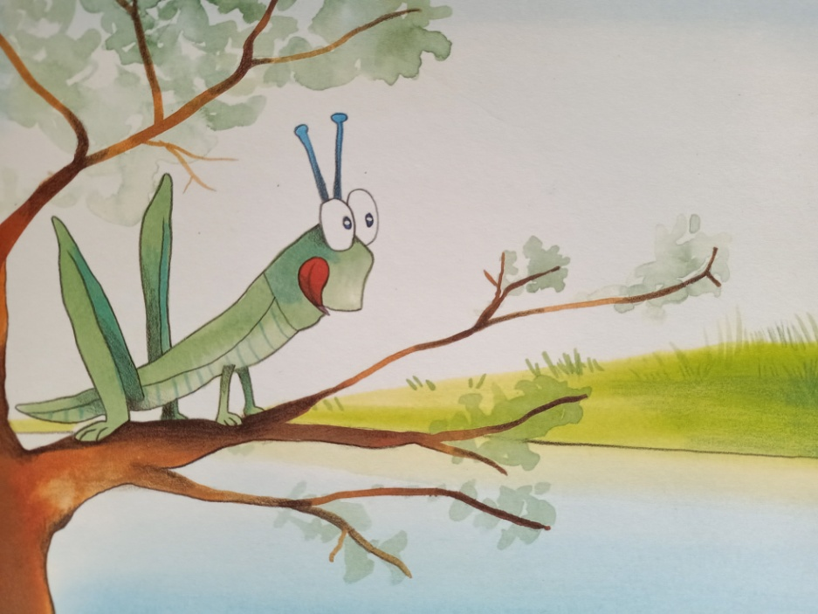
The grasshopper lives near the river.
“Nice green grass. Yummy. How can I get across?”
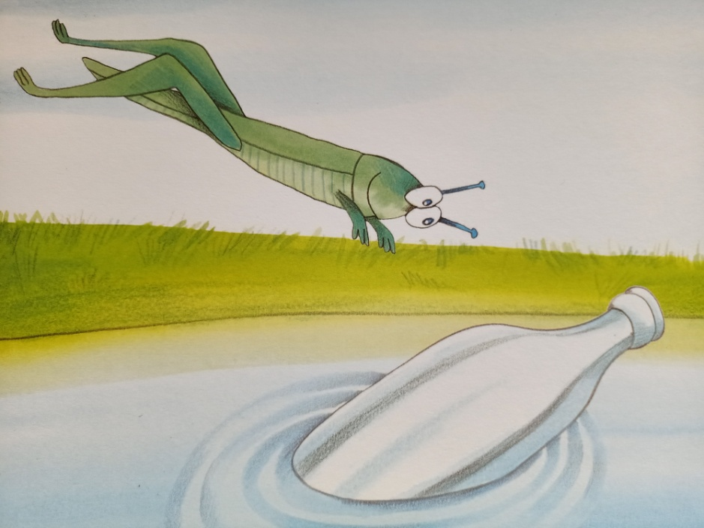
“Ah, there’s a boat.”

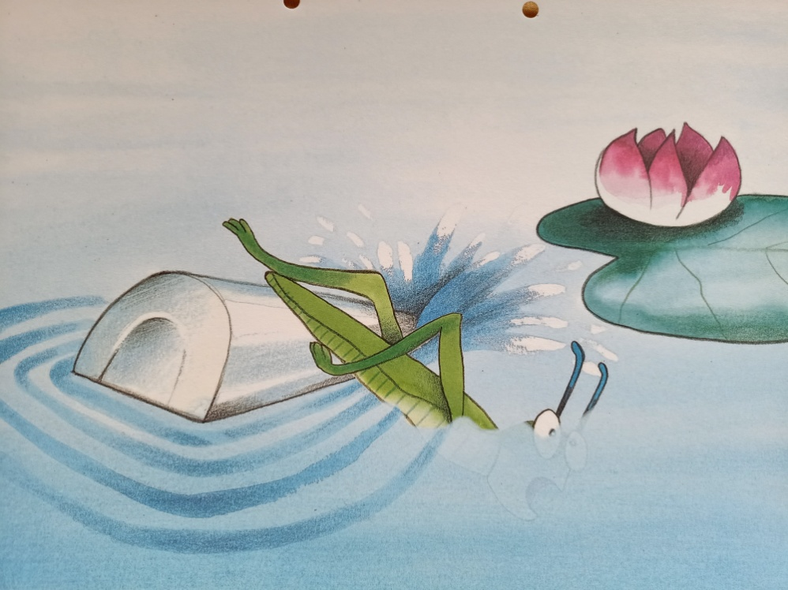
“Aaah!”
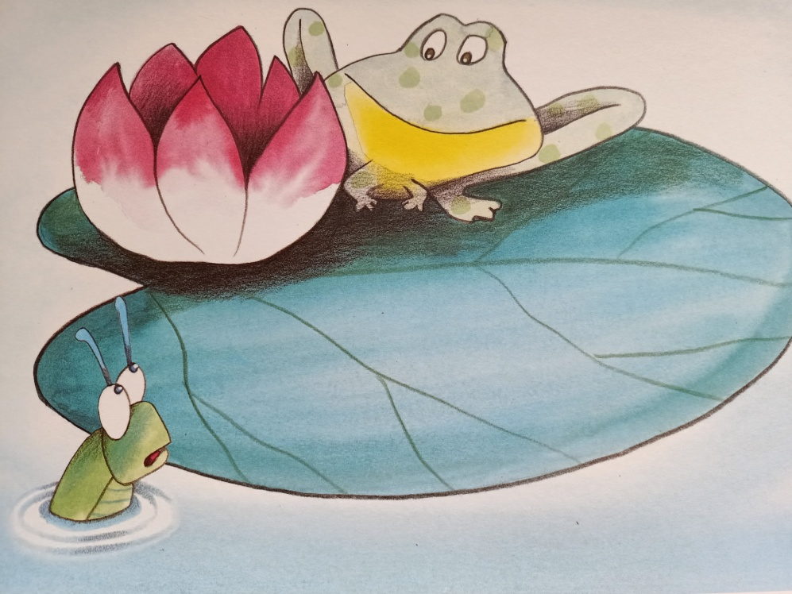
“Hello.”
“Hi.”
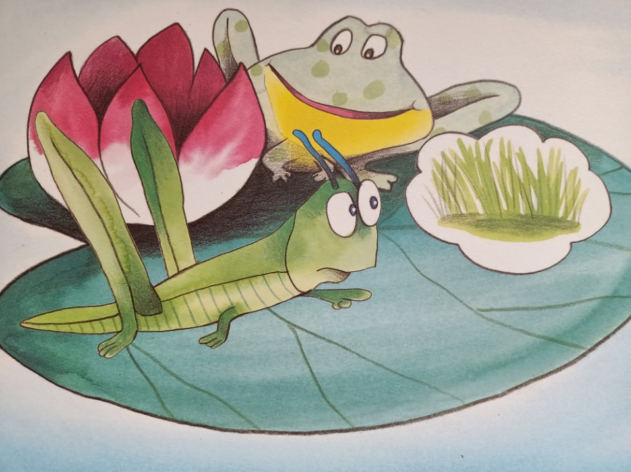
“Can you teach me to swim?”
“Swim?”
“Yes, I want to eat the lovely grass over there.”
“I can take you across.”
“Oh, great. Thank you.”
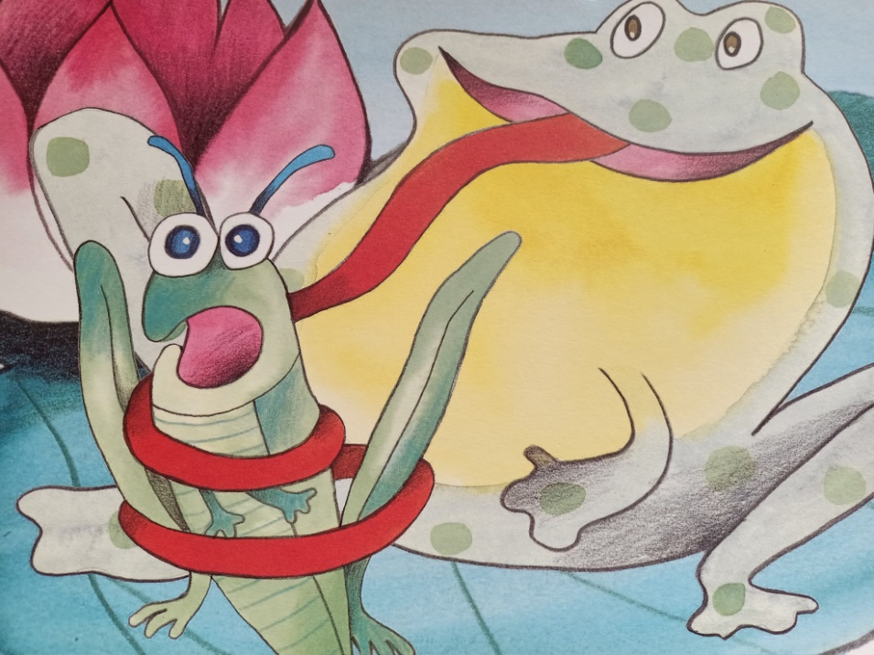
“Got you. Ha, ha, ha.”
“Frog, look. I’m not very fat. Take me across the river. I can eat the grass over there. Then you can eat a fat grasshopper.”
“Ha, ha, ha. Good idea.”
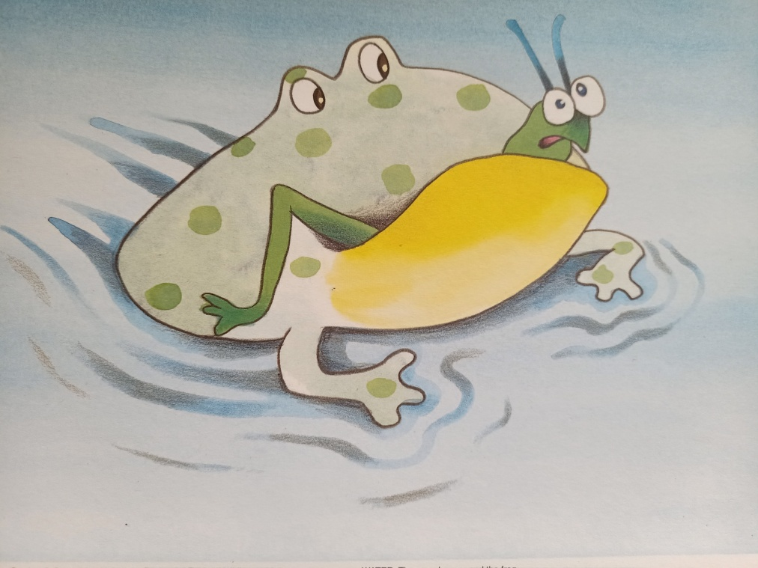

The frog takes the grasshopper across the river.

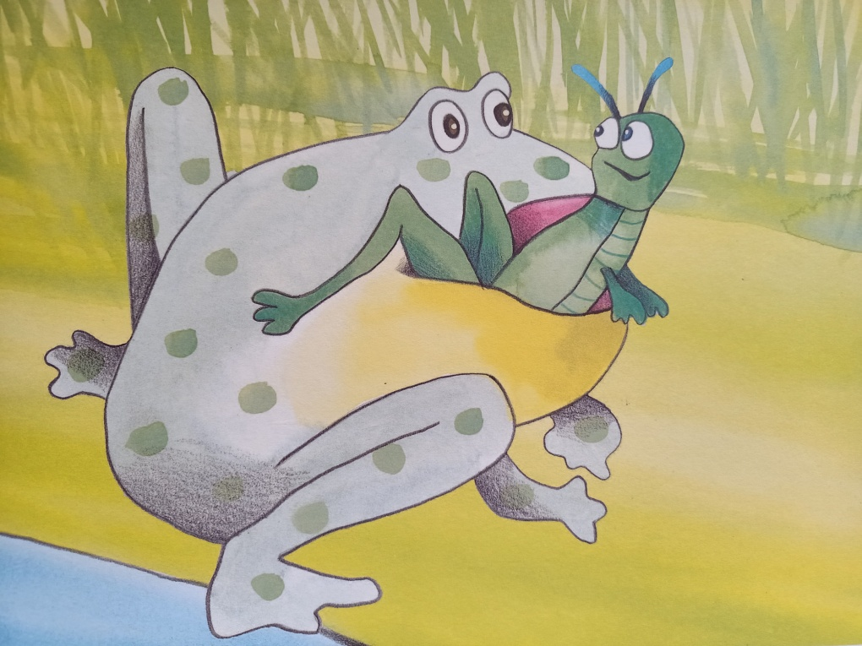
“Here we are. Have some grass. Then I’ll eat you.”

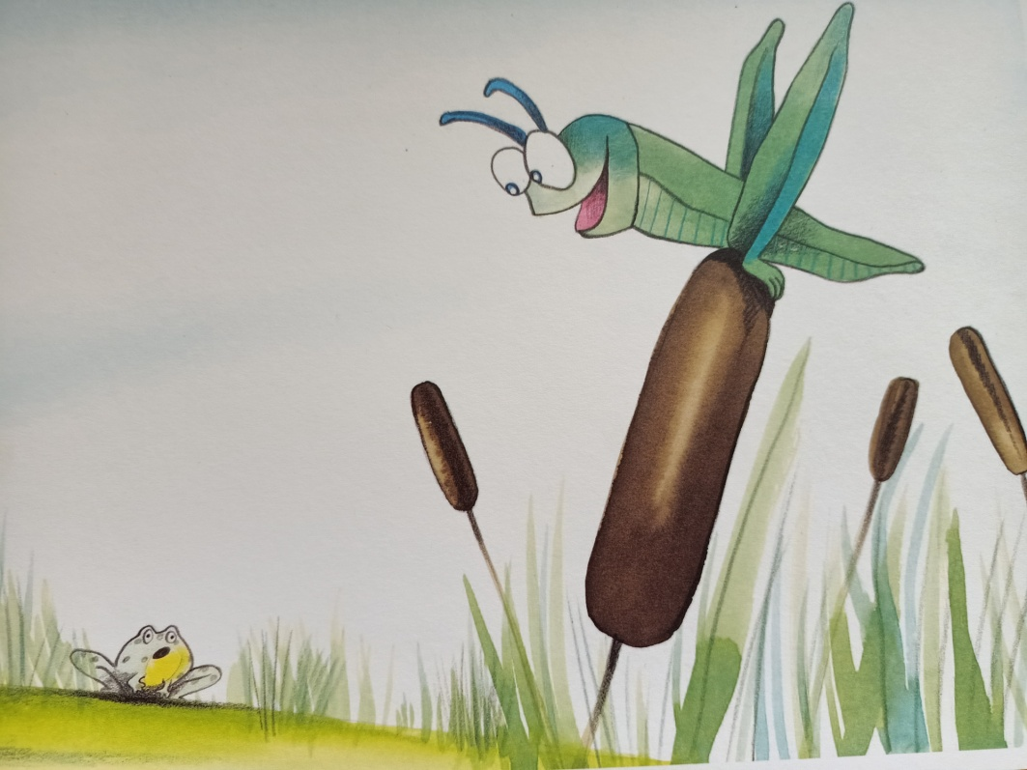
“Thank you, frog. Thanks a lot. Hee hee hee hee ...”

Ex. 2 Listen to the song:
https://www.youtube.com/watch?v=RN2qN9vSqgY
Ex. 3 Learn the names of little bugs:
https://www.youtube.com/watch?v=tksBMUzZUAs
Ex. 4 Enjoy the video!
https://www.youtube.com/watch?v=tYa6OLQHrEc

Opracowane na podstawie “Playway to English 2”, wyd. CUP

