Scenariusz lekcji języka angielskiego
Data: 12.04.2021
Temat: I like sport!
Ex. 1 Look and say:
playing basketball
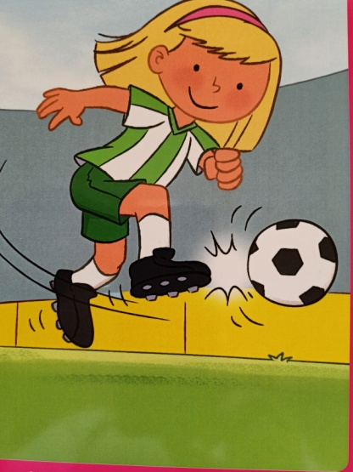 playing football
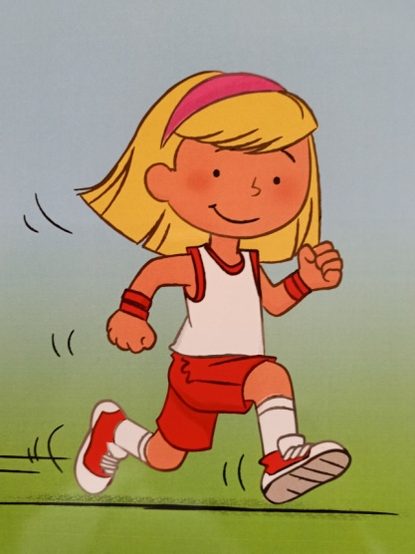 running

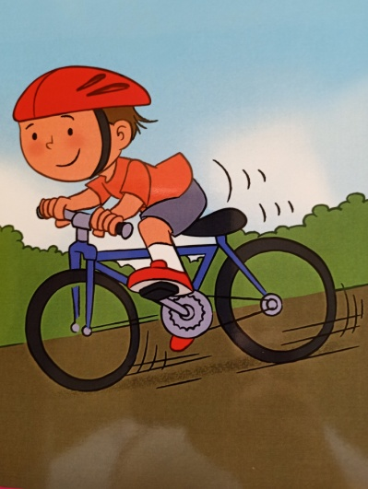 riding a bike
skating
swimming

Ex. 2 Listen to the story:
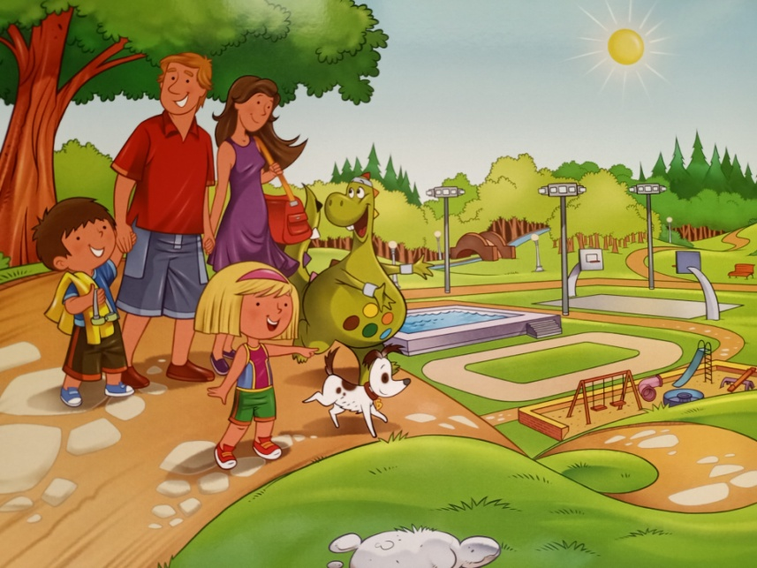
Dex, Charlie, Meg, Mummy and Daddy are in the park.
Daddy: It’s a nice day for sport!
Meg: I like sport.
Dex: I like sport, too.
Charlie: Let’s go!
Daddy: Do you like running, children?
Charlie: Yes, I do! I like running. I’m good at running. I’m fast.
Dex: Yes, I do! I like running. But I’m not good at running. I’m slow.
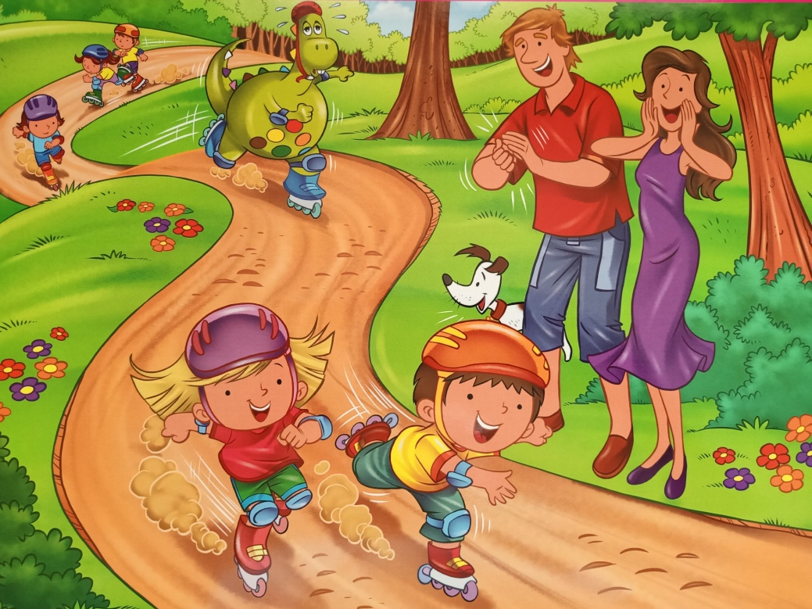
Mummy: Do you like skating?
Meg: Yes, I do! I like skating. I’m good at skating. I’m fast.
Dex: Yes, I do! I like skating. But I’m not good at skating. I’m slow.
Daddy: Do you like swimming, children?
Charlie: Yes, I do! I like swimming. I’m good at swimming. I’m fast.
Dex: Yes, I do! I like swimming. But I’m not good at swimming. I’m slow.
Mummy: Well done, Dex! Keep trying!
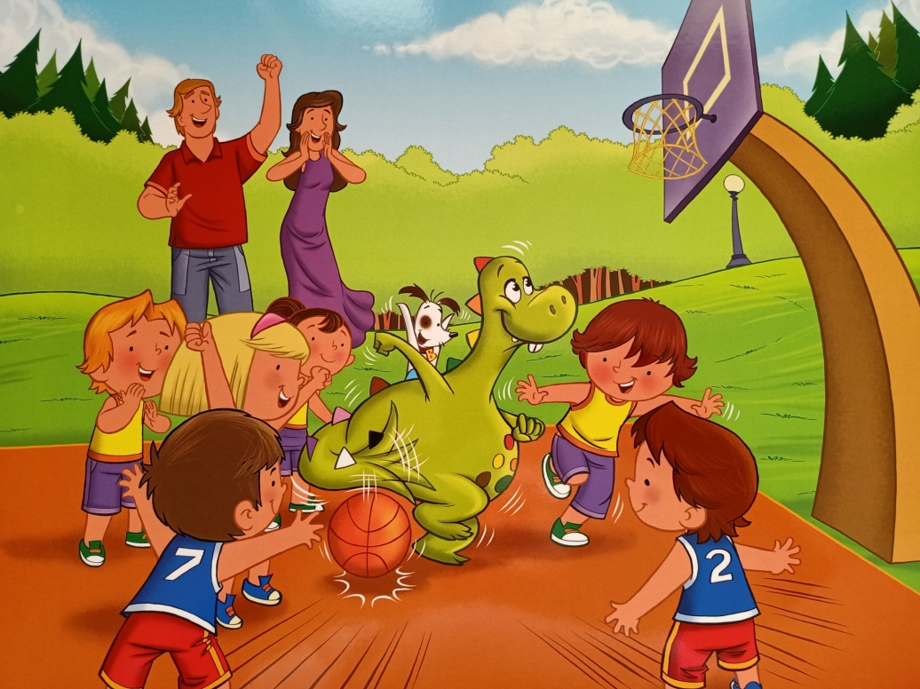
Mummy: Do you like playing basketball, children?
Meg: Yes, I do. I like playing basketball. I’m good at playing basketball. I’m fast.
Dex: Wow! I like playing basketball. I’m good at playing basketball, too. Look!

Meg: Score!
Charlie: Well done, Dex!
Dex: I like sport, but playing basketball is my favourite!

Ex. 3 Listen to the song:
https://www.youtube.com/watch?v=27f0QUUScQ8
and learn the words:
https://www.youtube.com/watch?v=yGJ0MoYXmZA

Ex. 4 Spot the differences:
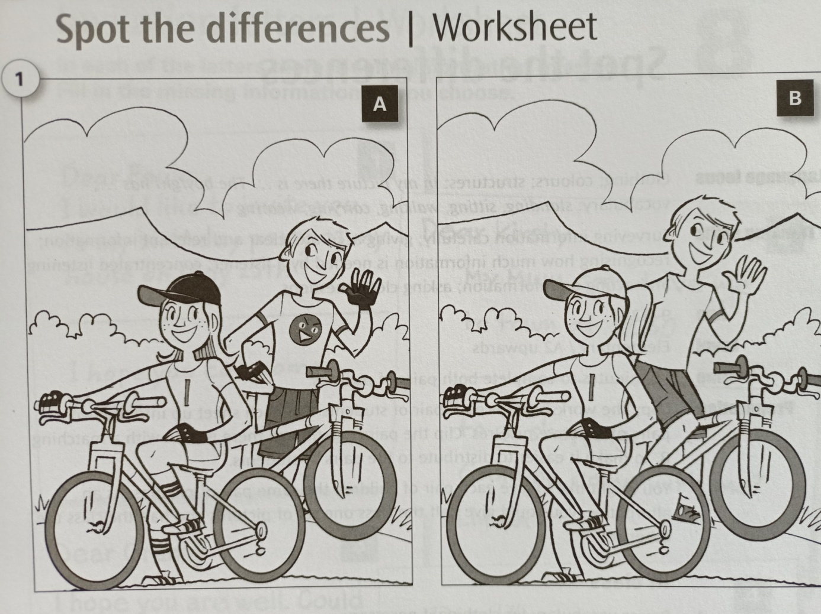

Opracowane na podstawie: Discover with Dex 2, wyd. Macmillan oraz Cross-Curricular Resources for Young Learners, wyd. Oxford

