Scenariusz lekcji języka angielskiego
Data: 12.04.2021
Temat: I like sport!
Ex. 1 Look and say:
playing basketball
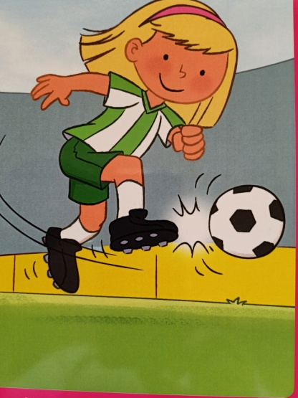 playing football
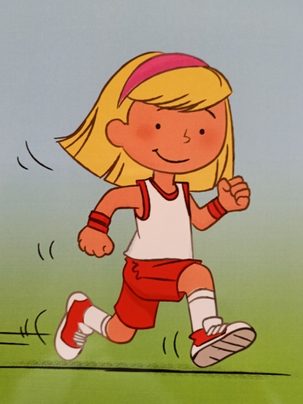 running

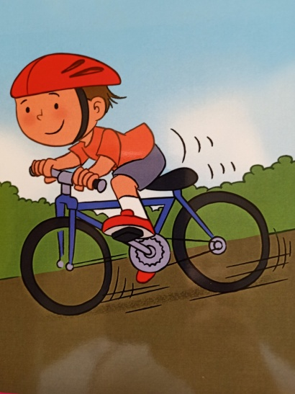 riding a bike
skating
swimming

Ex. 2 Say the rhyme:

Walking, walking, walking,
Hop, hop, hop!
Swimming, swimming, swimming,
Now, let’s stop!

Ex. 3 Listen to the song:
https://www.youtube.com/watch?v=27f0QUUScQ8

Ex. 4 Cut out the parts of the body. Place the body parts on a sheet of coloured paper to represent different movements.
+
+
+
+
+
+
+
+
+
+
+
+
+
+
+
+

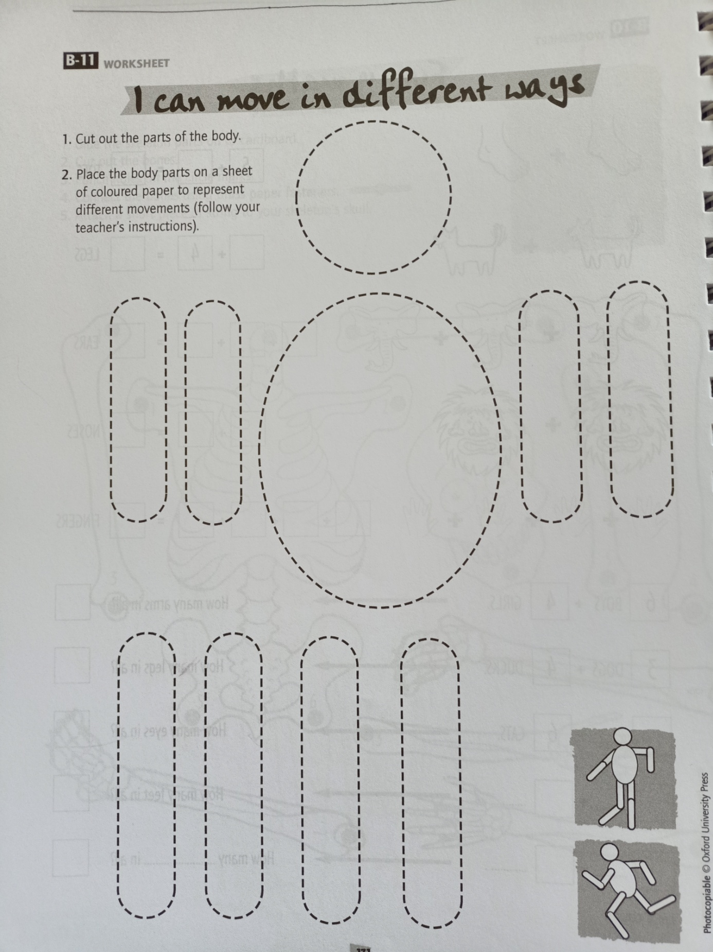
Opracowane na podstawie: Discover with Dex 2, wyd. Macmillan oraz Cross-Curricular Resources for Young Learners, wyd. Oxford

