Scenariusz lekcji języka angielskiego
Data: 08.04.21
Temat: A black sheep.
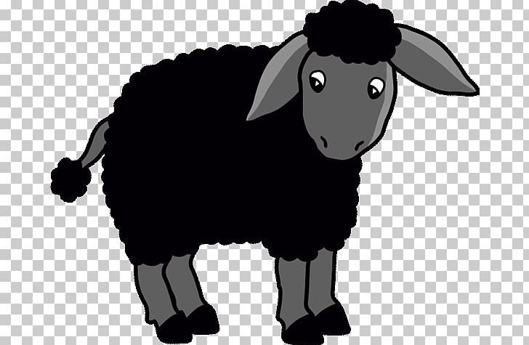
This is a black sheep.
It has got wool.
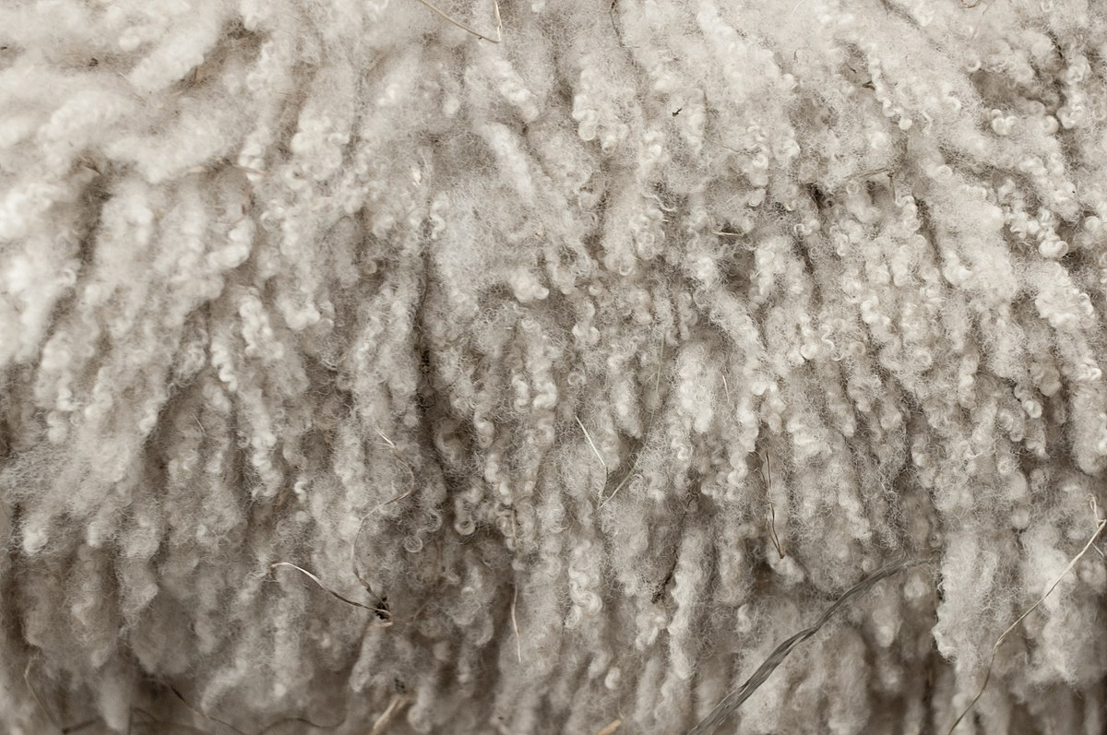
Read the rhyme:
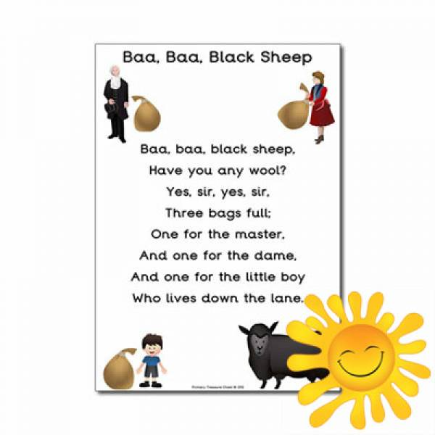

Listen to the song:
https://www.youtube.com/watch?v=CRHvTTOR8Ns
https://www.youtube.com/watch?v=i7ygKQunfmE

