Scenariusz zajęć języka angielskiego
Data: 02.04.2021
Temat: Happy Easter!
Ex. 1
Say the rhyme.
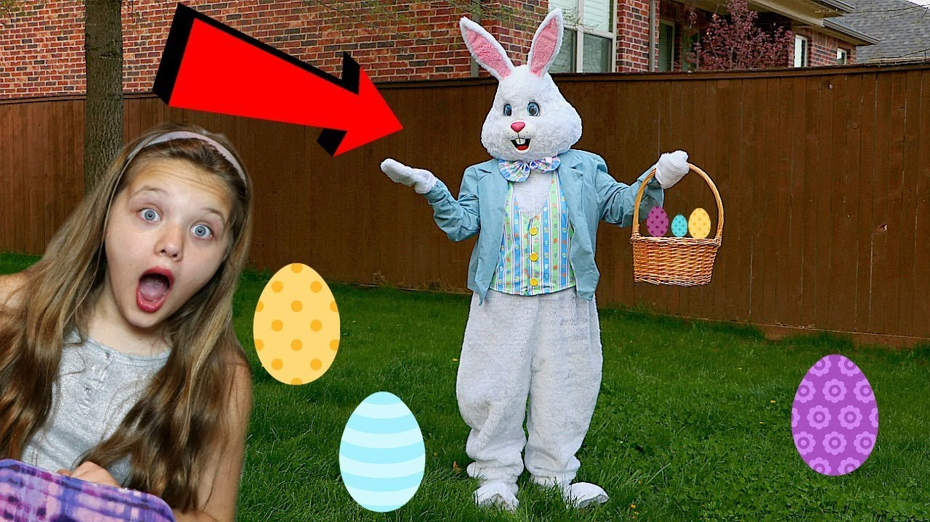
Hop, hop!
I’m the Easter Bunny.
Look, look!
I’ve got Easter eggs.
Yum, yum!
Easter eggs are yummy.
Happy Easter Daddy!
Happy Easter Mummy!
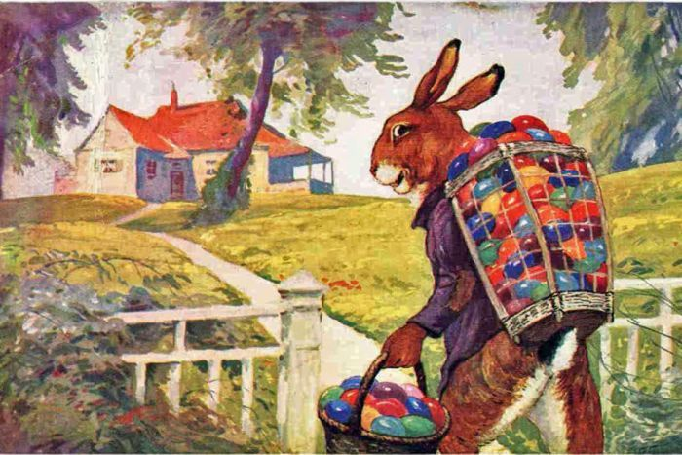
This is the Easter Bunny with Easter eggs
Ex. 2
Say the words:
https://www.youtube.com/watch?v=7yx2xIpNiQ4
https://www.youtube.com/watch?v=edOO0aV9gfk
Ex. 3
Play the game:
https://www.youtube.com/watch?v=YOSCE0XTwEI
Ex. 4
Listen to the song. Dance.
https://www.youtube.com/watch?v=IMzWTErrSxQ
You can watch a video (44 minutes)
https://www.youtube.com/watch?v=nZLIiq7B85g

Zadania do wyboru
Ex. 5
Colour the shapes:
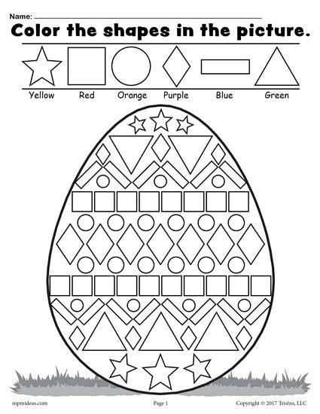

Ex. 6
Find and colour Easter eggs:
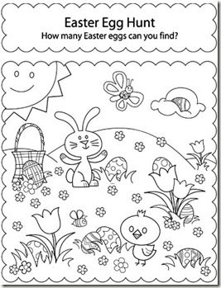

Ex. 7
Finish the patterns:
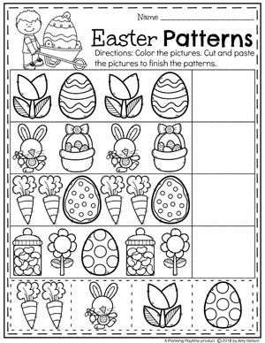

Ex. 8
Colour and cut:
