Scenariusz zajęć języka angielskiego
Data: 02.04.21
Temat: Happy Easter!
The Easter Bunny has got an Easter egg.

This is a lamb.
This is a lamb.

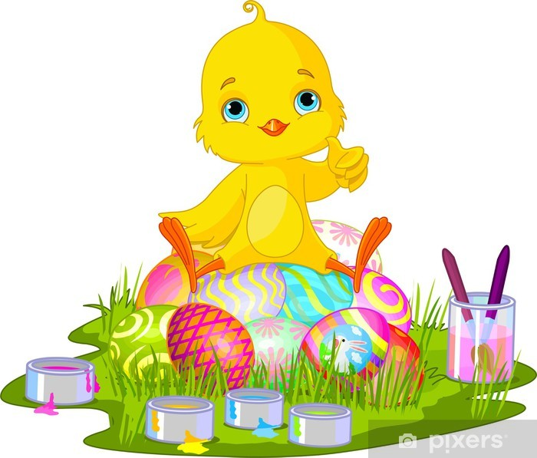
This is a chick.
Ex.2

Listen to the song. Dance.
https://www.youtube.com/watch?v=IMzWTErrSxQ
Play the game:
https://www.youtube.com/watch?v=YOSCE0XTwEI
You can watch a video (44 minutes)
https://www.youtube.com/watch?v=nZLIiq7B85g
Ex. 3
Colour the picture:
