Scenariusz zajęć języka angielskiego dla grup 3,4 i 5
Data: 29.03.2021
Subject: Farm animals – review
Ex. 1
Point to the pictures: cat, dog, horse, cow, sheep, pig, duck, goat, chicken, rooster.

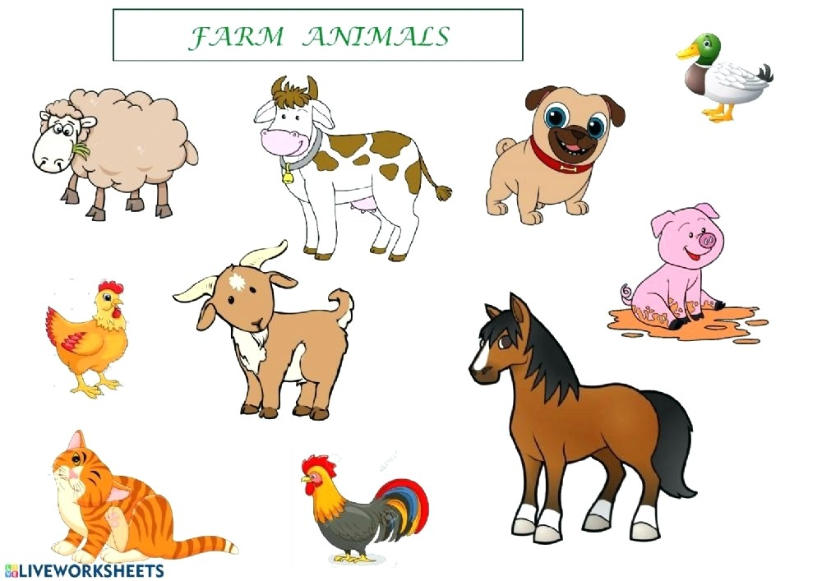

Ex. 2
Count the animals and find the objects on the picture by shadow.
How many cows can you see?
How many ducks can you see?
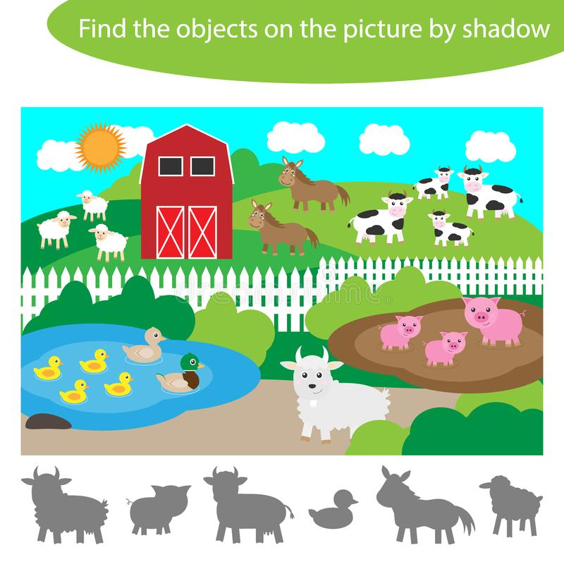
Ex. 3
Listen to the song “The farmer in the dell”:
https://www.youtube.com/watch?v=1TnqZh5Tw5s

Listen to the song “Old McDonald”:
https://www.youtube.com/watch?v=Y7T0WvaeGUU
Listen to the sounds. Imitate the sounds:
https://www.youtube.com/watch?v=5HgTgpqtwns

Ex. 4
Colour the animals:

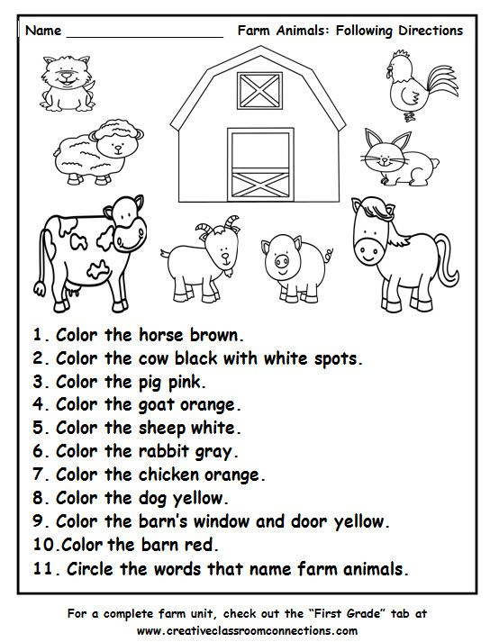
Opracowała: Elżbieta Giernatowska

