Scenariusz zajęć języka angielskiego dla grupy 1 i 2
Data: 29.03.2021
Temat: Farm animals – review
Ex. 1
Point to the picture. Name the animals.
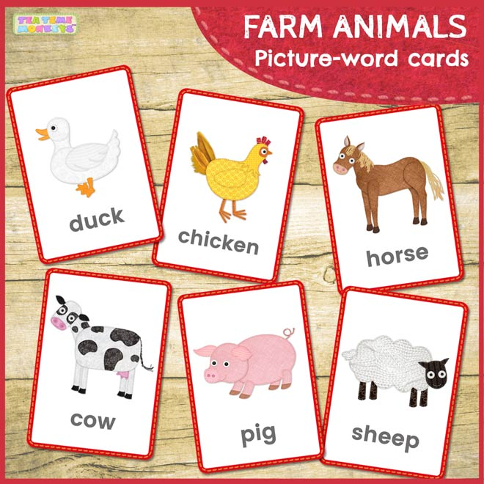
Ex. 2
Listen to the song “The farmer in the dell”:
https://www.youtube.com/watch?v=1TnqZh5Tw5s

Listen to the song “Old McDonald”:
https://www.youtube.com/watch?v=Y7T0WvaeGUU
Listen to the sounds. Imitate the sounds:
https://www.youtube.com/watch?v=5HgTgpqtwns

Good luck!
Opracowała: Elżbieta Giernatowska

